## **Python Operators Precedence Table**

|  |  |
| --- | --- |
| **Operator** | **Description** |
| ** | Exponentiation |
| ~, +, - | Complement, unary plus and unary minus |
| *, /, %, // | Multiply, divide, modulo and whole (floor) division |
| +, - | Addition and subtraction |
| >>, << | Right and left bitwise shift |
| & | Bitwise and |
| ^ ,| | Bitwise exclusive or and bitwise or |
| <=, < ,> ,>=, | Relational operators |
| <> ,== ,!= | Equality operators |
| = ,%= ,/= ,//= ,-= ,+= ,*=, **= | Assignment operators |
| is , is not | Identity operators |
| in not in | Membership operators |
| not , or , and | Logical operators |

## **Python Relational Operators**

|  |  |  |
| --- | --- | --- |
| **Operator** | **Meaning** | **Usage** |
| > | Greater than | x > y |
| < | Less than | x < y |
| == | Equal to | x == y |
| != | Not equal to | x != y |
| >= | Greater than or equal to | x >= y |
| <= | Less than or equal to | x <= y |

## **Python Logical Operators**

|  |  |  |
| --- | --- | --- |
| **Operator** | **Meaning** | **Usage** |
| and | True if both the operands are true | x and y |
| or | True if either of the operands is true | x or y |
| not | complements the operand | not x |

## **Python Membership Operators**

|  |  |  |
| --- | --- | --- |
| **Operator** | **Meaning** | **Usage** |
| in | Check to see if value is in the sequence | 5 in [2,5,3,7] |
| not in | Check to see if value is not in the sequence | 5 not in [2,5,3,7] |

## **Complete Precedence Table**

The following table shows the complete precedence of Python Operators: Highest to Lowest

|  |  |
| --- | --- |
| **OPERATOR** | **DESCRIPTION** |
| **()** | **Parenthesis (grouping)** |
| **f(args...), x[i:i], x[i], x.attr** | **Function call, slicing, subscript, dot** |
| **\*\*** | **Exponentiation** |
| **+, -, ~** | **Unary Positive, Unary Negative, bitwise NOT** |
| **\*, /, %** | **Multiplication, Division, Remainder** |
| **+, -** | **Addition, Subtraction** |
| **<<, >>** | **Shifts** |
| **&** | **Bitwise AND** |
| **^** | **Bitwise XOR** |
| **|** | **Bitwise OR** |
| **<, <=, >, >=, !=, ==, is, is not, in, not in** | **Comparisons, identity, membership** |
| **not** | **Boolean NOT** |
| **and** | **Boolean AND** |
| **or** | **Boolean OR** |
| **lambda** | **Lambda Expression** |

## **Conditional if**

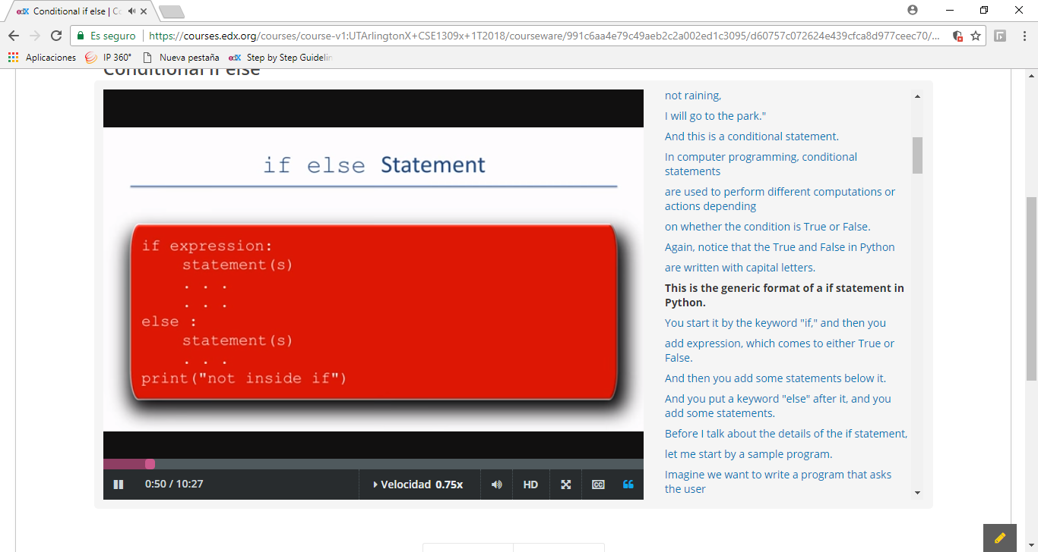

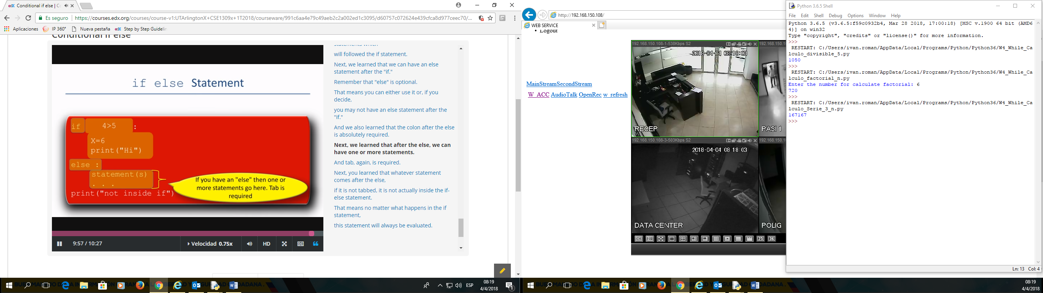

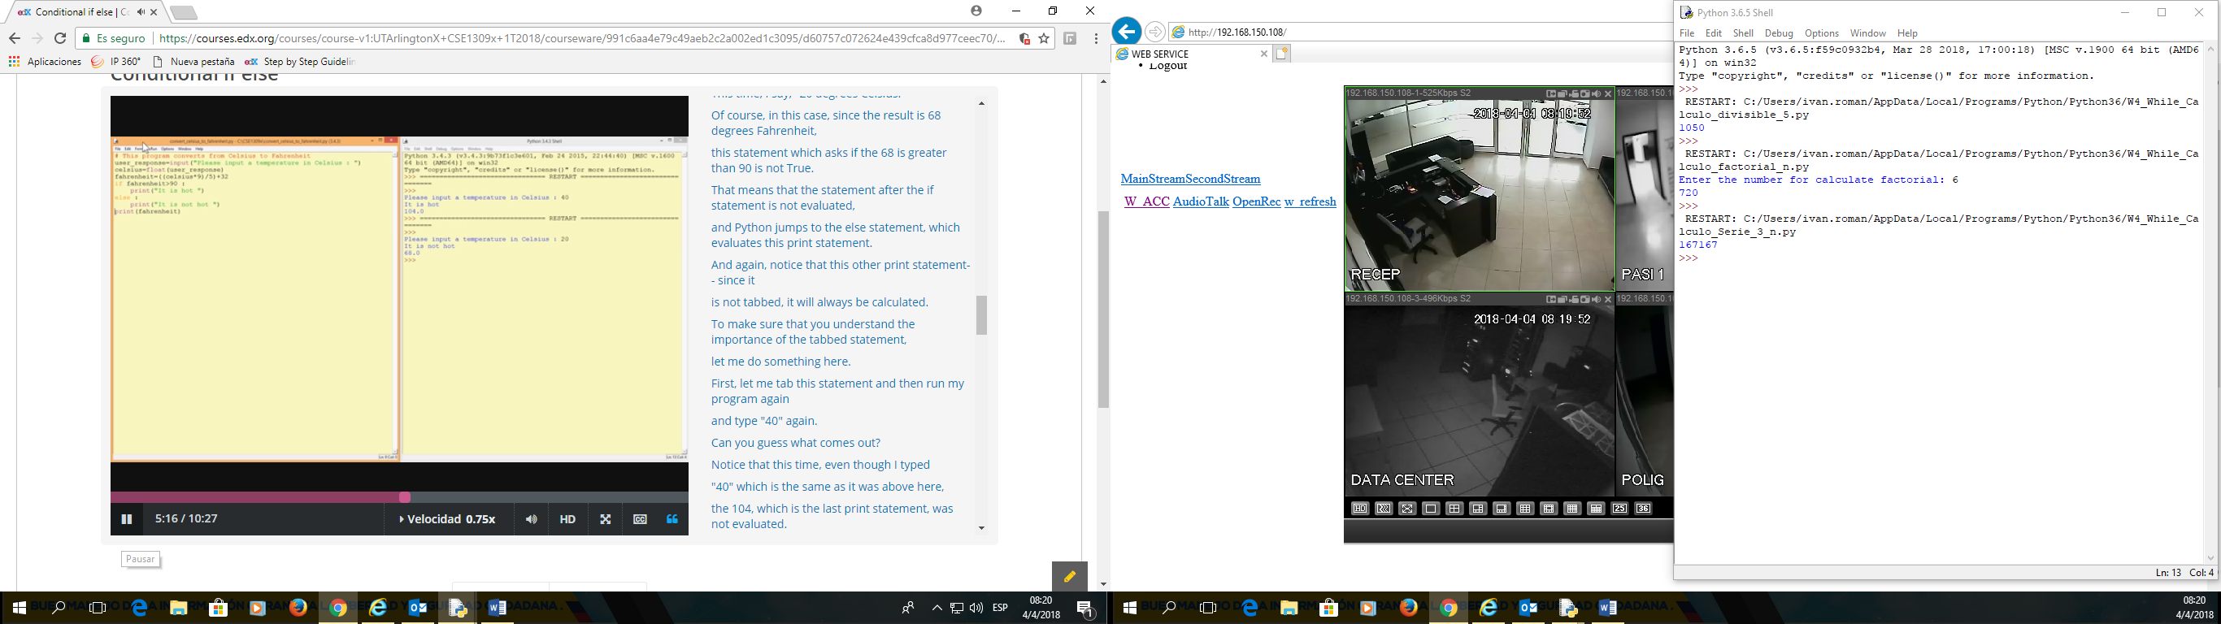

## **Conditional if elif else**

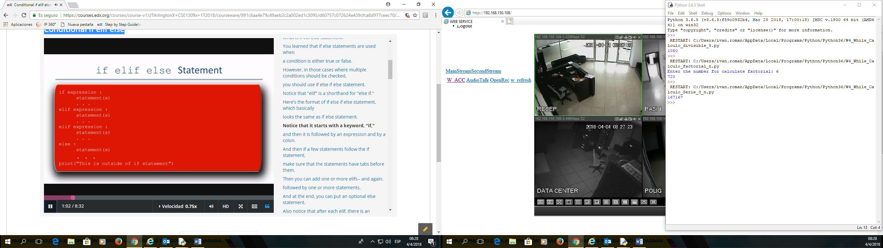

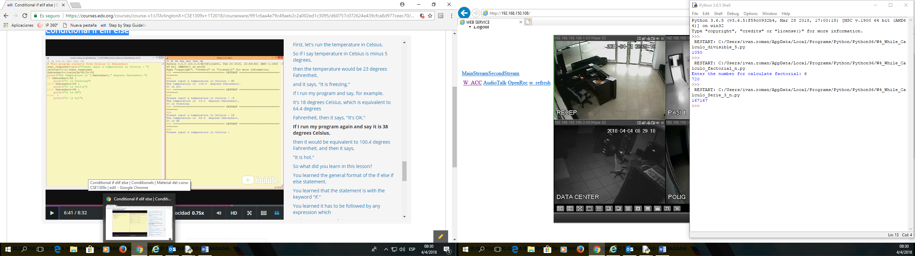

**WHILE LOP**

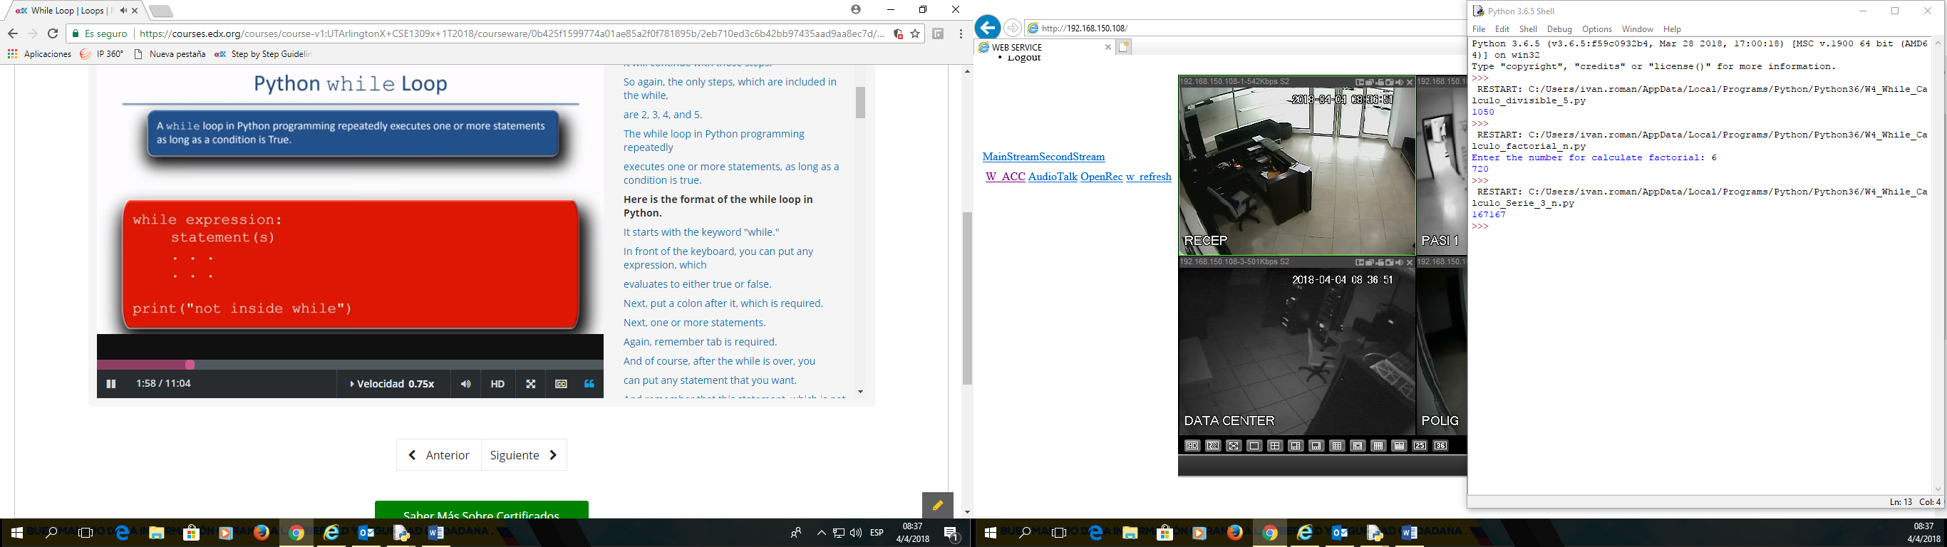

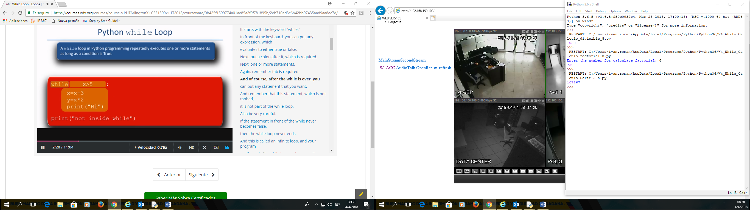

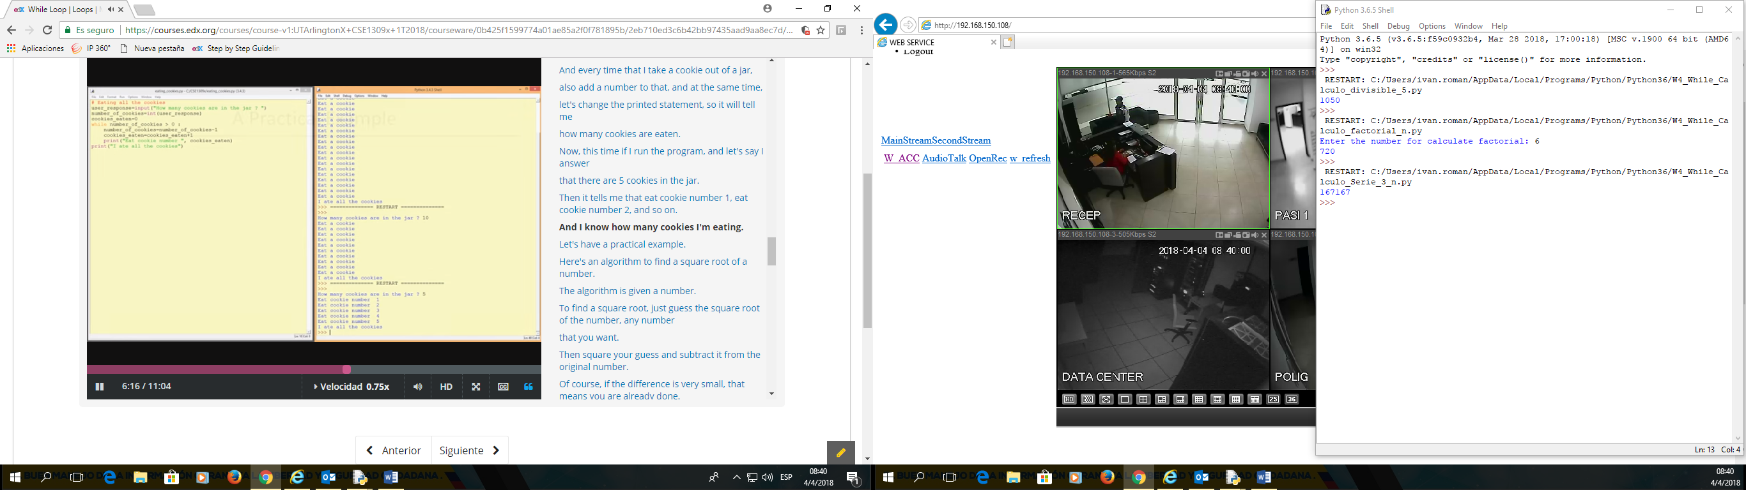

**For Loop**

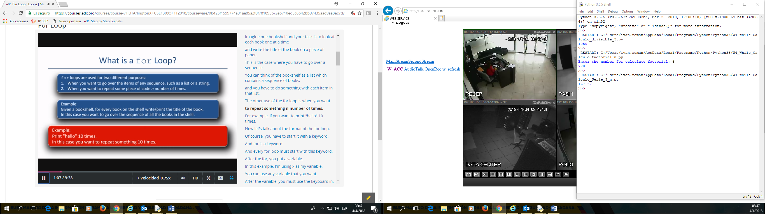

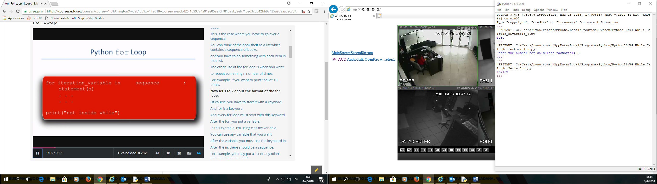

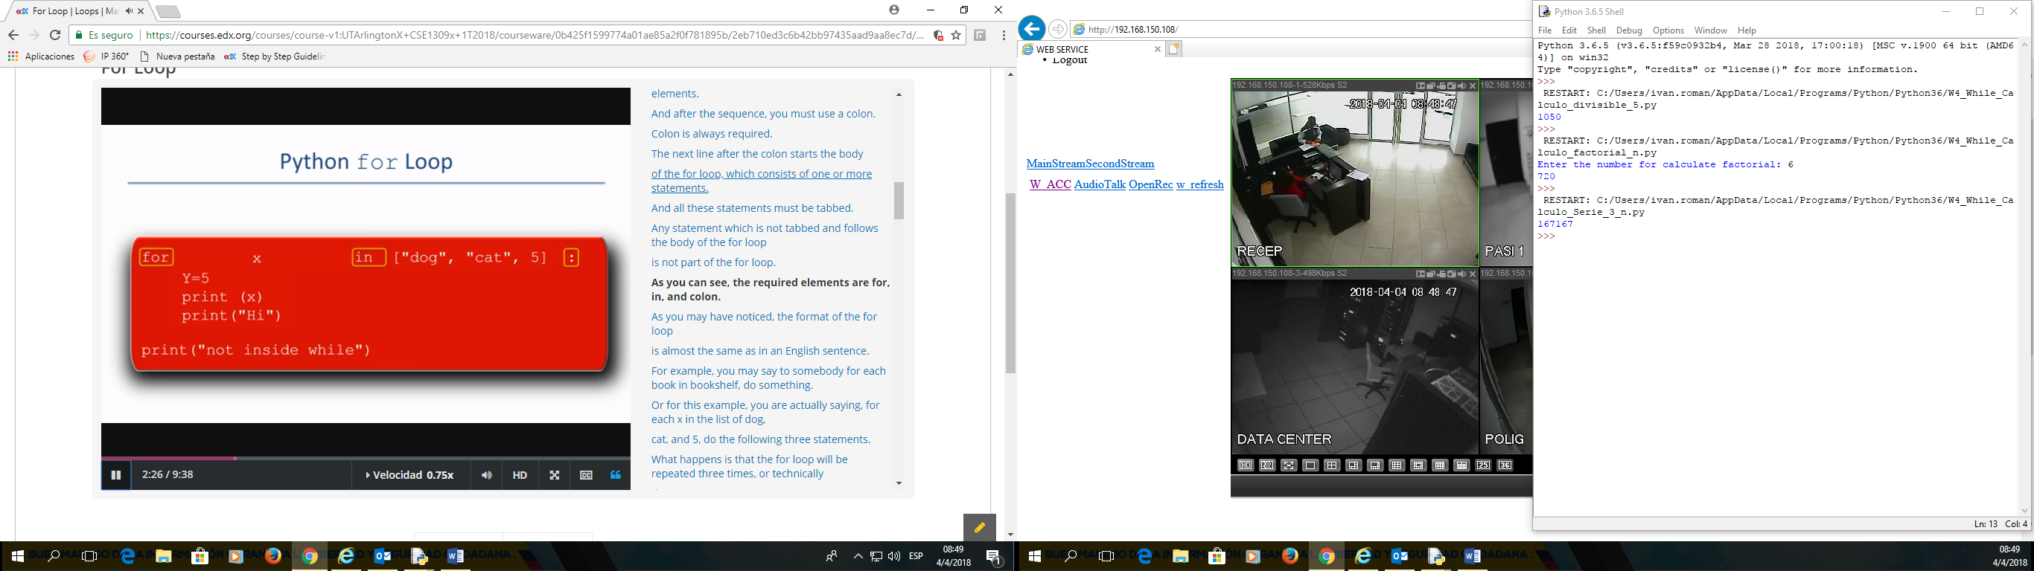

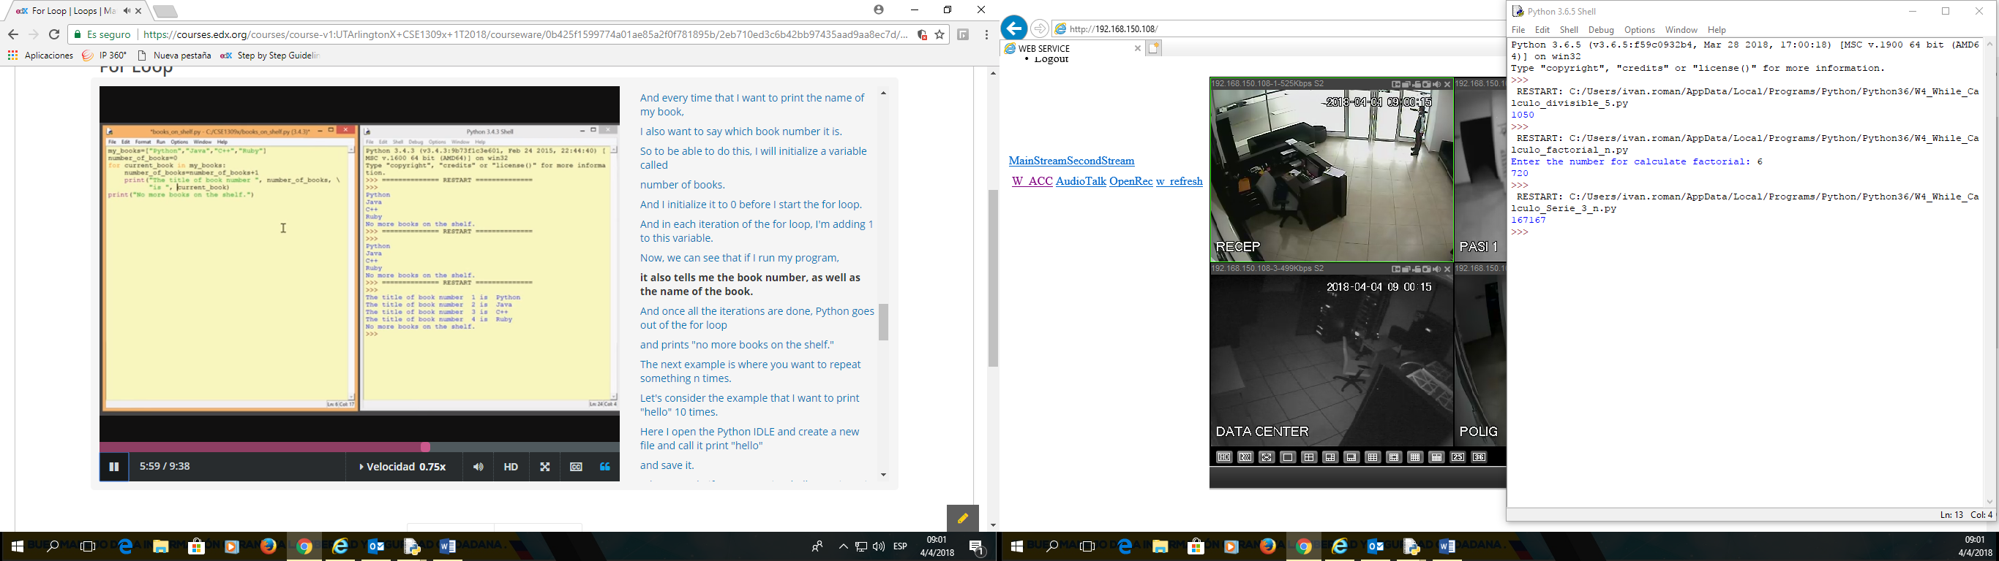

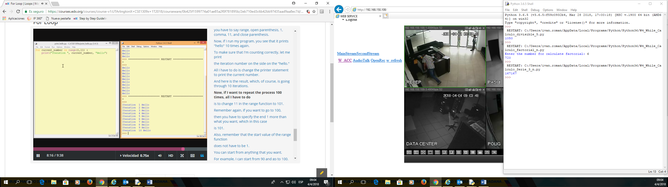

**Continue and Break**

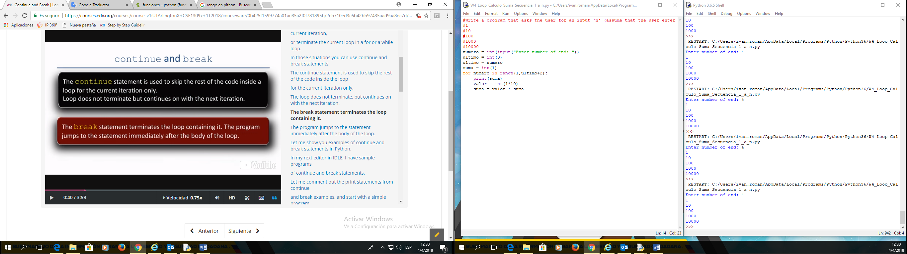

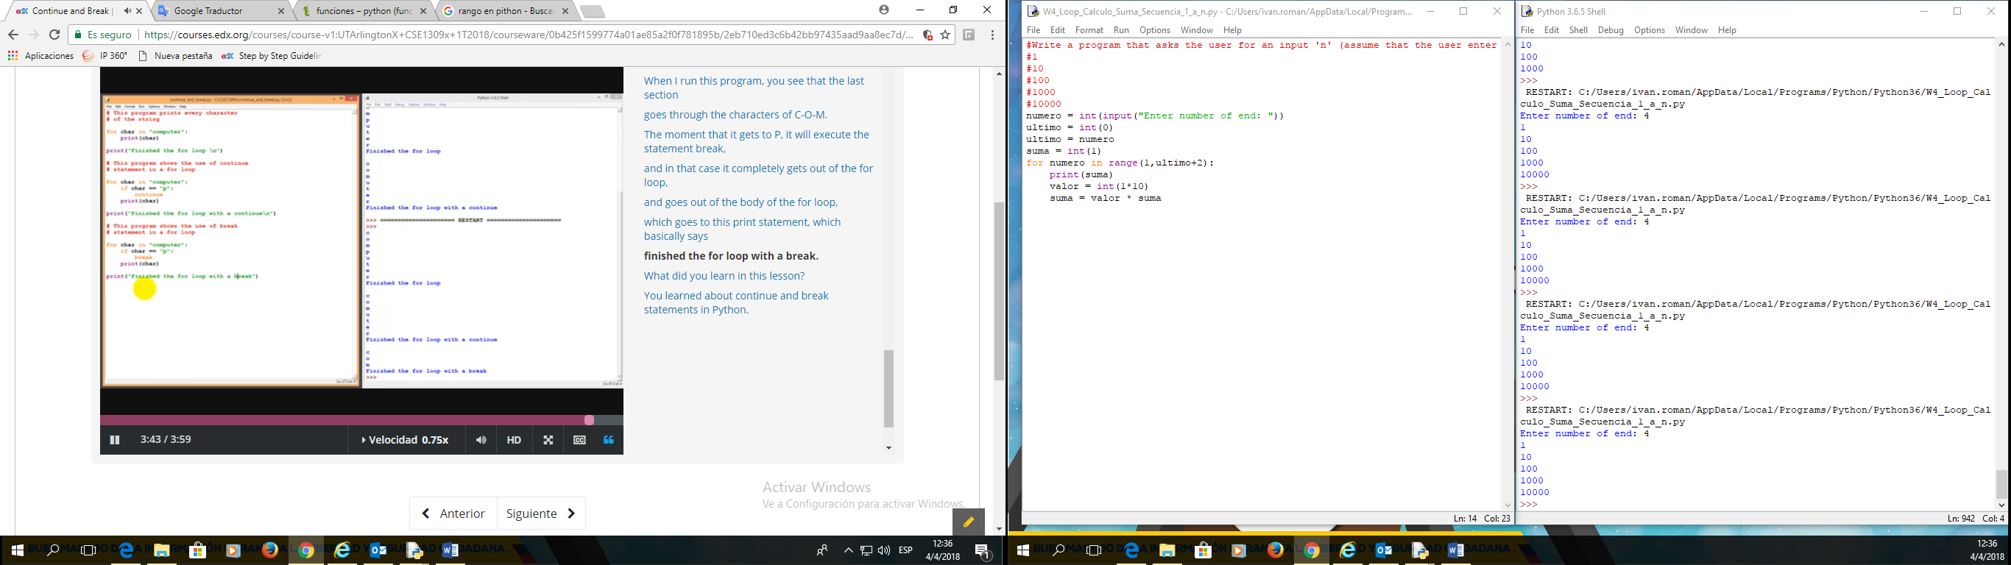

**Nested Loops**

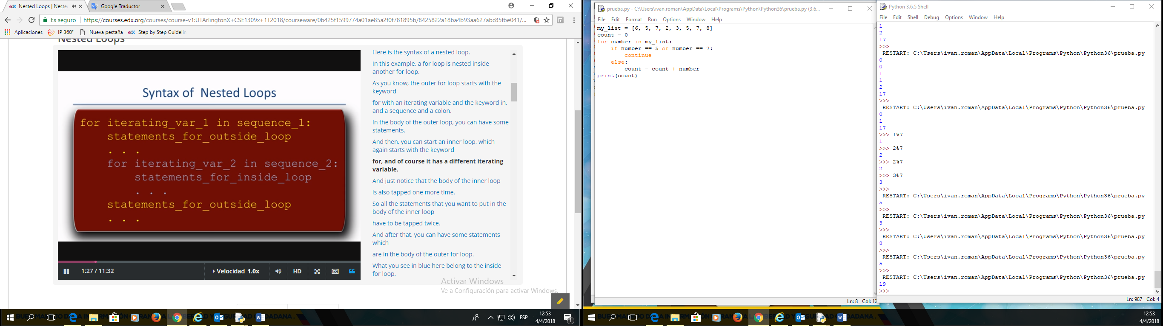

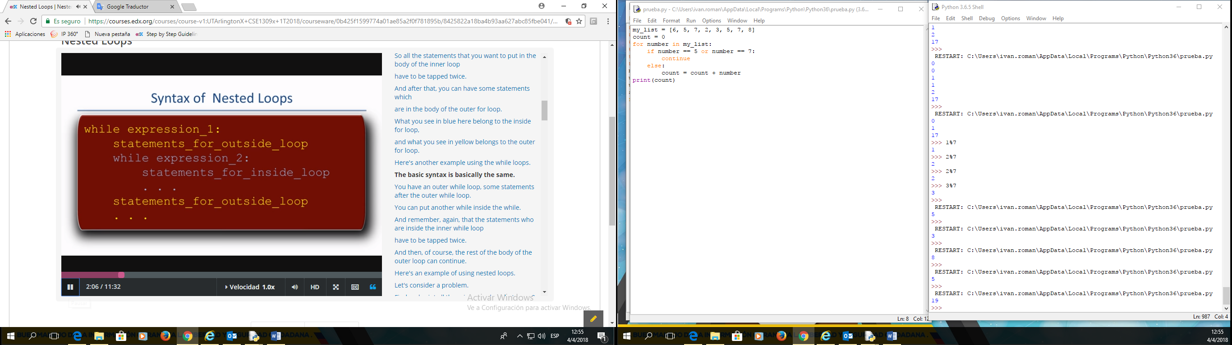

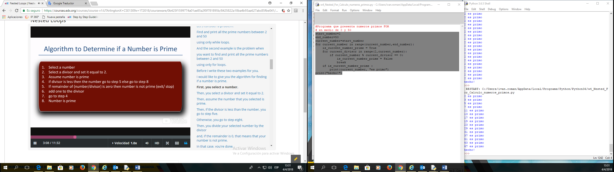

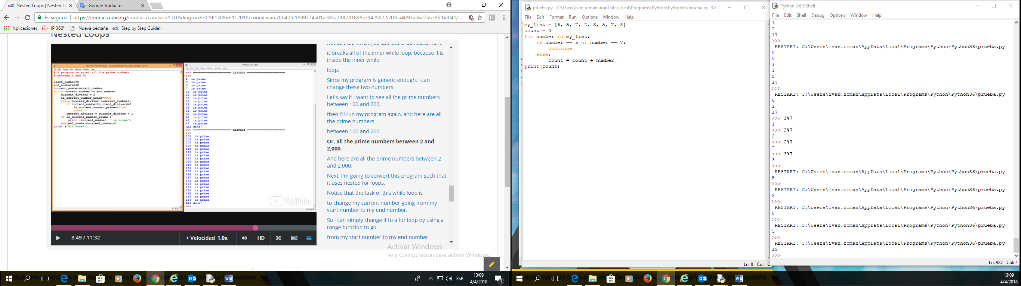

#Programa que presenta numeros primos **WHILE**

# en medio de 2 y 50

start_number=2

end_number=50

current_number=start_number

while current_number <= end_number:

current_divisor = 2

is_current_number_prime = True

while(current_divisor <current_number):

if current_number % current_divisor == 0:

is_current_number_prime = False

break

current_divisor = current_divisor + 1

if is_current_number_prime :

print(current_number, "es primo")

current_number = current_number + 1

print("hecho!")

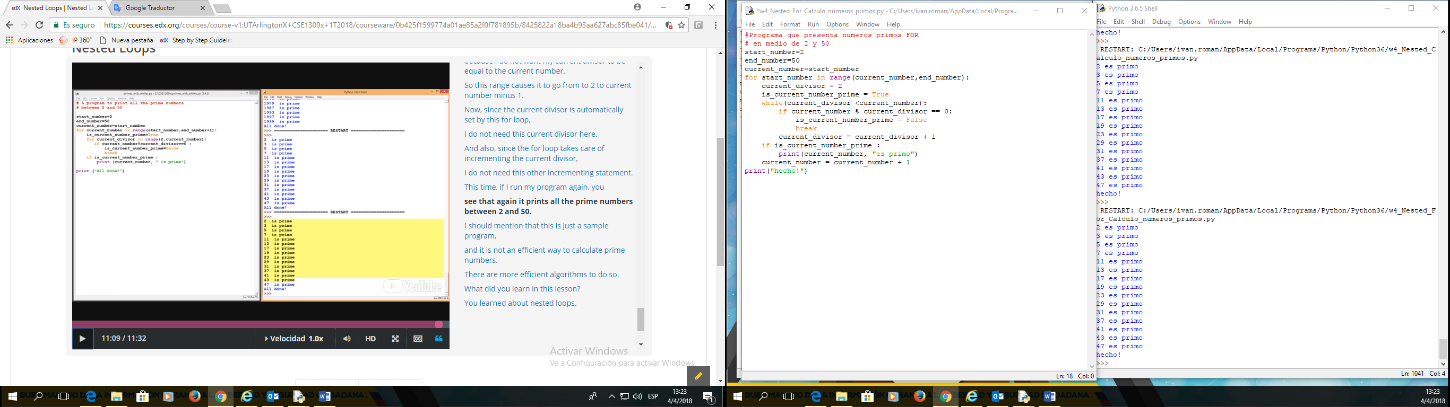

#Programa que presenta numeros primos **FOR**

# en medio de 2 y 50

start_number=2

end_number=50

current_number=start_number

for current_number in range(current_number,end_number+1):

is_current_number_prime = True

for current_divisor in range(2,current_number):

if current_number % current_divisor == 0:

is_current_number_prime = False

break

if is_current_number_prime :

print(current_number, "es primo")

print("hecho!")

**Functions**

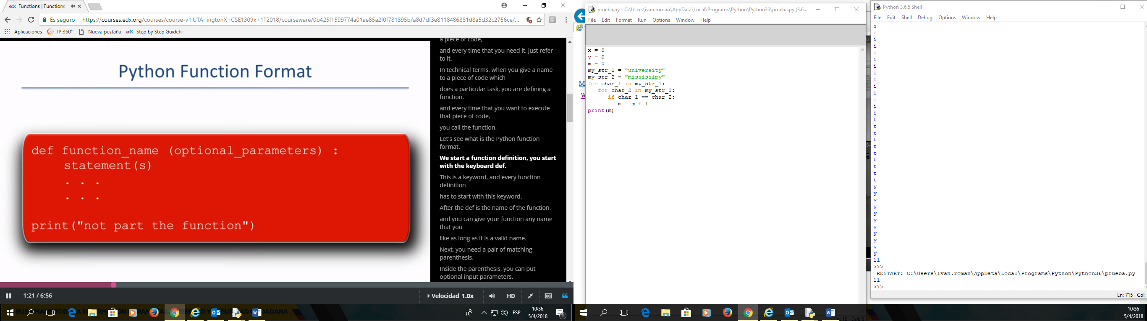

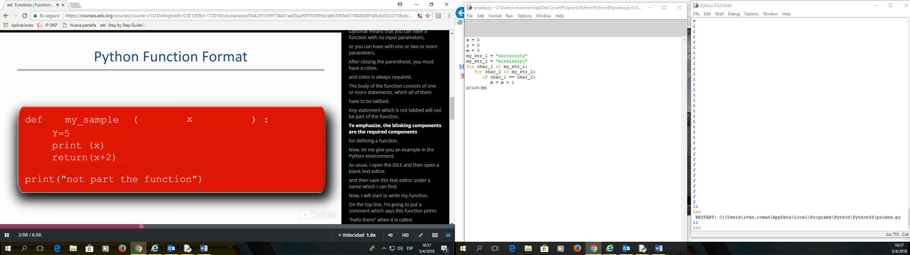

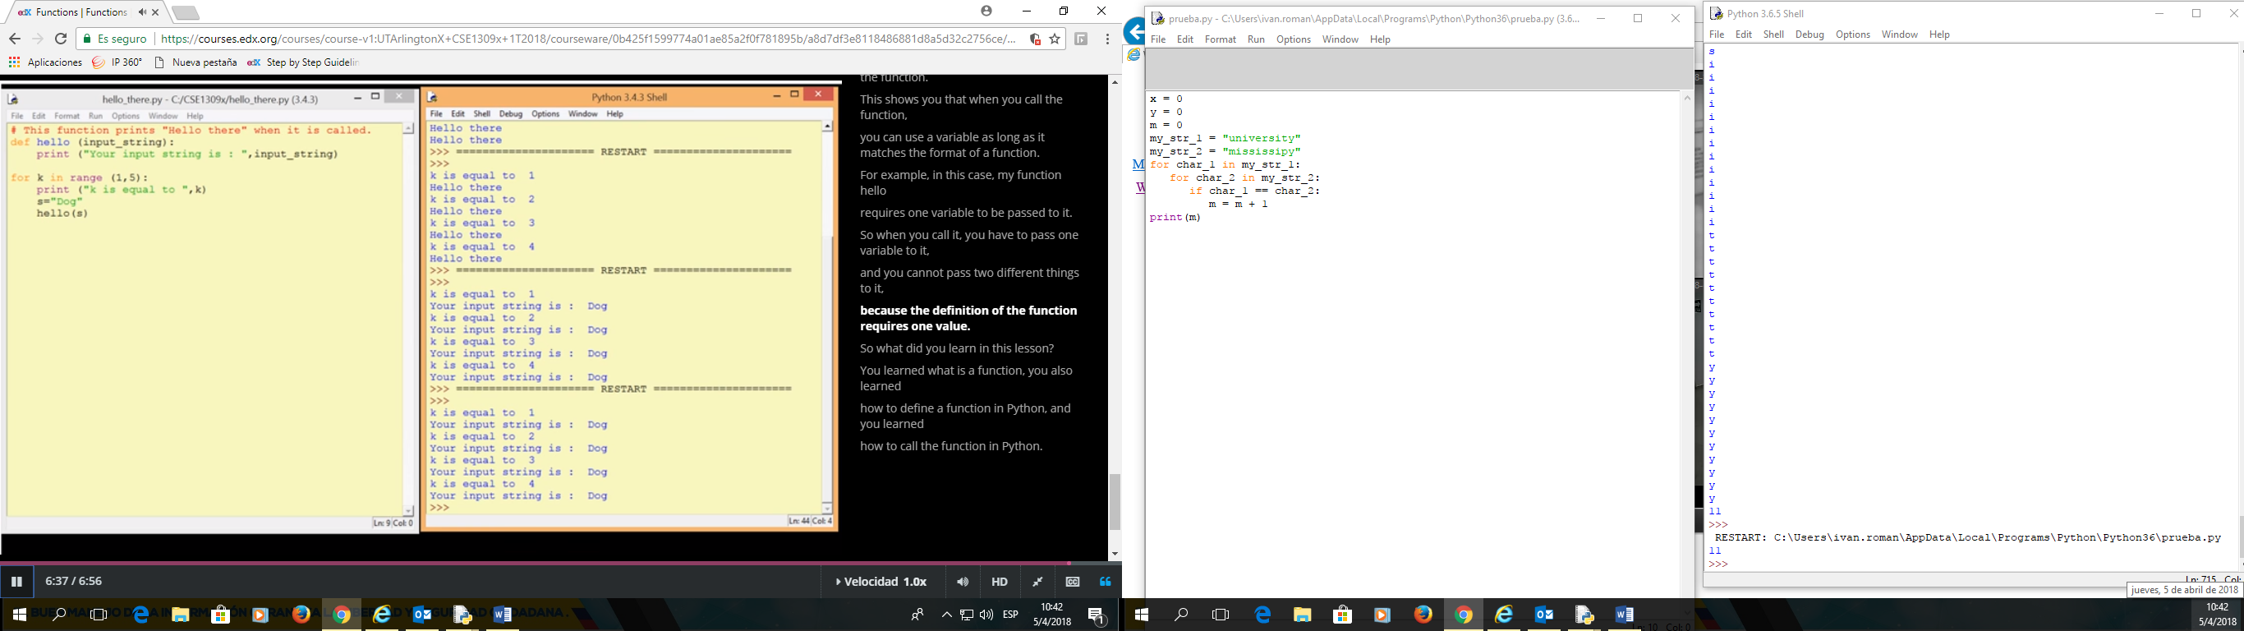

#This function print

def hello (input_string):

print ("Your input string is: ", input_string)

for k in range (1,5):

print ("k is equal to: ", k)

s="Dog"

hello(s)

**1. Nothing goes in, nothing comes out.**

Sometimes we need to do some task repeatedly and that task never changes. In this case, the function does not need any arguments (parameters) and it does not need to return anything.

**def** display_message():  
 print("**** PYTHON IS GREAT ****")  
 print("=============================")  
   
# Main Program #  
radius = 5  
print("The radius of the circle is: ", radius)  
display_message() # The function call   
  
circumference = 2*3.14*radius  
print("The circumference of the circle is:", circumference)  
display_message() # The function call

Note that the parentheses in the function call do not have any anything which means the function does not take any arguments. Also nothing is set equal to the function call i.e. the function call is on a line by itself which means it does not need to return anything. So basically, this function just keeps printing the same message every time it is called (Printing something is **not** the same as returning something). Even though, there is no **return** keyword in this function, it returns a **None**by default. 

This program produces:

The radius of the circle is: 5

**** PYTHON IS GREAT ****

=============================

The circumference of the circle is: 31.400000000000002

**** PYTHON IS GREAT ****

=============================

**2. Nothing goes in, something comes out.**

A great example of a function that does not receive anything but does return something is the following.

**import** random  
  
**def** report_random():  
 my_number = random.randint(20, 100)  
  **return** my_number  
  
# Main Program #  
a = report_random() # return a random int and assign it to a  
print("a is equal to ", a)  
b = report_random() # return a random int and assign it to b

print("b is equal to ", b)  
c = report_random() # return a random int and assign it to c

print("c is equal to ", c)

Notice that this function does not receive any arguments but each time we call this function it returns a random integer between 20 and 100 and assigns the returned value to the variable the function call was set equal to.

Sample run of this program produced: 

a is equal to 82

b is equal to 75

c is equal to 94

**3. Something goes in, nothing comes out.**

In this scenario, the function needs some arguments to do some task but it does not need to return anything.

**def** calculate_area(length, breadth):  
 area = length * breadth  
 perimeter = 2*length + 2*breadth  
 print("area is equal to", area)  
 print("perimeter is equal to", perimeter)  
  
# Main Program #  
calculate_area(10, 20)

Notice that this function does receive two arguments length and breadth and when we call this function, it calculates the area and perimeter of a rectangle and prints the results but it does not return anything! And again printing something is not the same as returning some value. The return value once again for this function is **None** as there is no **return** keyword.

Sample run of this program produces: 

area is equal to 200

perimeter is equal to 60

**4. Something goes in, something comes out.**

This is probably the most meaningful scenario where the function takes some arguments and performs some task using those arguments and returns some result as well.

**def** calculate_area(length, breadth):

area = length * breadth

perimeter = 2*length + 2*breadth  
 my_result = [area, perimeter] # put results in a list

return my_result # return the list

# Main Program #

my_list = calculate_area(10, 20) # two arguments are supplied   
print("The resulting list looks like:", my_list)

Sample run of this program produces: 

The resulting list looks like: [200, 60]

Note that we can return multiple things in python by separating them with a comma. For example instead of returning the results in a list we could have done the following:

return area, perimeter

In this situation, python would have returned the two values as a 'tuple', which would have looked like:

(200, 60)

We will discuss tuples in more detail later in the course.

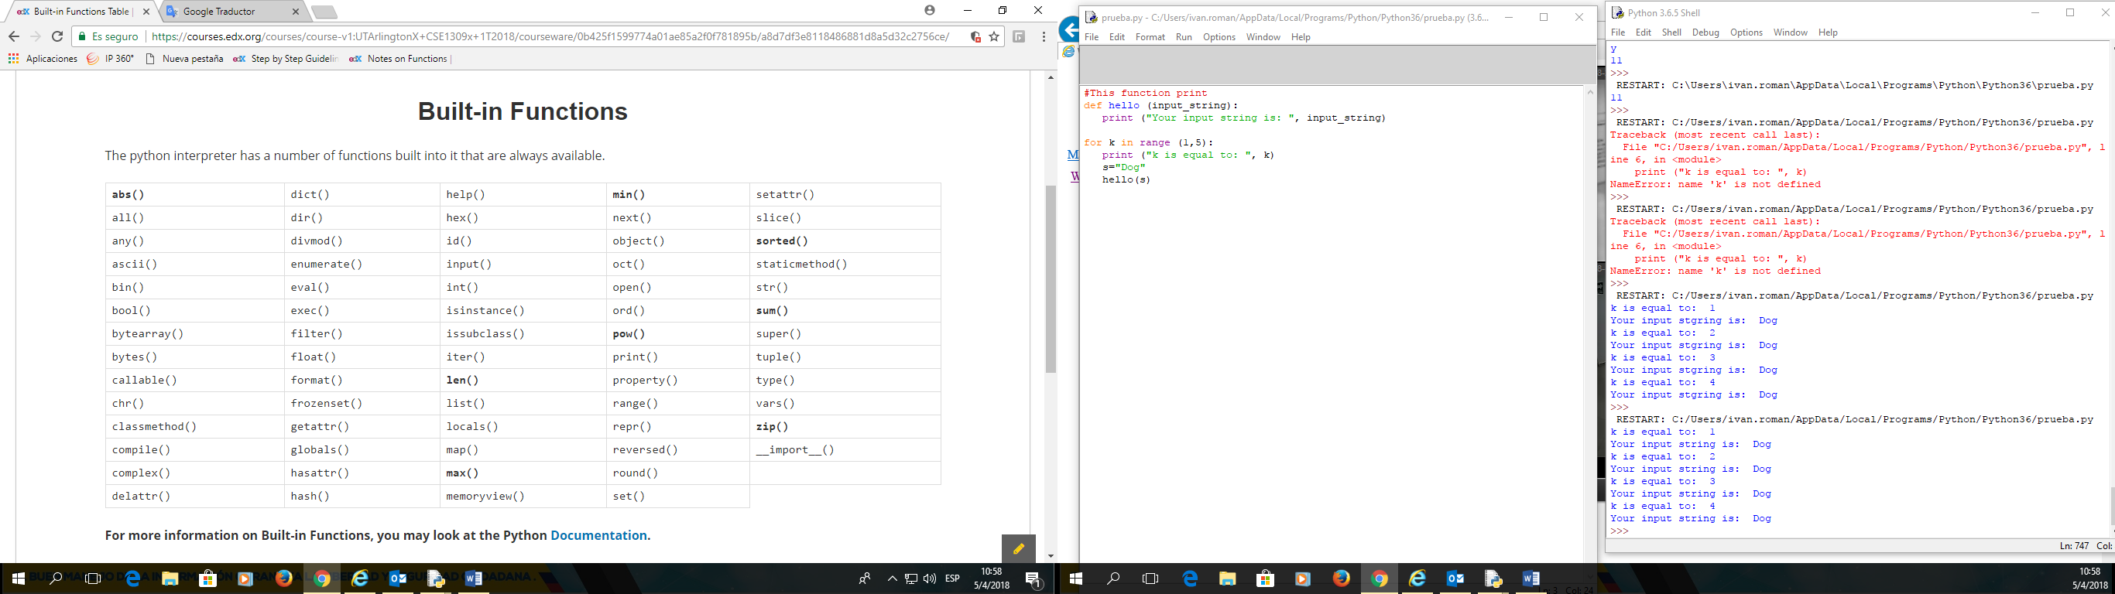

**Examples of Built in Functions**

**In this page, we will show examples of some of the built in functions.**

**abs**(x)

**This method returns the absolute value of a number. The argument maybe an integer or a floating point number. If the argument is a complex number, its magnitude is returned.**

**my_value = -11.55 # Notice that my_value is a negative floating point number**

**absolute = abs(my_value ) # Return the absolute value   
print("The absolute value is:", absolute)**

The result would be:

**The absolute value is: 11.55**

**len(x)**

**This method returns the length (the number of items) of an object. The argument maybe an sequence (such as a string, bytes, tuple, list, or range) or a collection (such as a dictionary, set, or frozen set).**

**my_list = ["abs", "len", 1, 2, "many", "more to come"] # Create a list called "my_list"**

**my_size = len(my_list) # Return length (the number of items) of my_list  
print("The length of my_list is:", my_size)**

The result would be:

**The length of my_list is: 6**

**max(iterable, *[, key, default])**

**max(arg1, arg2, *args[, key])**

**This method returns the largest item in an iterable or the largest of two or more arguments.**

**my_list = [-10, 12, 111, 32.3, 0, 4, 24] # Create a list called "my_list"**

**my_max1 = max(my_list) # Return the largest item in my_list  
my_max2 = max(my_list[0], my_list[-1]) # Return the largest among first & last element  
print("The largest item of my_list is:", my_max1) # Print my_max1 to see what was returned  
print("The larger among first and last item is:", my_max2)**

The result would be:

**The largest item of my_list is: 111**

**The larger among first and last item is: 24**

**min(iterable, *[, key, default])**

**min(arg1, arg2, *args[, key])**

**This method returns the smallest item in an iterable or the smallest of two or more arguments.**

**my_list = [10, -12, 11, 32.3, 1, 14, -5] # Create a list called "my_list"**

**my_min1 = min(my_list) # Return the smallest item in my_list  
my_min2 = min(my_list[0], my_list[-1]) # Return the smallest among first & last element  
print("The smallest item of my_list is:", my_min1) # Print my_min1 to see what was returned  
print("The smaller among first and last item is:", my_min2)**

The result would be:

**The smallest item of my_list is: -12**

**The smaller among first and last item is: -5**

**pow(x, y[, z])**

**This method returns x to the power y. The argument z is optional. If z is present then it returns x to the power of y, modulo z. Note that pow(x, y) is equivalent to using the power operator: x**y**

**x = 5 # initialize a variable x**

**y = 3 # initialize a variable y  
result = pow(x, y) # Return x to the power of y. Same as x**y  
print("The result of the operation is", result)**

The result would be:

**The result of the operation is 125**

**sorted(*iterable[, key][, reverse]*)**

**This method returns a new sorted list from the items in iterable.  
Has two optional arguments which must be specified as keyword arguments.**

**key: specifies a function of one argument that is used to extract a comparison key from each list element:  
 key=str.lower. The default value is None (compare the elements directly).**

**reverse: is a boolean value. If set to True, then the list elements are sorted as if each comparison were reversed.**

**# Lets sort the following list by the first item in each sub-list.   
my_list = [[2, 4], [0, 13], [11, 14], [-14, 12], [100, 3]]  
# First, we need to define a function that specifies what we would like our items sorted by  
def my_key(item):**

**return item[0] # Make the first item in each sub-list our key  
new_sorted_list = sorted(my_list, key=my_key) # Return a sorted list as specified by our key  
print("The sorted list looks like:", new_sorted_list)**

The result would be:

**The sorted list looks like: [[-14, 12], [0, 13], [2, 4], [11, 14], [100, 3]]**

**sum(*iterable*[*, start*])**

**This method sums *start* and the items of an iterable from left to right and returns the total. *start* defaults to 0. The iterables's items are normally numbers and the start value is not allowed to be a string.**

**my_list = [1, 2, 3, 4, 5] # Create a list**

**my_sum = sum(my_list) # Return the sum of the list  
print("The sum of my list is :", my_sum) # Print my_sum**

The result would be:

**The sum of my list is : 15**

**zip(*iterables)**

**This method returns an iterator of tuples, where the *i-*th tuple contains the *i-*th element from each of the argument sequence of iterables. The iterator stops when the shortest input iterable is exhausted.**

**x = [1, 2, 3, 4, 5] # Create a list**

**y = ['a', 'b', 'c'] # Note that this list only has 3 elements  
zipped = list(zip(x, y) ) # Return the zipped object as a list of tuples  
print("The result of the operation is:", zipped)**

The result would be:

**The result of the operation is: [(1, 'a'), (2, 'b'), (3, 'c')]**

**Functions Analogy**

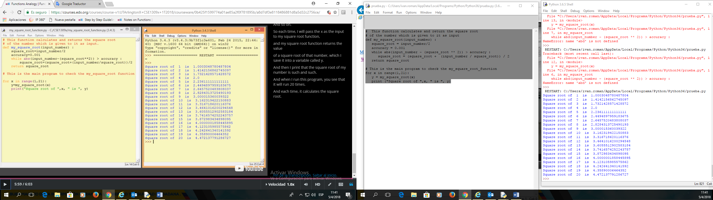

# This function calculates and return the square root

# of the number which is given to it as input

def my_square_root(input_number) :

square_root = input_number/2

accuracy = 0.001

while abs(input_number - (square_root ** 2)) > accuracy :

square_root = (square_root + (input_number / square_root)) / 2

return square_root

# This is the main program to check the my_square_root_function

for x in range(1,21):

y = my_square_root(x)

print ("Square root of ",x, " is ", y)

**MODULES**

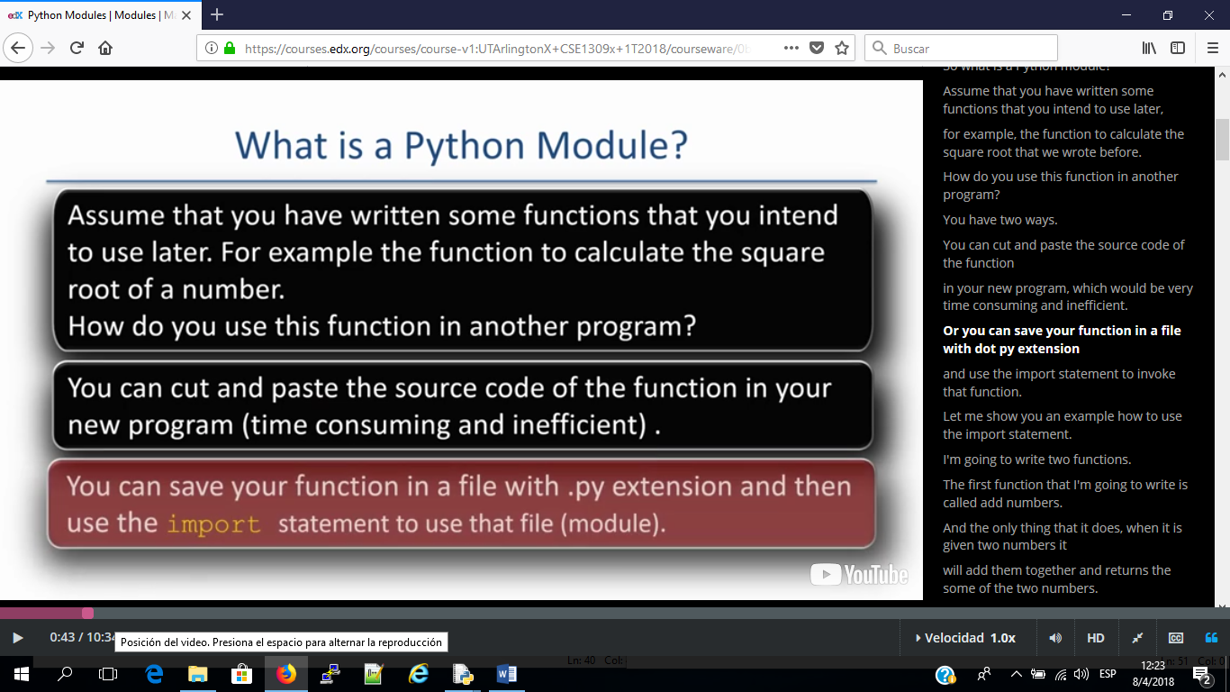

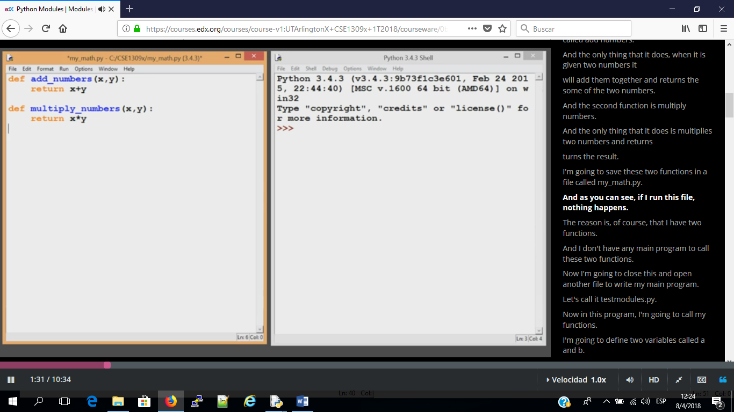

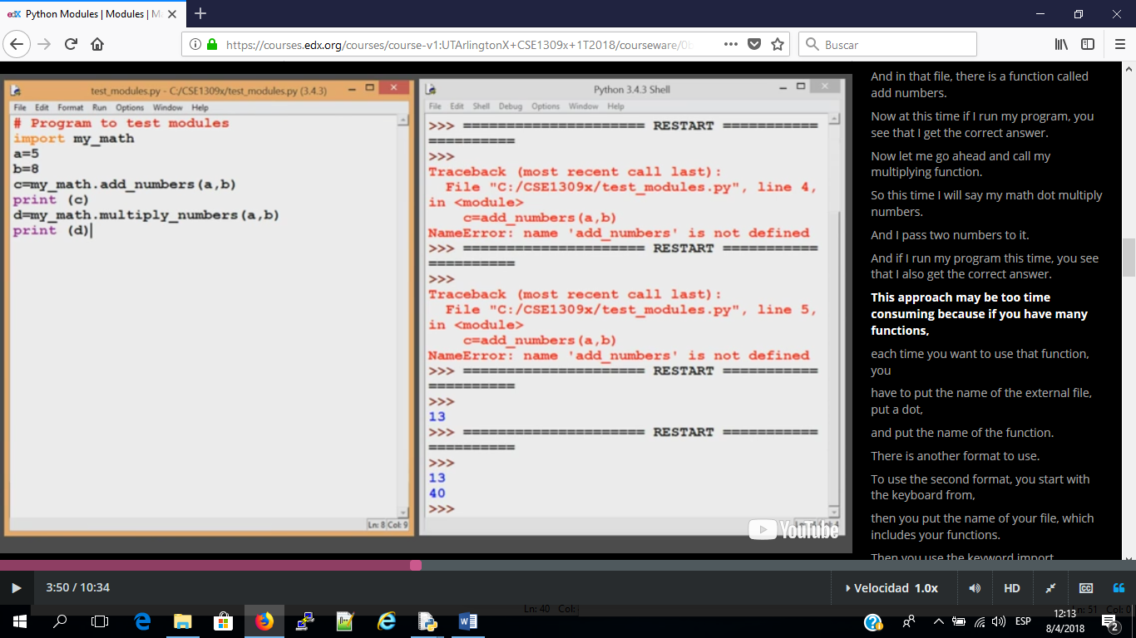

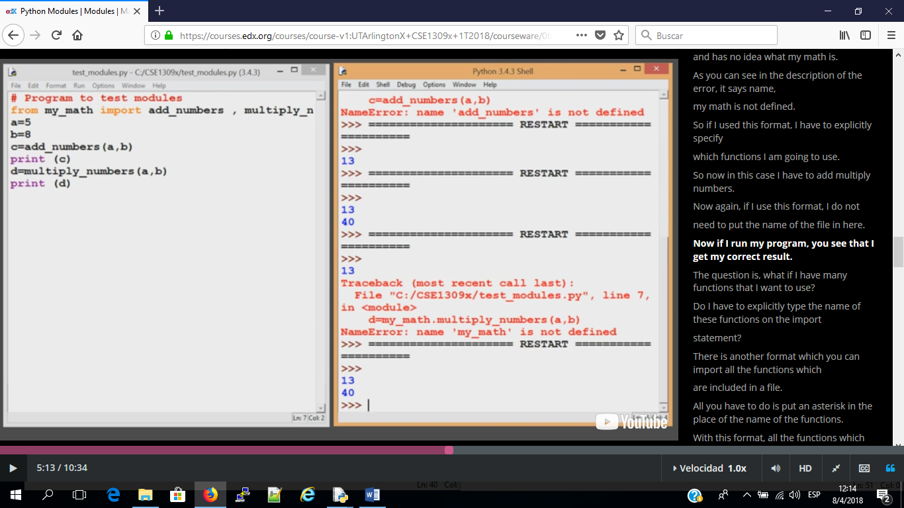

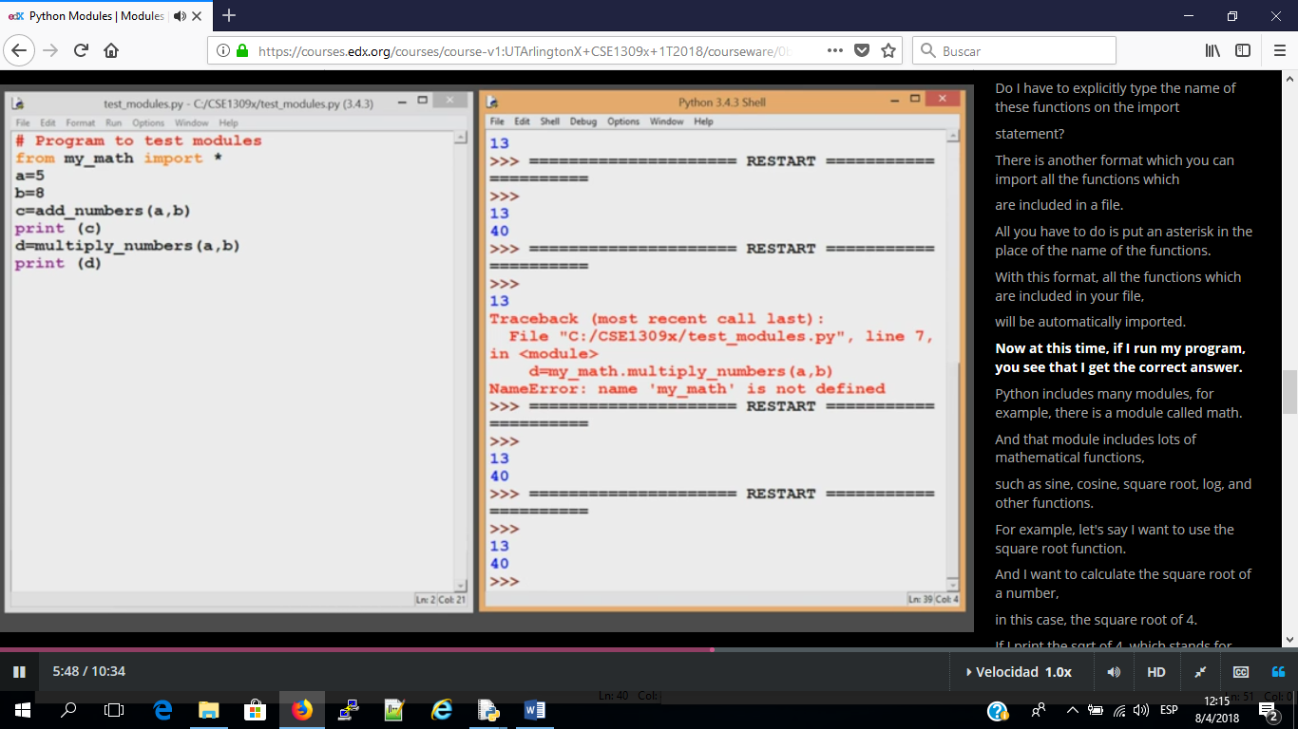

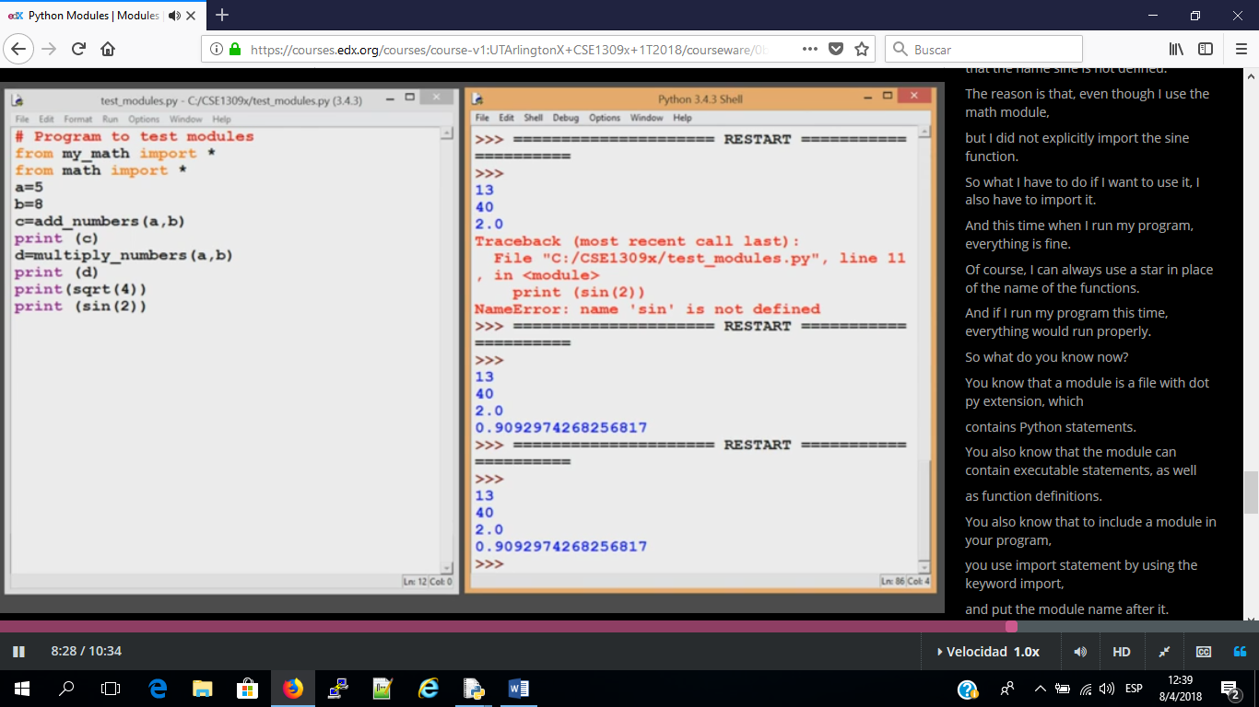

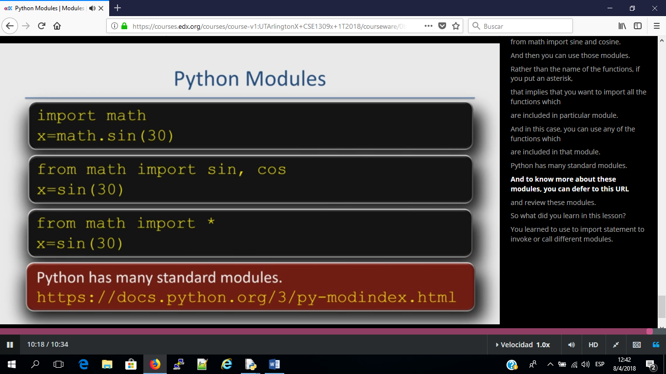

**LIST METHODS**

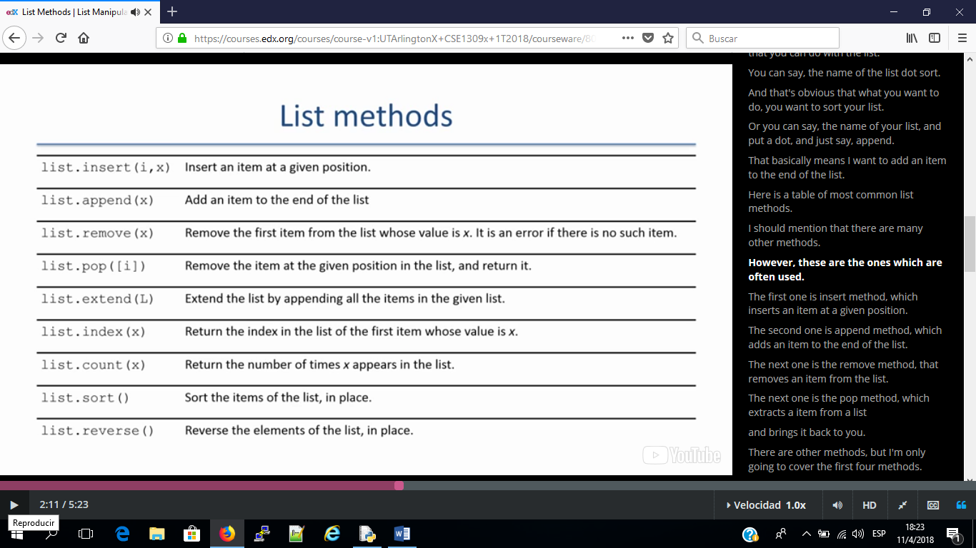

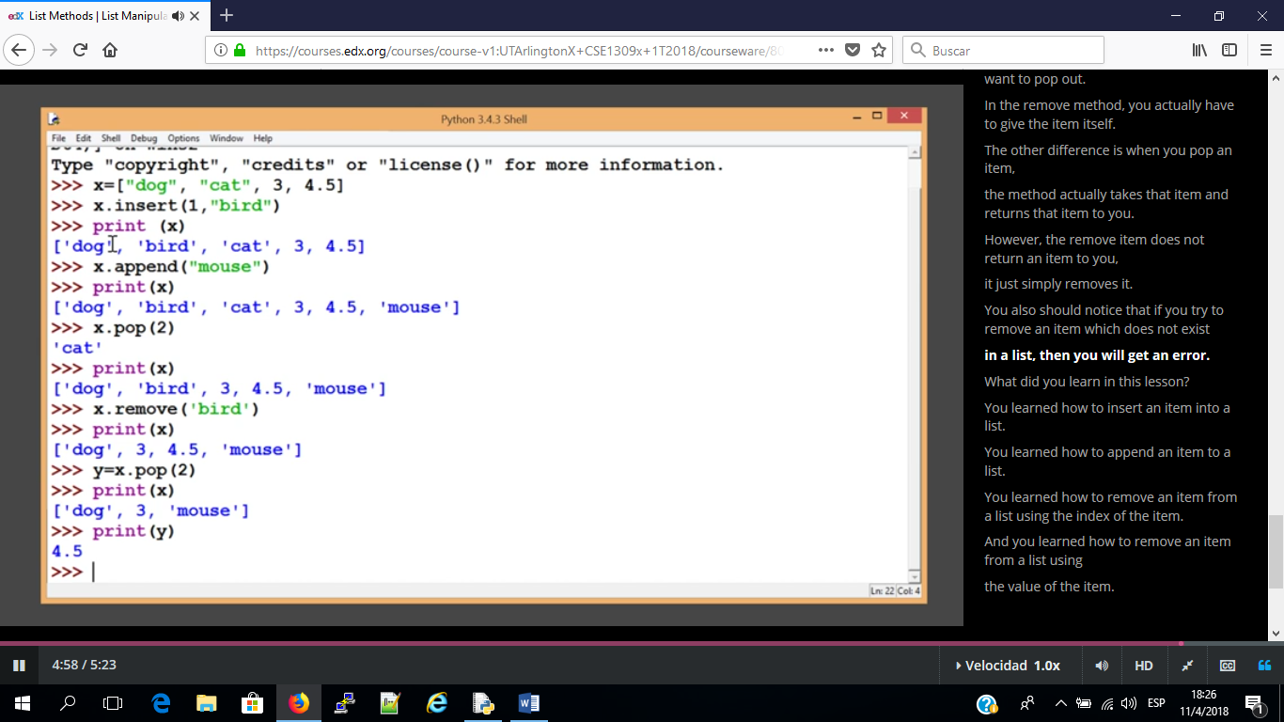

**Table of common methods for lists**

|  |  |
| --- | --- |
| list.append(x) | Add an item to the end of the list. Equivalent to a[len(a):] = [x]. |
| list.extend(L) | Extend the list by appending all the items in the given list. Equivalent to a[len(a):] = L. |
| list.insert(i, x) | Insert an item at a given position. The first argument is the index of the element to insert. |
| list.remove(x) | Remove the first item from the list whose value is x. It is an error if there is no such item. |
| list.copy() | Return a shallow copy of the list. Equivalent to a[:]. |
| list.pop([i]) | Remove the item at the given position and return it. If no index is specified, removes the last item. |
| list.clear() | Remove all items from the list. Equivalent to del a[:]. |
| list.index(x) | Return the index in the list of the first item whose value is x. It is an error if there is no such item. |
| list.count(x) | Return the number of times x appears in the list. |
| list.reverse() | Reverse the elements of the list in place. |
| list.sort(key=None, reverse=False) | Sort the items of the list in place (the arguments can be used for sort customization). |

**List Methods With Examples**

### list.****append****(x)

**This method adds an item to the end of the list.**  
**It is equivalent to doing: a[len(a):] = [x]**

**my_list = ["Tom", "Henry", "Mickey", "Juliet", "Sophie"] # Create a List**

**my_list.append("William") # Append "William" to the end of the list**

**print(my_list)**

The result would be:

**['Tom', 'Henry', 'Mickey', 'Juliet', 'Sophie', 'William']**

### list.****extend****(x)

**This method extends the list by appending all the items in the given list.**  
**It is equivalent to doing: a[len(a):] = L**

**list_one = [1, 2, 3, 4, 5, 6, 7] # This is the first list  
list_two = [10, 12, 14] # This is the second list**

**list_one.extend(list_two) # Extend list_one by appending all items of list_two**

**print(list_one)**

The result would be:

**[1, 2, 3, 4, 5, 6, 7, 10, 12, 14]**

### list.****insert****(i, x)

**This method inserts an item at a given position in the list. Where:**  
 **i : The index at which the item is to be inserted.**   
 **x : The item that is to be inserted.**

**my_list = ["Tom", "Henry", "Mickey", "Juliet", "Sophie"] # Create a List**

**my_list.insert(1, "Siddhartha") # Insert the string "Siddhartha" at index 1**

**print(my_list)**

The result would be:

**['Tom', 'Siddhartha', 'Henry', 'Mickey', 'Juliet', 'Sophie']**

### list.****remove****(x)

**This method removes the first item from the list whose value is x. It is an error if there is no such item.**

**my_list = ["Thou", "art", "precious!", "art", "gracious"] # Create a list  
my_list.remove("art") # Remove the first occurrence of the string "art"  
print(my_list)**

The result would be:

**['Thou', 'precious!', 'art', 'gracious']**

### list.****pop****([i])

**This method removes the item at the given position in the list and returns it.**   
**If no index is specified , list.pop() removes the last item in the list.**   
**Note that the square brackets around the i in the method signature denotes that the parameter is optional, not that you should type square brackets at the position.**

**my_list = ["Thou", "art", "precious!", "art", "gracious"] # Create a list  
my_item = my_list.pop(2) # Remove item at index 2 and return it  
print("The item that was popped was: ", my_item) # Print my_item to see what was returned  
print("my list now looks like = ", my_list)**

The result would be:

**The item that was popped was: precious!**

**my list now looks like = ['Thou', 'art', 'art', 'gracious']**

### list.****clear****()

**This method removes all the items from the list.**   
**It is equivalent to doing:**  
**del a[:]**

**my_list = [2, 3, 5, 7, 11, 13] # Create a list  
my_list.clear() # Remove all the items from the list  
print(my_list)**

The result would be:

**[]**

### list.****index****(x)

**This method returns the index in the list of the first item whose value is x. It is an error if there is not such item.**

**my_list = ["Python", "is", "awesome", "Java", "is", "Alright"] # Create a list  
my_index = my_list.index("is") # Return the index of the first "is"  
print("The item was first found at index:", my_index)**

The result would be:

**The item was first found at index: 1**

### list.****count****(x)

**This method returns the number of times x appears in the list**

**my_list = ["mew", "mew", "kitten", "mew", "mew"] # Create a list  
my_count = my_list.count("mew") # Return the number of times "mew" appears  
print("The number of times the item appeared was:", my_count)**

The result would be:

**The number of times the item appeared was: 4**

### list.****sor****t(key=None, reverse=False)

**This method sorts the items of the list in place. Note that this method does not return anything. (The arguments are optional and can be used for sort customization, see** [**sorted()**](https://docs.python.org/3/library/functions.html#sorted) **for their explanation.)**

**my_list = [5, 3, 6, 1, 2, 4, 7] # Create a list  
my_list.sort() # Sort the items of the list in place  
print("Sorted list looks like:", my_list)**

The result would be:

**Sorted list looks like: [1, 2, 3, 4, 5, 6, 7]**

### list.****reverse****()

**This method reverses the items of the list in place. Note that this method does not return anything.**

**my_list = ["zero", "one", "two", "three", "four", "five"] # Create a list  
my_list.reverse() # Reverse the items of the list in place  
print("Reversed list looks like:", my_list)**

The result would be:

**Reversed list looks like: ['five', 'four', 'three', 'two', 'one', 'zero']**

### list.****copy****()

**This method returns a shallow copy of the list.   
It is equivalent to doing:  
a[:]**

**original_list = ["zero", "one", "two", "three"] # Create a list  
copied_list = original_list.copy() # Copy the original list and return it.   
print("Copied list looks like:", copied_list)**

The result would be:

**Copied list looks like: ['zero', 'one', 'two', 'three']**

**LIST SLICING**

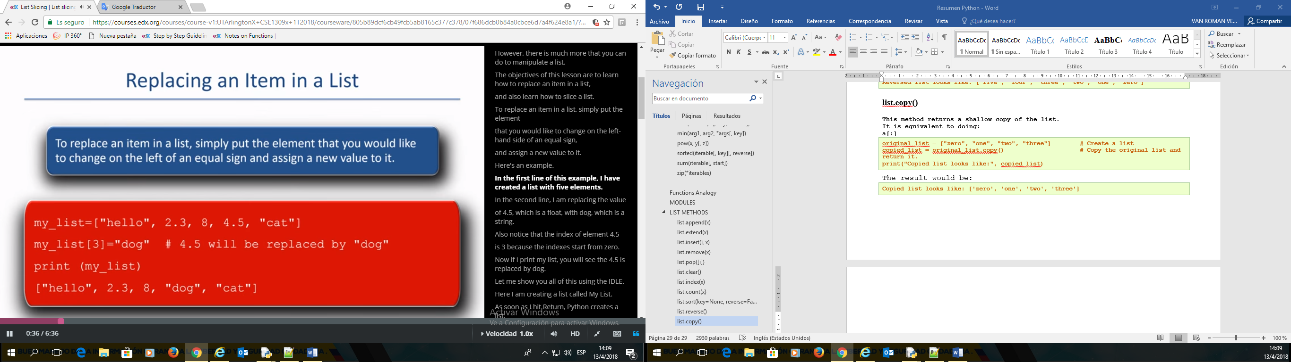

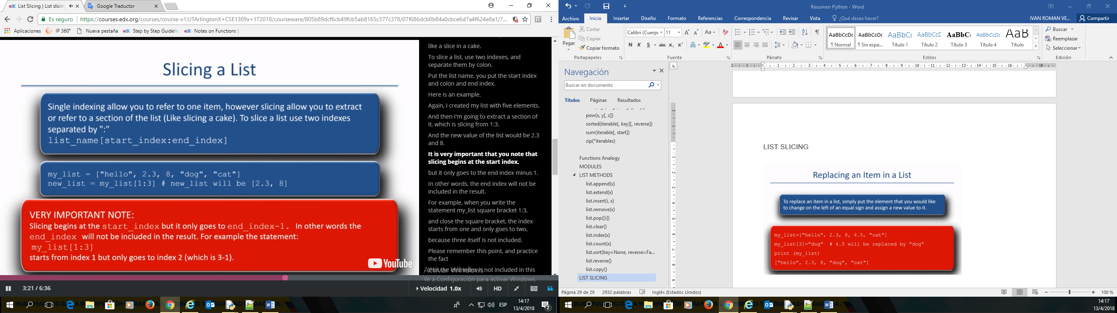

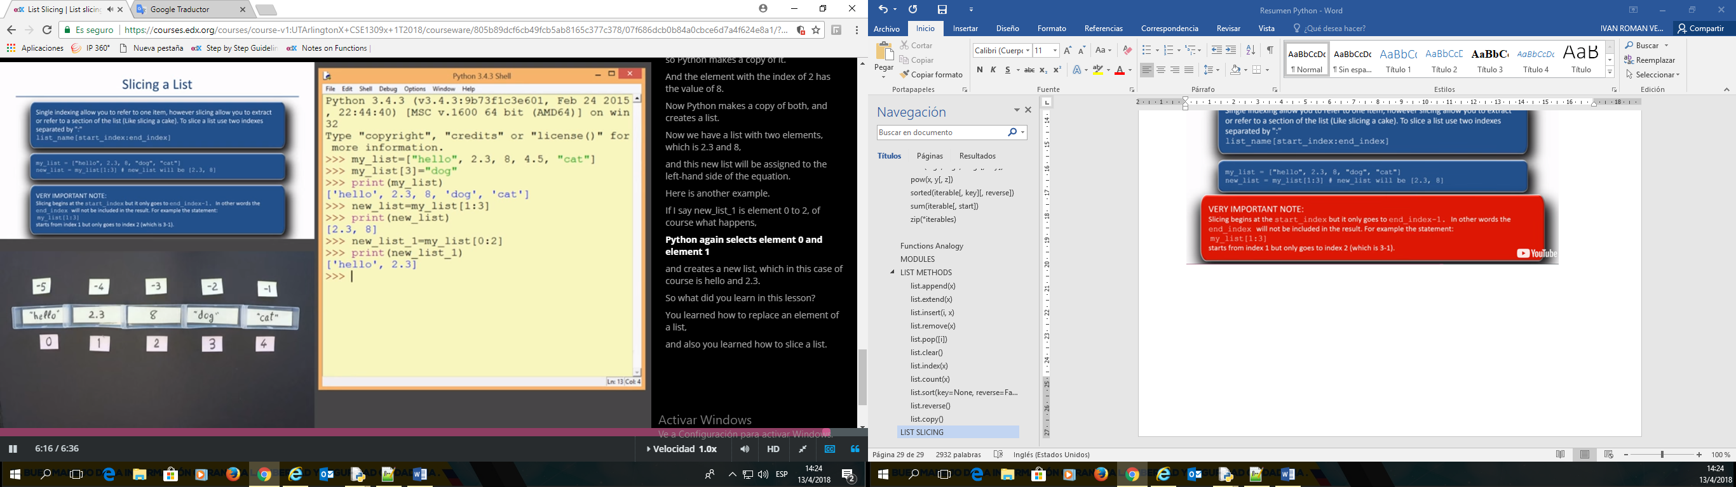

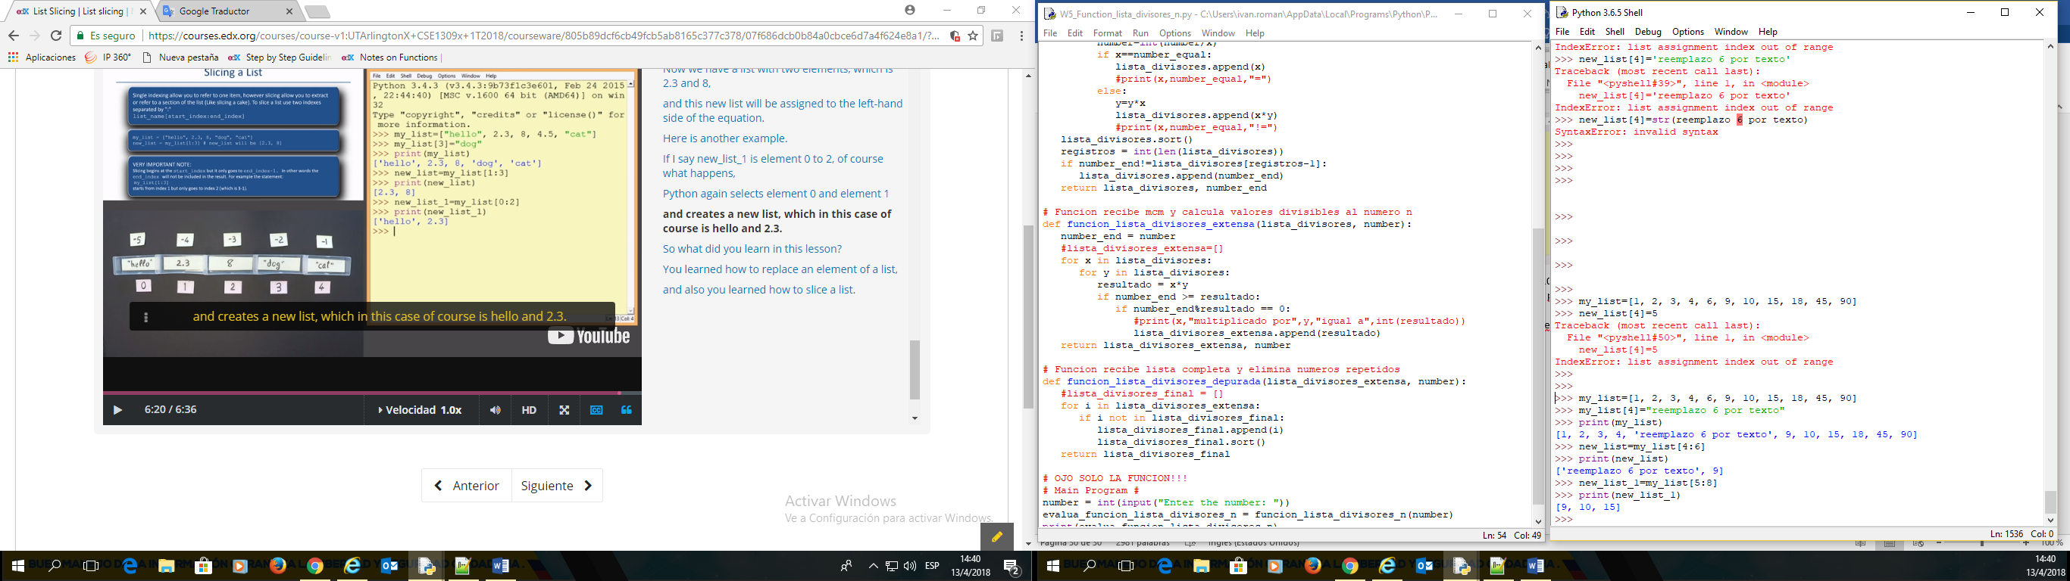

>>> my_list=[1, 2, 3, 4, 6, 9, 10, 15, 18, 45, 90]

>>> my_list[4]="reemplazo 6 por texto"

>>> print(my_list)

[1, 2, 3, 4, 'reemplazo 6 por texto', 9, 10, 15, 18, 45, 90]

>>> new_list=my_list[4:6]

>>> print(new_list)

['reemplazo 6 por texto', 9]

>>> new_list_1=my_list[5:8]

>>> print(new_list_1)

[9, 10, 15]

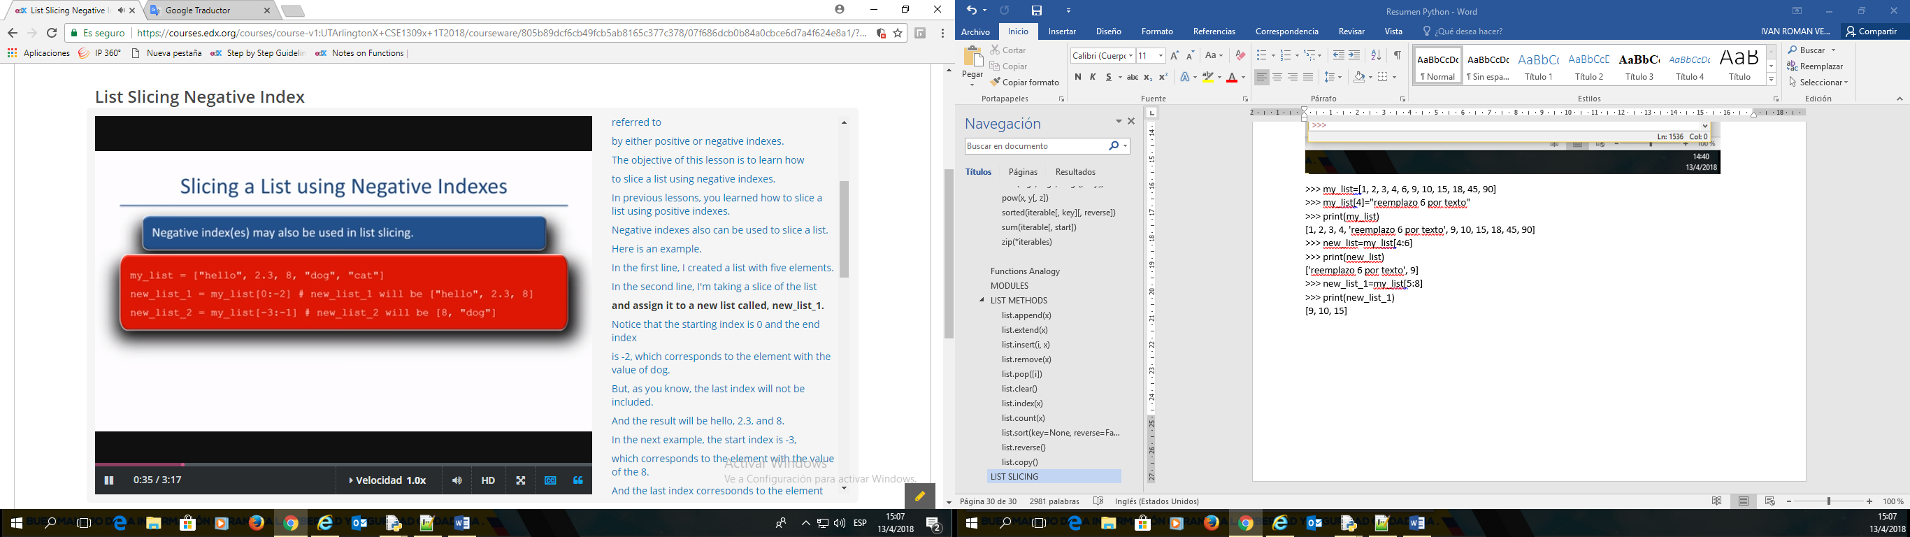

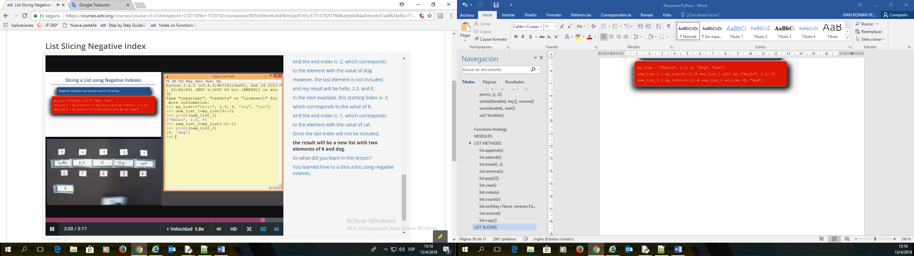

>>> my_list=[1, 2, 3, 4, 6, 9, 10, 15, 18, 45, 90]

>>> new_list_1=my_list[0:-4]

>>> print(new_list_1)

[1, 2, 3, 4, 6, 9, 10]

>>> new_list_2=my_list[-6:-2]

>>> print(new_list_2)

[9, 10, 15, 18]

>>>

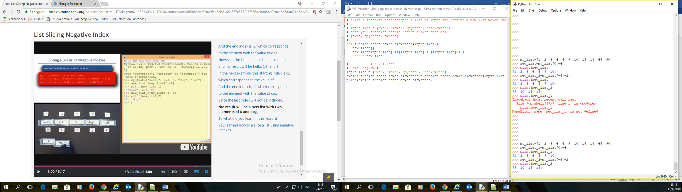

## **List Slicing With Step**

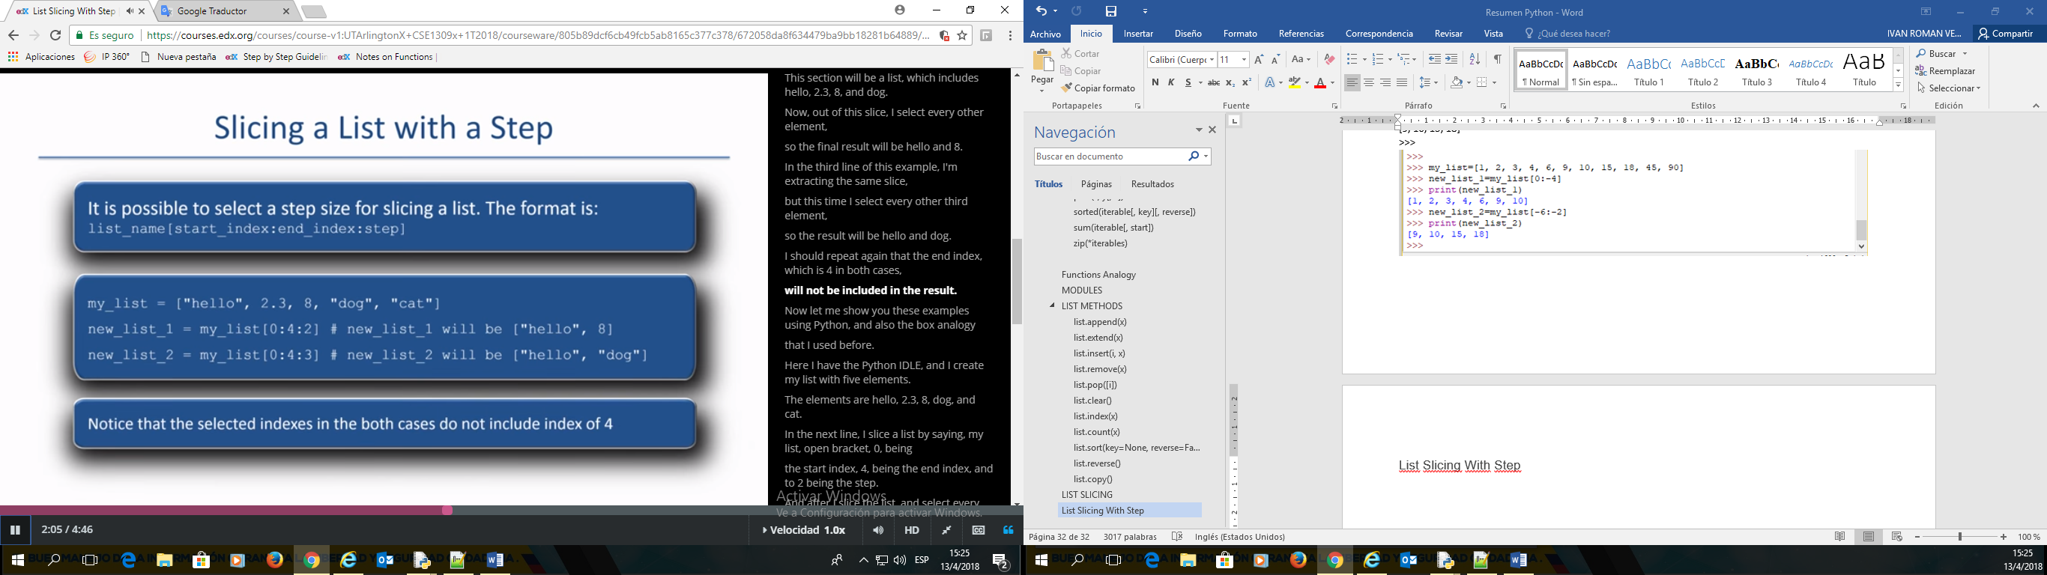

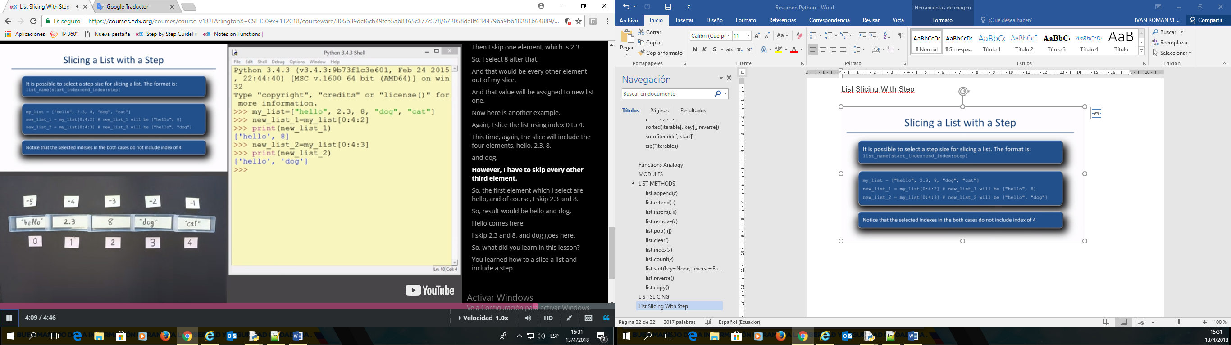

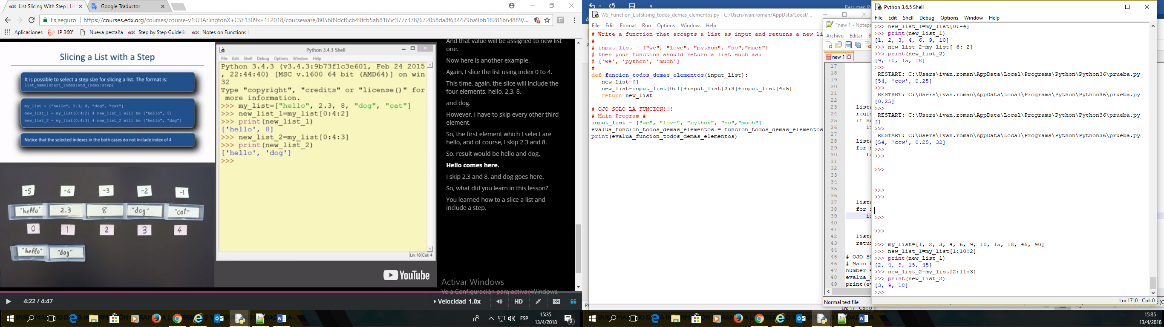

>>> my_list=[1, 2, 3, 4, 6, 9, 10, 15, 18, 45, 90]

>>> new_list_1=my_list[1:10:2]

>>> print(new_list_1)

[2, 4, 9, 15, 45]

>>> new_list_2=my_list[2:11:3]

>>> print(new_list_2)

[3, 9, 18]

## **List Slicing default index**

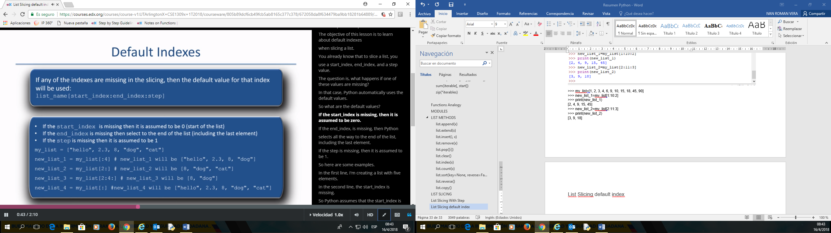

## **STRINGS**

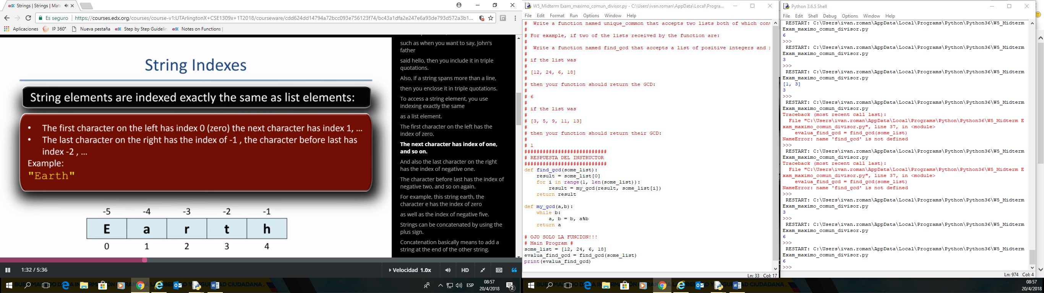

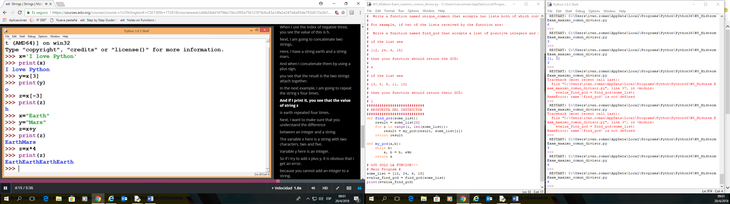

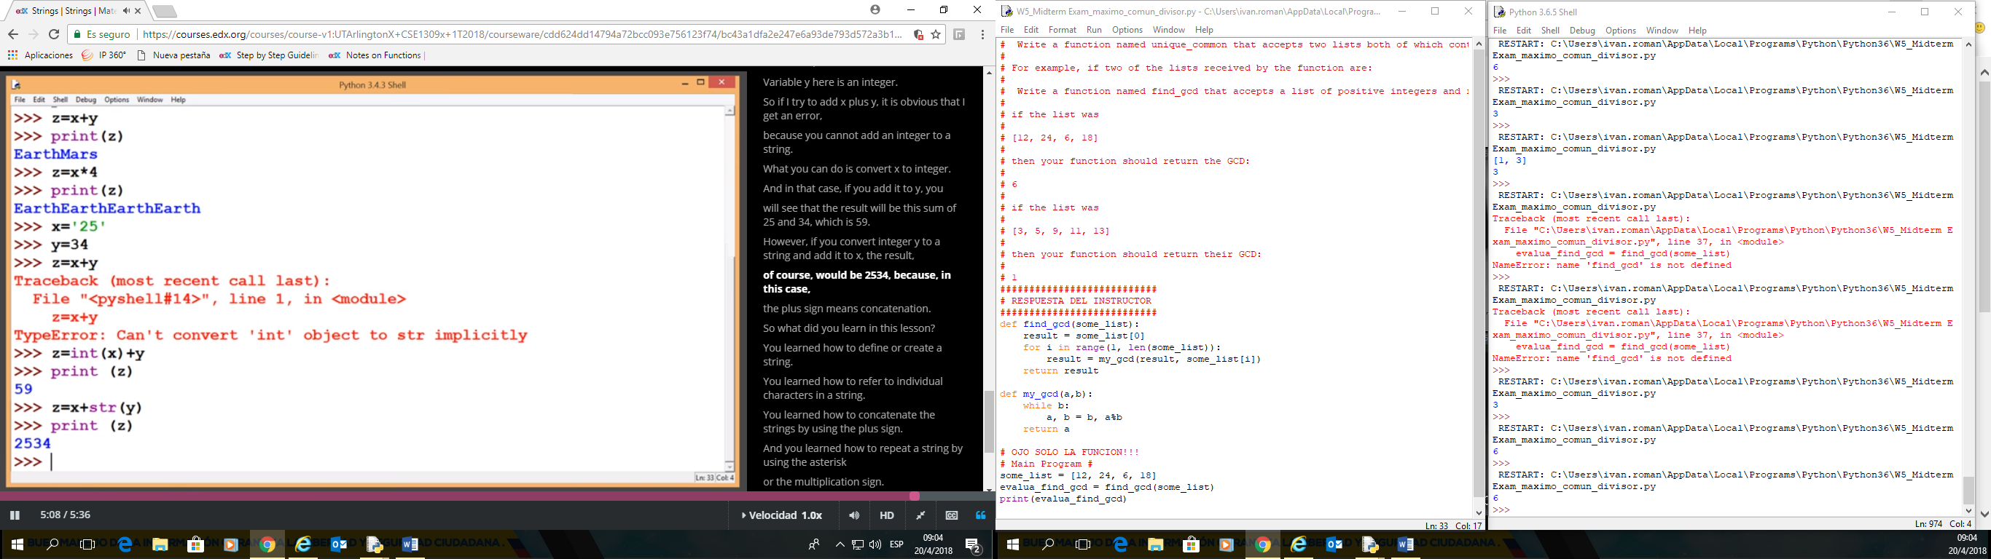

## **CHARACTER ENCODING**

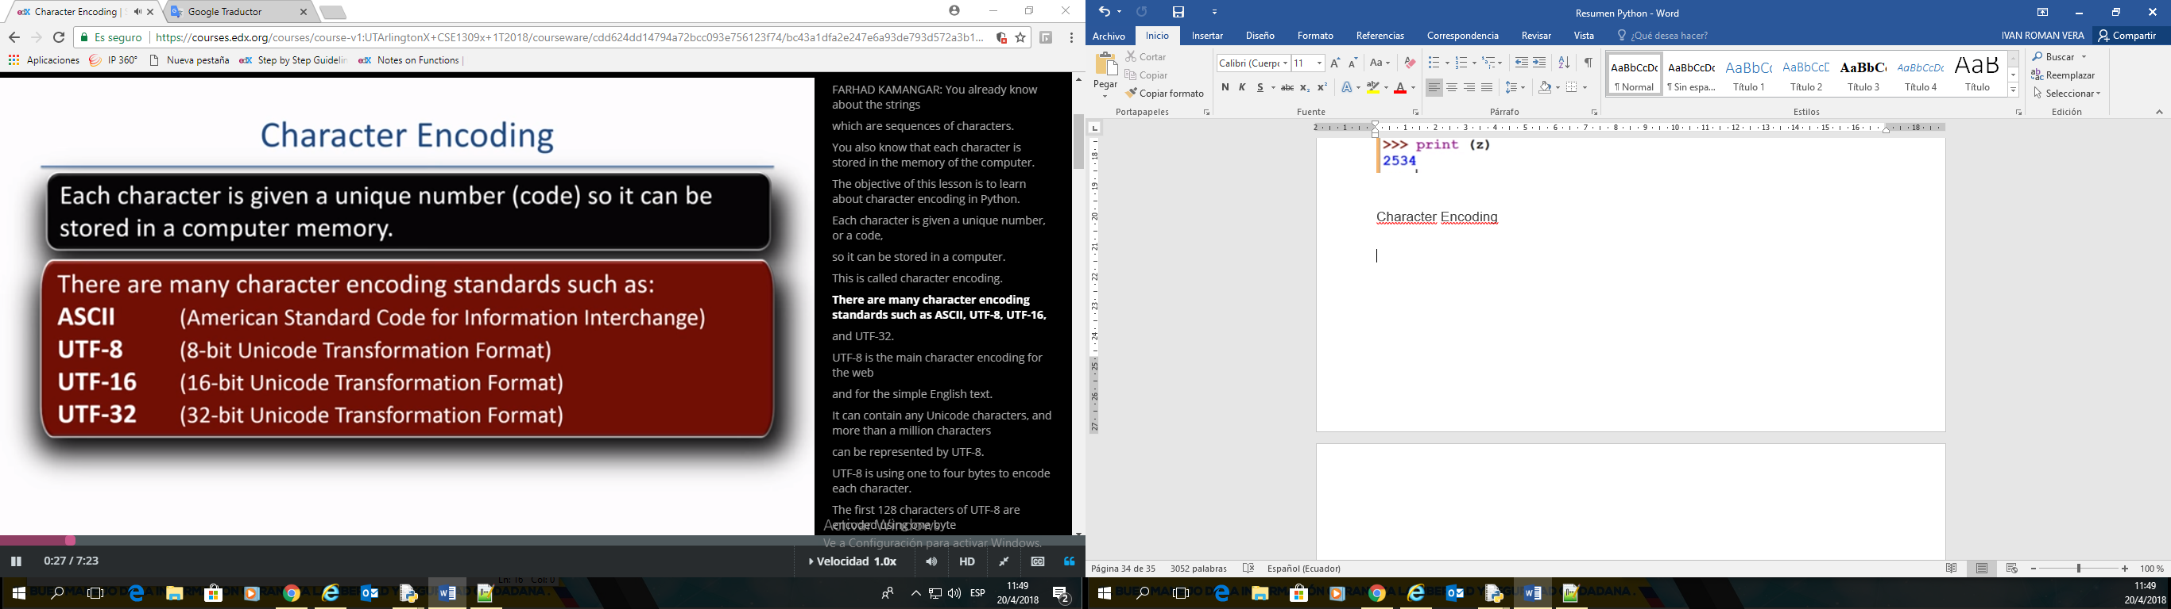

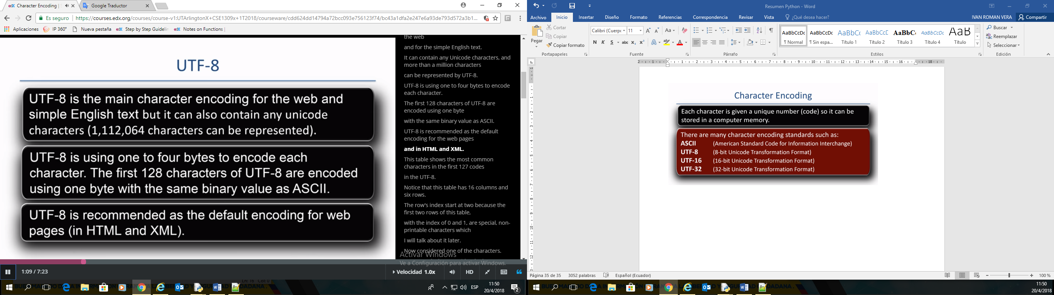

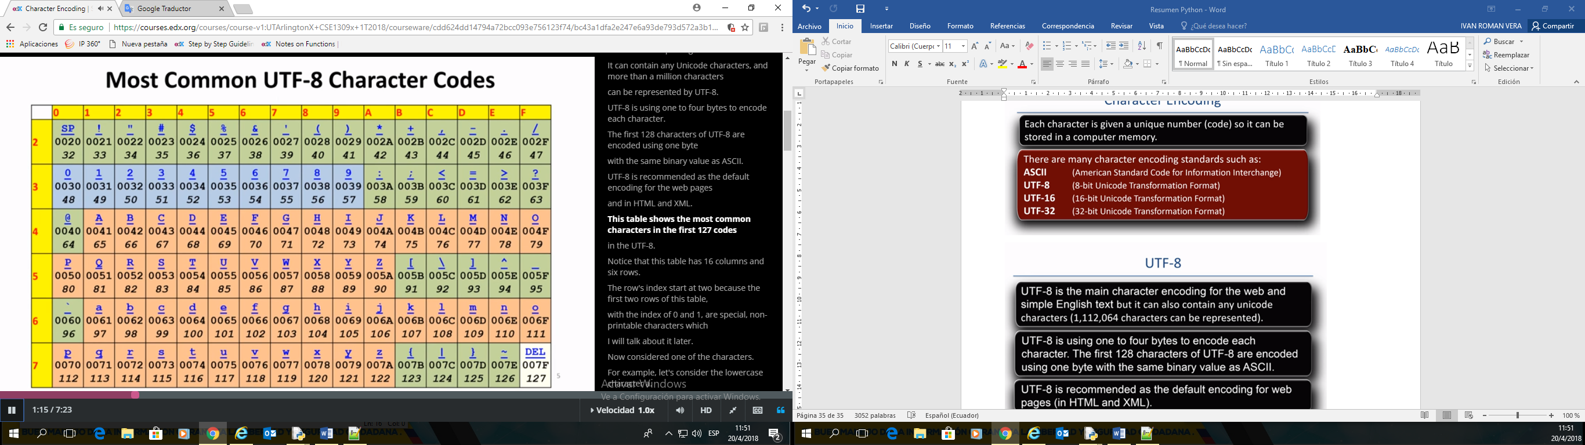

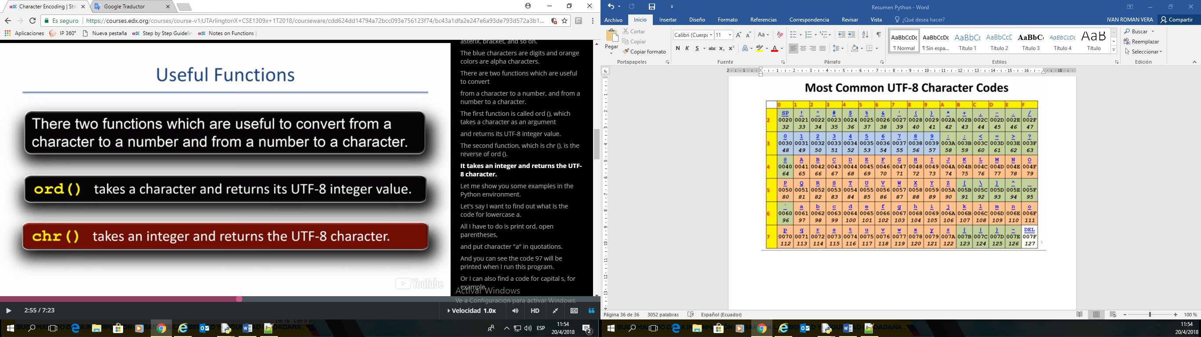

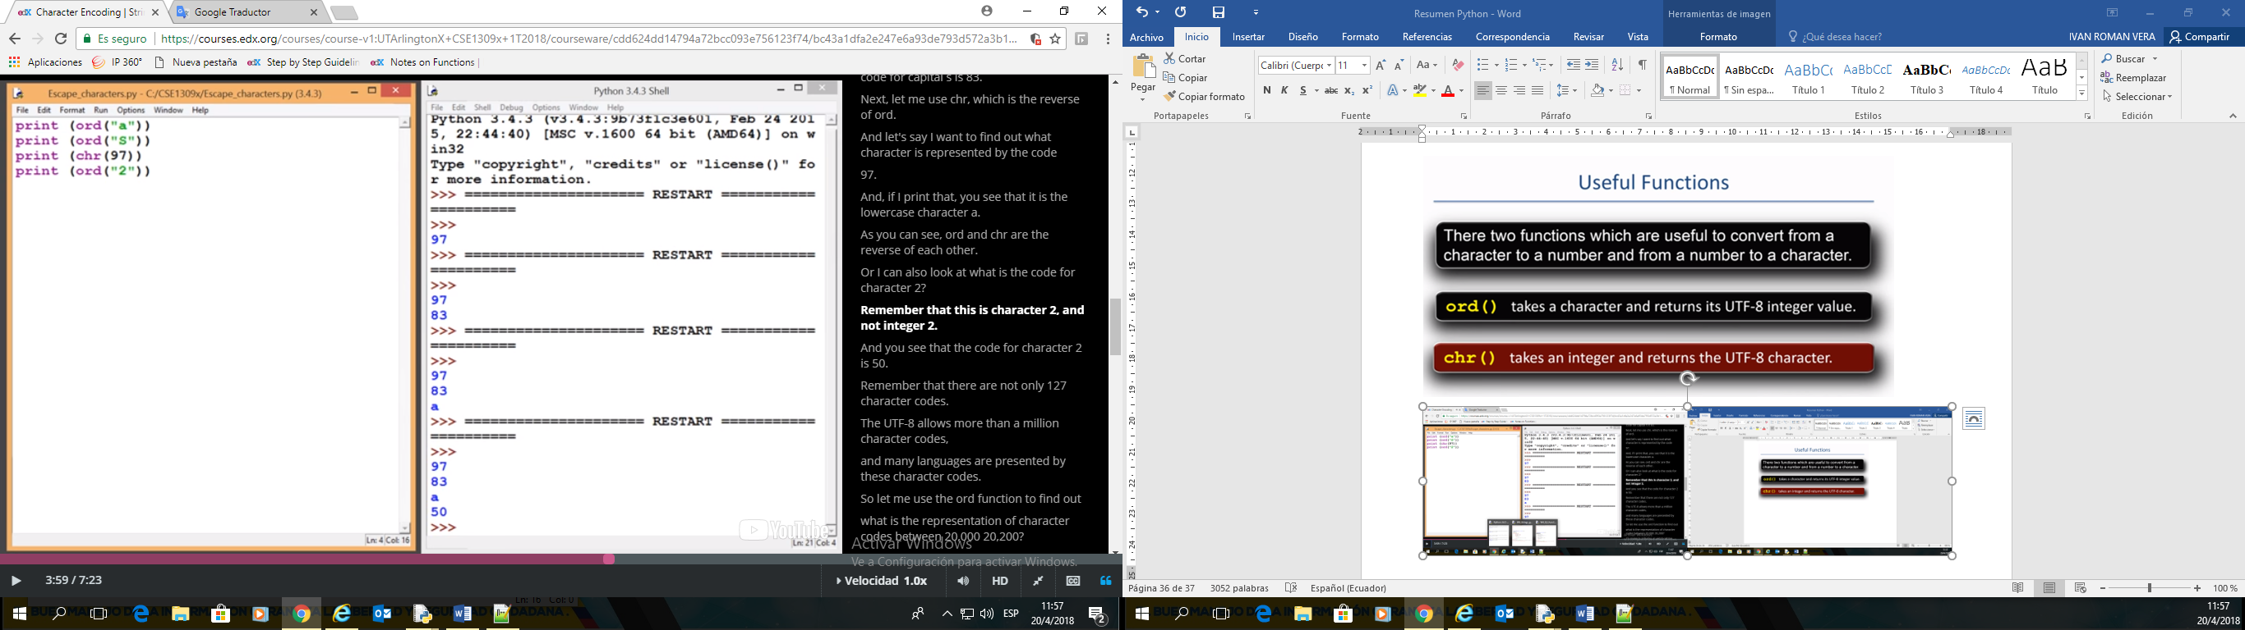

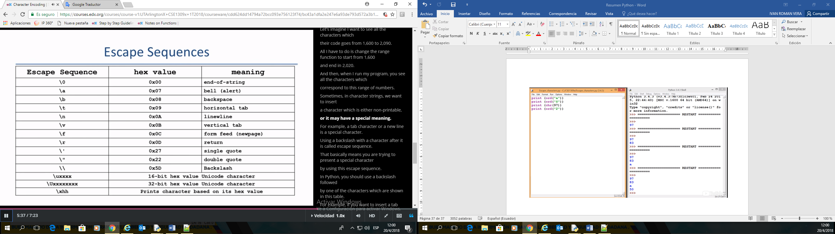

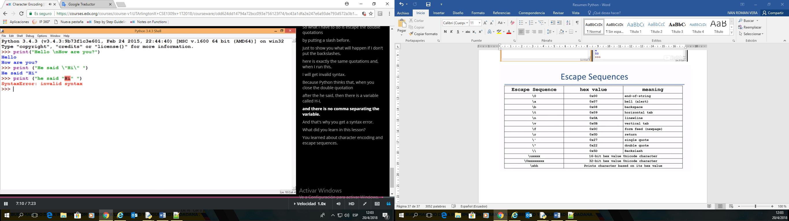

|  |  |  |  |  |
| --- | --- | --- | --- | --- |
| **Table of ASCII Control Characters** |  |  |  |  |
|  |  |  |  |  |
| **Decimal** | **Hexadecimal** | **Binary** | **Character** | **Description** |
| 0 | 0 | 0 | NUL | null |
| 1 | 1 | 1 | SOH | start of header |
| 2 | 2 | 10 | STX | start of text |
| 3 | 3 | 11 | ETX | end of text |
| 4 | 4 | 100 | EOT | end of transmission |
| 5 | 5 | 101 | ENQ | enquiry |
| 6 | 6 | 110 | ACK | acknowledge |
| 7 | 7 | 111 | BEL | bell |
| 8 | 8 | 1000 | BS | backspace |
| 9 | 9 | 1001 | **HT** | horizontal tab |
| 10 | 0A | 1010 | LF | line feed |
| 11 | 0B | 1011 | VT | vertical tab |
| 12 | 0C | 1100 | FF | form feed |
| 13 | 0D | 1101 | **CR** | **enter / carriage return** |
| 14 | 0E | 1110 | SO | shift out |
| 15 | 0F | 1111 | SI | shift in |
| 16 | 10 | 10000 | DLE | data link escape |
| 17 | 11 | 10001 | DC1 | device control 1 |
| 18 | 12 | 10010 | DC2 | device control 2 |
| 19 | 13 | 10011 | DC3 | device control 3 |
| 20 | 14 | 10100 | DC4 | device control 4 |
| 21 | 15 | 10101 | NAK | negative acknowledge |
| 22 | 16 | 10110 | SYN | synchronize |
| 23 | 17 | 10111 | ETB | end of trans. block |
| 24 | 18 | 11000 | CAN | cancel |
| 25 | 19 | 11001 | EM | end of medium |
| 26 | 1A | 11010 | SUB | substitute |
| 27 | 1B | 11011 | ESC | escape |
| 28 | 1C | 11100 | FS | file separator |
| 29 | 1D | 11101 | GS | group separator |
| 30 | 1E | 11110 | RS | record separator |
| 31 | 1F | 11111 | US | unit separator |

|  |  |  |  |  |
| --- | --- | --- | --- | --- |
| **Table of printable ASCII Characters:** |  |  |  |  |
|  |  |  |  |  |
| **Decimal** | **Hexadecimal** | **Binary** | **Character** | **Description** |
|
| **32** | **20** | **100000** | **Space** | **space** |
| **33** | **21** | **100001** | **!** | **exclamation mark** |
| **34** | **22** | **100010** | **"** | **double quote** |
| **35** | **23** | **100011** | **#** | **number** |
| **36** | **24** | **100100** | **$** | **dollar** |
| **37** | **25** | **100101** | **%** | **percent** |
| **38** | **26** | **100110** | **&** | **ampersand** |
| **39** | **27** | **100111** | **'** | **single quote** |
| **40** | **28** | **101000** | **(** | **left parenthesis** |
| **41** | **29** | **101001** | **)** | **right parenthesis** |
| **42** | **2A** | **101010** | **\*** | **asterisk** |
| **43** | **2B** | **101011** | **+** | **plus** |
| **44** | **2C** | **101100** | **,** | **comma** |
| **45** | **2D** | **101101** | **-** | **minus** |
| **46** | **2E** | **101110** | **.** | **period** |
| **47** | **2F** | **101111** | **/** | **slash** |
| **48** | **30** | **110000** | **0** | **zero** |
| **49** | **31** | **110001** | **1** | **one** |
| **50** | **32** | **110010** | **2** | **two** |
| **51** | **33** | **110011** | **3** | **three** |
| **52** | **34** | **110100** | **4** | **four** |
| **53** | **35** | **110101** | **5** | **five** |
| **54** | **36** | **110110** | **6** | **six** |
| **55** | **37** | **110111** | **7** | **seven** |
| **56** | **38** | **111000** | **8** | **eight** |
| **57** | **39** | **111001** | **9** | **nine** |
| **58** | **3A** | **111010** | **:** | **colon** |
| **59** | **3B** | **111011** | **;** | **semicolon** |
| **60** | **3C** | **111100** | **<** | **less than** |
| **61** | **3D** | **111101** | **=** | **equality sign** |
| **62** | **3E** | **111110** | **>** | **greater than** |
| **63** | **3F** | **111111** | **?** | **question mark** |
| **64** | **40** | **1000000** | **@** | **at sign** |
| **65** | **41** | **1000001** | **A** |  |
| **66** | **42** | **1000010** | **B** |  |
| **67** | **43** | **1000011** | **C** |  |
| **68** | **44** | **1000100** | **D** |  |
| **69** | **45** | **1000101** | **E** |  |
| **70** | **46** | **1000110** | **F** |  |
| **71** | **47** | **1000111** | **G** |  |
| **72** | **48** | **1001000** | **H** |  |
| **73** | **49** | **1001001** | **I** |  |
| **74** | **4A** | **1001010** | **J** |  |
| **75** | **4B** | **1001011** | **K** |  |
| **76** | **4C** | **1001100** | **L** |  |
| **77** | **4D** | **1001101** | **M** |  |
| **78** | **4E** | **1001110** | **N** |  |
| **79** | **4F** | **1001111** | **O** |  |
| **80** | **50** | **1010000** | **P** |  |
| **81** | **51** | **1010001** | **Q** |  |
| **82** | **52** | **1010010** | **R** |  |
| **83** | **53** | **1010011** | **S** |  |
| **84** | **54** | **1010100** | **T** |  |
| **85** | **55** | **1010101** | **U** |  |
| **86** | **56** | **1010110** | **V** |  |
| **87** | **57** | **1010111** | **W** |  |
| **88** | **58** | **1011000** | **X** |  |
| **89** | **59** | **1011001** | **Y** |  |
| **90** | **5A** | **1011010** | **Z** |  |
| **91** | **5B** | **1011011** | **[** | **left square bracket** |
| **92** | **5C** | **1011100** | **\** | **backslash** |
| **93** | **5D** | **1011101** | **]** | **right square bracket** |
| **94** | **5E** | **1011110** | **^** | **caret / circumflex** |
| **95** | **5F** | **1011111** | **_** | **underscore** |
| **96** | **60** | **1100000** | **`** | **grave / accent** |
| **97** | **61** | **1100001** | **a** |  |
| **98** | **62** | **1100010** | **b** |  |
| **99** | **63** | **1100011** | **c** |  |
| **100** | **64** | **1100100** | **d** |  |
| **101** | **65** | **1100101** | **e** |  |
| **102** | **66** | **1100110** | **f** |  |
| **103** | **67** | **1100111** | **g** |  |
| **104** | **68** | **1101000** | **h** |  |
| **105** | **69** | **1101001** | **i** |  |
| **106** | **6A** | **1101010** | **j** |  |
| **107** | **6B** | **1101011** | **k** |  |
| **108** | **6C** | **1101100** | **l** |  |
| **109** | **6D** | **1101101** | **m** |  |
| **110** | **6E** | **1101110** | **n** |  |
| **111** | **6F** | **1101111** | **o** |  |
| **112** | **70** | **1110000** | **p** |  |
| **113** | **71** | **1110001** | **q** |  |
| **114** | **72** | **1110010** | **r** |  |
| **115** | **73** | **1110011** | **s** |  |
| **116** | **74** | **1110100** | **t** |  |
| **117** | **75** | **1110101** | **u** |  |
| **118** | **76** | **1110110** | **v** |  |
| **119** | **77** | **1110111** | **w** |  |
| **120** | **78** | **1111000** | **x** |  |
| **121** | **79** | **1111001** | **y** |  |
| **122** | **7A** | **1111010** | **z** |  |
| **123** | **7B** | **1111011** | **{** | **left curly bracket** |
| **124** | **7C** | **1111100** | **|** | **vertical bar** |
| **125** | **7D** | **1111101** | **}** | **right curly bracket** |
| **126** | **7E** | **1111110** | **~** | **tilde** |
| **127** | **7F** | **1111111** | **DEL** | **delete** |

## **String Methods**

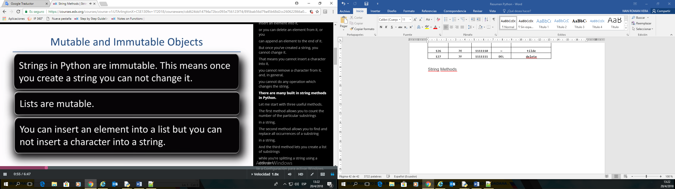

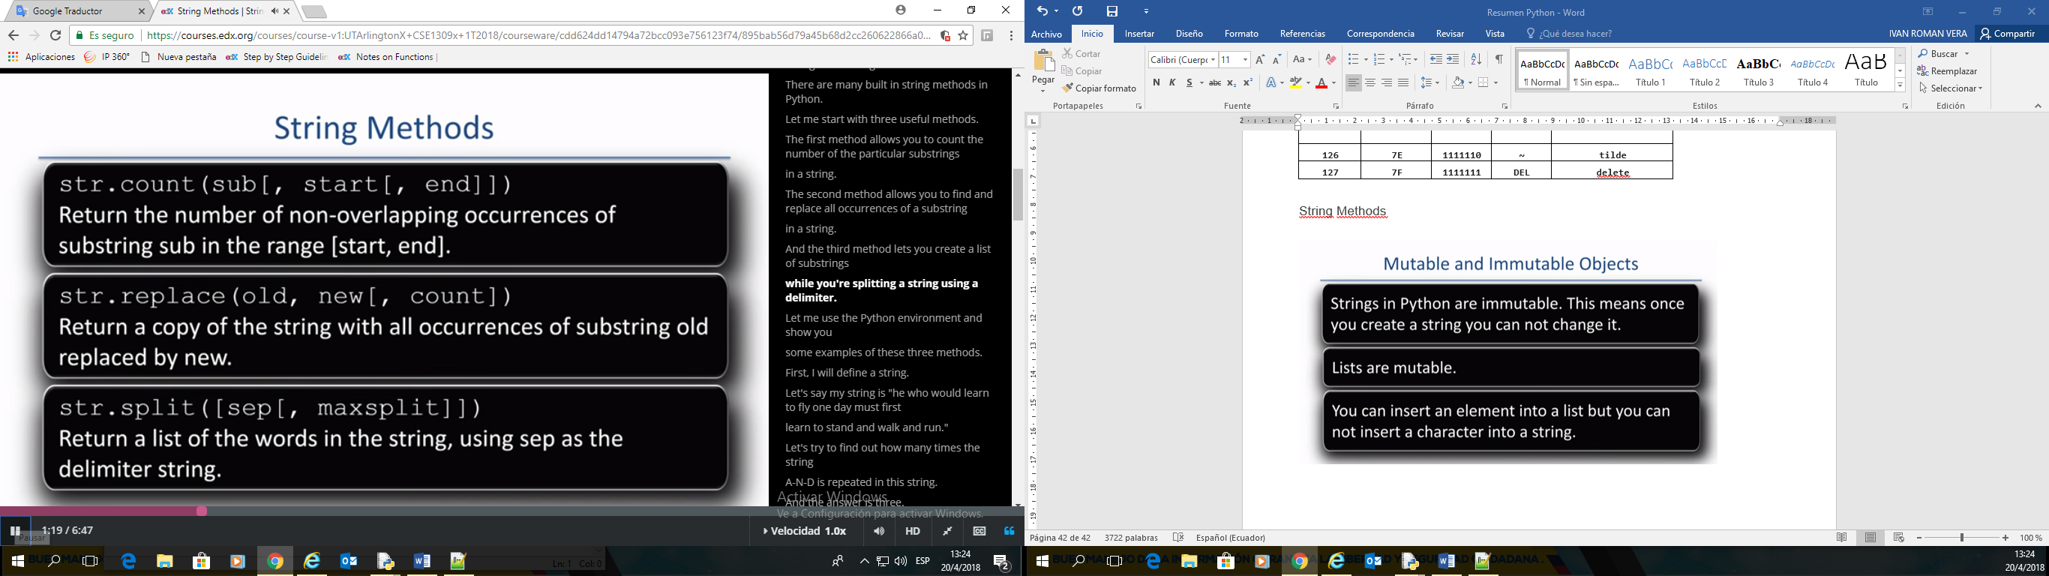

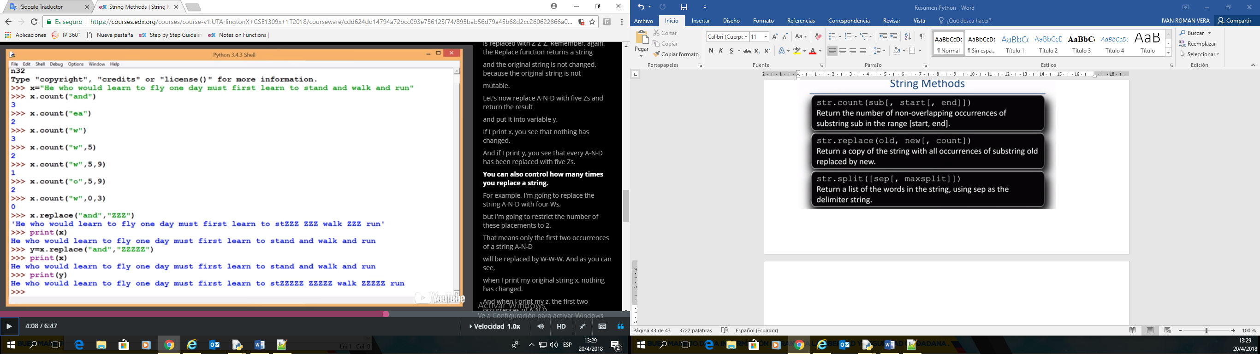

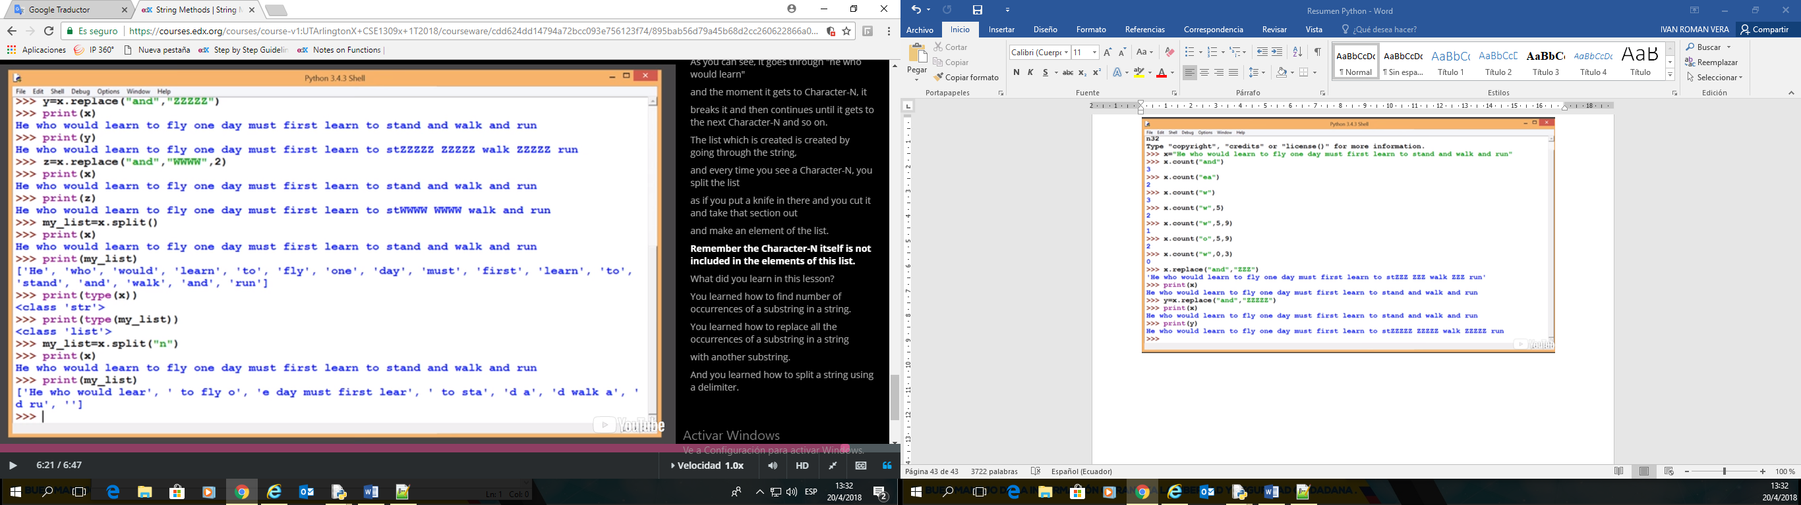

|  |  |
| --- | --- |
| **Table of common methods for Strings** |  |
|  |  |
| Method | Description |
| s.capitalize() | The first character of s is put in uppercase |
| s.center([width]) | Centers s in a field of length width |
| s.count(sub [,start [, end]]) | Counts occurrences of sub between start and end |
| s.encode([encoding [, errors]]) | Encode s using encoding as code and error |
| s.expandtabs([tabsize]) | Expands tabs |
| s.find(sub [, start [, end]]) | Finds the first occurrence of sub between start and end |
| s.index(sub [,start [, end]]) | same as find but raises an exception if no occurrence is found |
| s.islower() | Returns True if all chracters are lowercase, False otherwise |
| s.isupper() | Returns True if all chracters are uppercase, False otherwise |
| s.join(words) | Joins the list of words with s as delimiter |
| s.ljust(width) | Left align s in a string of length width |
| s.lower() | Returns a lowercase version of s |
| s.lstrip() | Removes all leading whitespace characters of s |
| s.replace(old, new [, maxrep]) | Replace maximal maxrep versions of substring old with substring new |
| s.rfind(sub [, start [, end]]) | Finds the last occurrence of substring sub between start and end |
| s.rindex(sub [,start [, end]]) | Same as rfind but raise an exception if sub does not exists |
| s.rjust(width) | Right-align s in a string of length width |
| s.rstrip() | Removes trailing whitespace characters |
| s.split([sep [, maxsplit]])) | Split s into maximal maxsplit words using sep as separator (default whitespace) |
| s.splitlines([keepends]) | Split s into lines, if keepends is 1 keep the trailing newline |
| s.strip() | Removes trailing and leading whitespace characters |
| s.swapcase() | Returns a copy of s with lowercase letters turn into uppercase and vice versa |
| s.title() | Returns a title-case version of s (all words capitalized) |
| s.upper() | Returns an uppercase version of s |

**String Methods With Examples**

**Like many of Python's built-in types, strings have a number of powerful and useful methods. In this page, we will provide examples of how some of them can be used.**

**\*\*\*Remember: square brackets indicate optional arguments.\*\*\***

### str.****capitalize****( )

**This method returns a copy of the first character capitalized and the rest lowercased.**

**>>> my_string = "sTrInG mEtHoDs" # Create a string**

**>>> new_string = my_string.capitalize() # Capitalize 1st, lower rest & return**

**>>> new_string**

The result would be:

**'String methods'**

### str.****casefold****( )

**This method returns a casefolded copy of the string. Casefolded strings may be used for caseless matching. Casefolding is similar to lowercasing but more aggressive because it is intended to remove all case distinctions in a string.**

**>>> my_string = "sTrInG mEtHoDs" # Create a String**

**>>> new_string = my_string.casefold() # Return a casefolded copy**

**>>> new_string**

The result would be:

**'string methods'**

### str.****center****(width[, fillchar])

**This method returns a centered in a string of length width. Padding is done using the specified fillchar (default is an ASCII space). The original string is returned if width is less than or equal to len(s).**

**>>> my_string = "sTrInG mEtHoDs" # Create a String**

**>>> new_string = my_string.center(20, 'x') # Center in 20 spaces, fill spaces with 'x' & return**

**>>> new_string**

The result would be:

**'xxxsTrInG mEtHoDsxxx'**

### str.****count****(sub[, start[, end]])

**This method returns the number of non-overlapping occurrences of substring sub in the range [start, end]. Optional arguments start and end are interpreted as in slice notation.**

**>>> my_string = "this is python. It is awesome!" # Create a String**

**>>> my_count = my_string.count('is', 0, -1) # count occurrences of'is' and return**

**>>> my_count**

The result would be:

**3**

### str.****endswith****(suffix[, start[, end]])

**This method returns True if the string ends with the specified suffix, otherwise returns False. suffix can also be a tuple of suffixes to look for. With optional start, test beginning at that position. With optional end, stop comparing at that position.**

**>>> my_string = "we love python" # Create a String**

**>>> my_value = my_string.endswith('python') # Return a boolean**

**>>> my_value**

The result would be:

**True**

### str.****find****(sub[, start[, end]])

**This method returns the lowest index in the string where substring sub is found such that sub is contained in the slice s[start:end]. Optional arguments start and end are interpreted as in slice notation. This method returns -1 if sub is not found.**

**>>> my_string = "we love python" # Create a String**

**>>> my_index = my_string.find('o') # Return the lowest index where substring was found**

**>>> my_index**

The result would be:

**4**

### str.****format****(*\*args, **kwargs*)

**This method performs a string formatting operation. The string on which this method is called can contain literal text or replacement fields delimited by braces {}. Each replacement field contains either the numeric index of a positional argument, or the name of a keyword argument. It returns a copy of the string where each replacement field is replaced with the string value of the corresponding argument.**

**>>> a = 10**

**>>> b = 30   
>>> my_sum = a + b  
>>> my_product = a * b**

**>>> "The sum of a and b is {0} and their product is {1}".format(my_sum, a*b)**

The result would be:

**'The sum of a and b is 40 and their product is 300'**

### str.****index****(sub[, start[, end]])

**This method returns the lowest index in the string where substring sub is found such that sub is contained in the slice s[start:end]. Optional arguments start and end are interpreted as in slice notation. This method is very similar to str.find except it raises a** [**ValueError**](https://docs.python.org/3/library/exceptions.html#ValueError) **if the substring is not found.**

**>>> my_string = "we love python" # Create a String**

**>>> my_index = my_string.index('o') # Return lowest index at which the substring was found**

**>>> my_index # Check to see what was returned**

The result would be:

**4**

### str.****isalnum****()

**This method returns True if all the characters in the string are alphanumeric and there is at least one character, False otherwise.**

**>>> my_string_1 = "StarWars2016" # Notice there is no space   
>>> my_string_2 = "I love star wars 2016" # This string contains spaces**

**>>> check_1 = my_string_1.isalnum() # Returns a Boolean value   
>>> check_2 = my_string_2.isalnum() # Returns a Boolean value**

**>>> "check_1 is: {0} and check_2 is: {1}".format(check_1, check_2) # Check to see what was returned**

The result would be:

**'check_1 is: True and check_2: is False'**

### ****\*\*\* Several other methods that are similar to str.isalnum() which return some Boolean value are as following:\*\*\*****

### ****str.isalpha()****

**Return True if all characters in the string are alphabetic and there is at least one character, False otherwise. Alphabetic characters are those characters defined in the Unicode character database as “Letter”**

### ****str.isdecimal()****

**Return True if all characters in the string are decimal characters and there is at least one character, False otherwise. Decimal characters are those from general category “Nd”. This category includes digit characters, and all characters that can be used to form decimal-radix numbers, e.g. U+0660, ARABIC-INDIC DIGIT ZERO.**

### ****str.isdigit()****

**Return True if all characters in the string are digits and there is at least one character, False otherwise. Digits include decimal characters and digits that need special handling, such as the compatibility superscript digits. Formally, a digit is a character that has the property value Numeric_Type=Digit or Numeric_Type=Decimal.**

### ****str.isidentifier()****

**Return True if the string is a valid identifier according to the language definition, section**  [**Identifiers and Keywords**](https://docs.python.org/3/reference/lexical_analysis.html#identifiers)**.**

### ****str.islower()****

**Return True if all cased characters in the string are lowercase and there is at least one cased character, false otherwise.**

### ****str.isnumeric()****

**Return True if all characters in the string are numeric characters, and there is at least one character, False otherwise. Numeric characters include digit characters, and all characters that have the Unicode numeric value property**

### ****str.isprintable()****

**Return True if all characters in the string are printable or the string is empty, False otherwise. Nonprintable characters are those characters defined in the Unicode character database as “Other” or “Separator”, excepting the ASCII space (0x20) which is considered printable.**

### ****str.isspace()****

**Return True if there are only whitespace characters in the string and there is at least one character, False otherwise. Whitespace characters are those characters defined in the Unicode character database as “Other” or “Separator” and those with bidirectional property being one of “WS”, “B”, or “S”.**

### ****str.istitle()****

**Return True if the string is a titlecased string and there is at least one character, for example uppercase characters may only follow uncased characters and lowercase characters only cased ones. Return False otherwise.**

### ****str.isupper()****

**Return True if all cased characters in the string are uppercase and there is at least one cased character, False otherwise**

**String Methods With Examples Continued**

**In this page we will continue to provide examples of how some more of the string methods can be used.**

**\*\*\*Remember: square brackets indicate optional arguments.\*\*\***

### str.****join****(iterable )

**This method returns a string which is the concatenation of the strings in the** [***iterable***](https://docs.python.org/3/glossary.html#term-iterable)**. A** [**TypeError**](https://docs.python.org/3/library/exceptions.html#TypeError) **will be raised if there are any non-strings values in iterable, including bytes objects. The separator between elements is the string providing this method.**

**>>> sign = "+"**

**>>> my_list = ["One", "Two", "Three", "Four"]**

**>>> new_string = sign.join(my_list)   
>>> new_string**

The result would be:

**'One+Two+Three+Four'**

### str.ljust(width[, fillchar])

**This method returns the string left justified in a string of length width. Padding is done using the specified fillchar (default is an ASCII space). The original string is returned if width is less than or equal to len(s).**

**>>> my_string = "unjustified text" # Create a String**

**>>> new_string = my_string.ljust(2*len(my_string), "X") # left justify, fit within 2*len of string, fill with X**

**>>> new_string**

The result would be:

**'unjustified textXXXXXXXXXXXXXXXX'**

### str.****lower****()

**This method returns a copy of the string with all the cased characters converted to lowercase.**

**>>> my_string = "sTrInG mEtHoDs" # Create a String**

**>>> new_string = my_string.lower() # Return the lowercased string**

**>>> new_string # Check to see what was returned**

The result would be:

**'string methods'**

### str.****lstrip****([chars])

**This method returns a copy of the string with leading characters removed. The chars argument is a string specifying the   
set of characters to be removed. If omitted or None, the Chars argument defaults to removing whitespace. The chars argument is not a prefix; rather all combinations of its values are stripped.**

**>>> my_string = " python is fun" # Notices the whitespaces**

**>>> new_string = my_string.lstrip() # strip leading characters & return**

**>>> new_string # Check to see what was returned**

The result would be:

**'python is fun'**

### str.replace(*old,* new[, count])

**This method returns a copy of the string with all occurrences of substring *old* replaced by new. If the optional argument count is given, only the first count occurrences are replaced.**

**>>> my_string = "we love python very very much" # Notice there are five spaces in the string**

**>>> new_string = my_string.replace(" ", "Z", 3) # Replace first 3 white spaces with 'Z' & return**

**>>> new_string # Check to see what was returned**

The result would be:

**'weZloveZpythonZvery very much'**

### str.****rfind****(sub[, start[, end]])

**This method returns the highest index in the string where substring sub is found such that sub is contained in the slice s[start:end]. Optional arguments start and end are interpreted as in slice notation. This method returns -1 if sub is not found.**

**>>> my_string = "we love python" # Create a String**

**>>> my_index = my_string.rfind('o') # Return the highest index at which the substring was found**

**>>> my_index # Check to see what was returned**

The result would be:

**12**

### str.****rindex****(sub[, start[, end]])

**This method performs like rfind() but raises ValueError when the substring sub is not found.**

### str.split(*sep=None, maxsplit=-1*)

**This method returns a list of the words in the string, using sep as the delimiter string. If maxsplit is given, at most maxsplit splits are done. If maxsplit is not specified or -1, then there is no limit on the number of splits.**

**>>> my_string = "1,3,5,7,9,11" # Notice that the numbers here are separated by commas**

**>>> my_list = my_string.split(',') # Return a list, split using comma as delimiter**

**>>> my_list**

The result would be:

**['1', '3', '5', '7', '9', '11']**

### str.****strip****([chars])

**This method returns a copy of the string with the leading and trailing characters removed. The chars argument is a string specifying the set of characters to be removed. If omitted or None, the chars argument defaults to removing whitespace. The char argument is not a prefix or a suffix; rather, all combinations of its values are stripped.**

**>>> my_string = " https://docs.python.org/3/ " # Notice the white spaces in the string  
>>> new_string = my_string.strip() # Remove all leading & trailing characters & return  
>>> new_string**

The result would be:

**'https://docs.python.org/3/'**

## **Practice With String 1**

EJEMPLO DE REVERSA EN UN STRING SIN USAR FUNCTION .**reverse**()

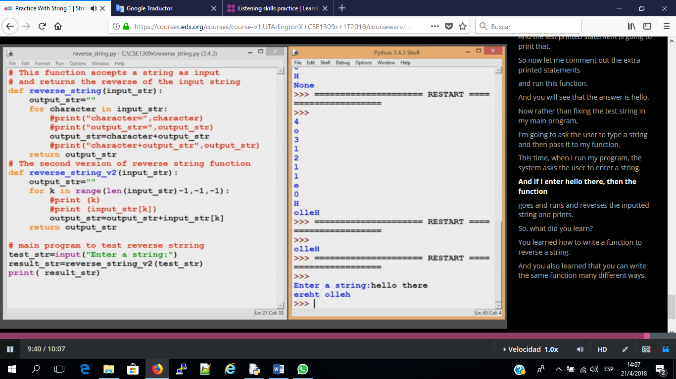

# Write a function which accepts an input string and returns a string where the case of the characters are changed, i.e. all the uppercase characters are changed to lower case and all the lower case characters are changed to upper case. The non-alphabetic characters should not be changed. Do NOT use the string methods upper(), lower(), or swap().

#

#Version 1

def funcion_reverse_string_1(input_string):

output_string=""

for caracter in input_string:

output_string=caracter+output_string

return output_string

#Version 2

def funcion_reverse_string_2(input_string):

output_string=""

for caracter in range(len(input_string)-1,-1,-1):

output_string=output_string+input_string[caracter]

return output_string

# OJO SOLO FUNCION!!!

# Main Program #

input_string = str(input("Enter string: "))

evalua_funcion_reverse_string_1 = funcion_reverse_string_1(input_string)

evalua_funcion_reverse_string_2 = funcion_reverse_string_2(input_string)

print("Version-1",evalua_funcion_reverse_string_1)

print("Version-2",evalua_funcion_reverse_string_2)

## **Practice With String 2**

EJEMPLO DE CONTAR LAS PALABRAS DE UN STRING

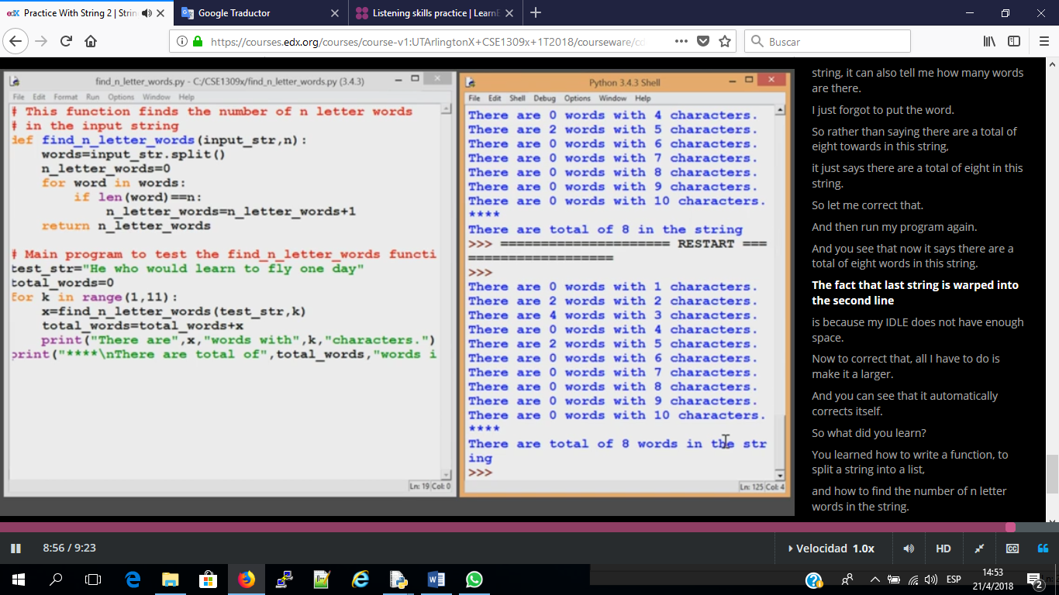

# Write a function which accepts an input string and returns a string

# and count words of the input string

#Version 1

def funcion_n_contar_words(input_string, n):

words=input_string.split()

n_letter_words=0

for word in words:

if len(word)==n:

n_letter_words=n_letter_words+1

return n_letter_words

# OJO SOLO FUNCION!!!

# Main Program #

input_string = "Espero que tengamos todos un lindo dia lleno de alegria"

total_words=0

for k in range(1,11):

x = funcion_n_contar_words(input_string, k)

total_words=total_words+x

print("There are",x,"words with",k,"characters")

print("****\nThere are total of:",total_words,"words")

**Why Use Another IDE?**

It is true that you can use any plain and simple text editor for writing Python code, however, using a more powerful editor may make your life a lot easier.

* A good IDE should support functionalities such as:
* Code highlighting
* Integrated debugging
* Line numbering
* Code completion
* Code folding
* Multi tab windows
* Support for projects
* Flexible find and replace
* Syntax error highlighting
* Light weight and Fast
* Support for modules and libraries

Although the default IDE which is included with Python 3.x is adequate but it lacks some functionalities. It is best if you learn to use a more user friendly and more powerful IDE. There are many Python IDEs that you can download and use for free. My suggestion is to use the Wing IDE 101. This IDE is free and it is designed for  beginning programmers while having a balance between features and responsiveness.

The following unit includes a step by step guide for downloading and installing the free Wing IDE 101.

Here is a list of other free IDEs which support Python:

* Eclipse plus PyDev
* PyScripter
* Eric Python IDE
* PyCharm Community Edition
* CodeSkulptor

## **Multidimensional Lists**

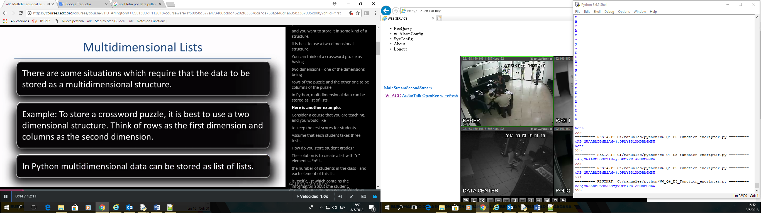

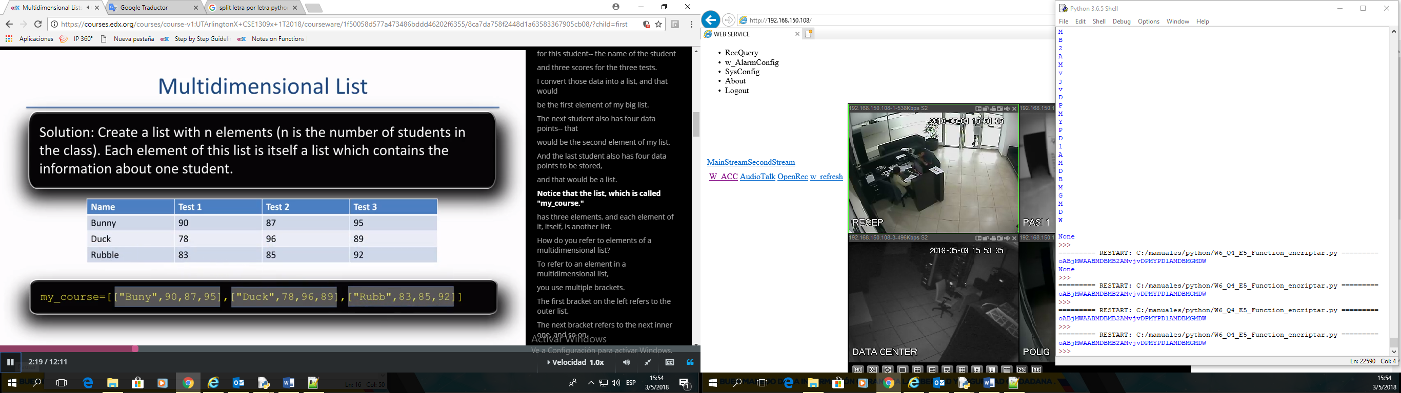

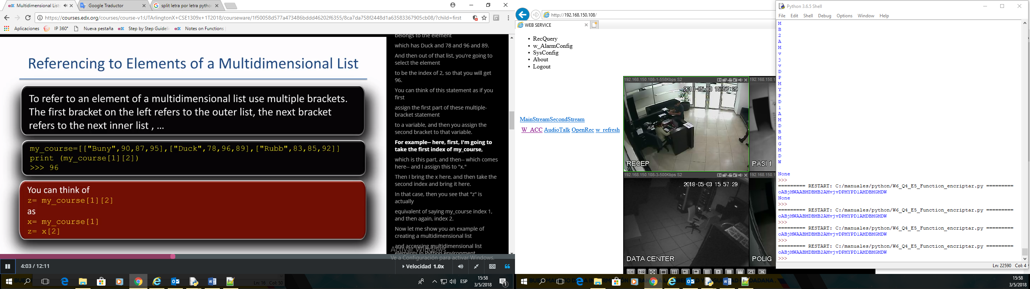

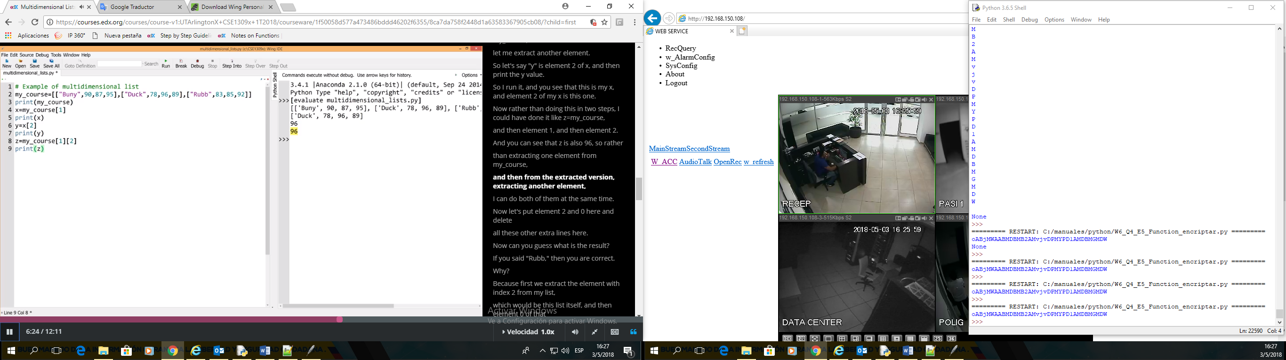

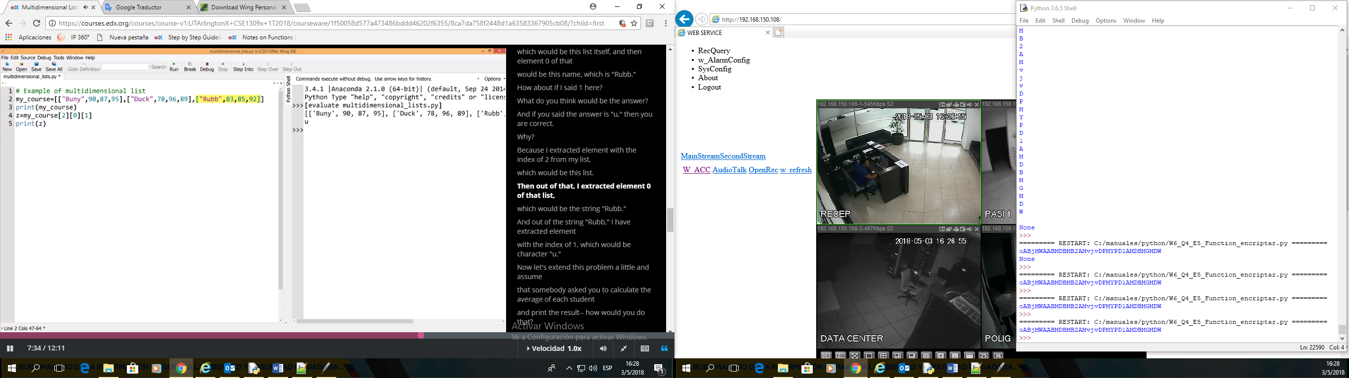

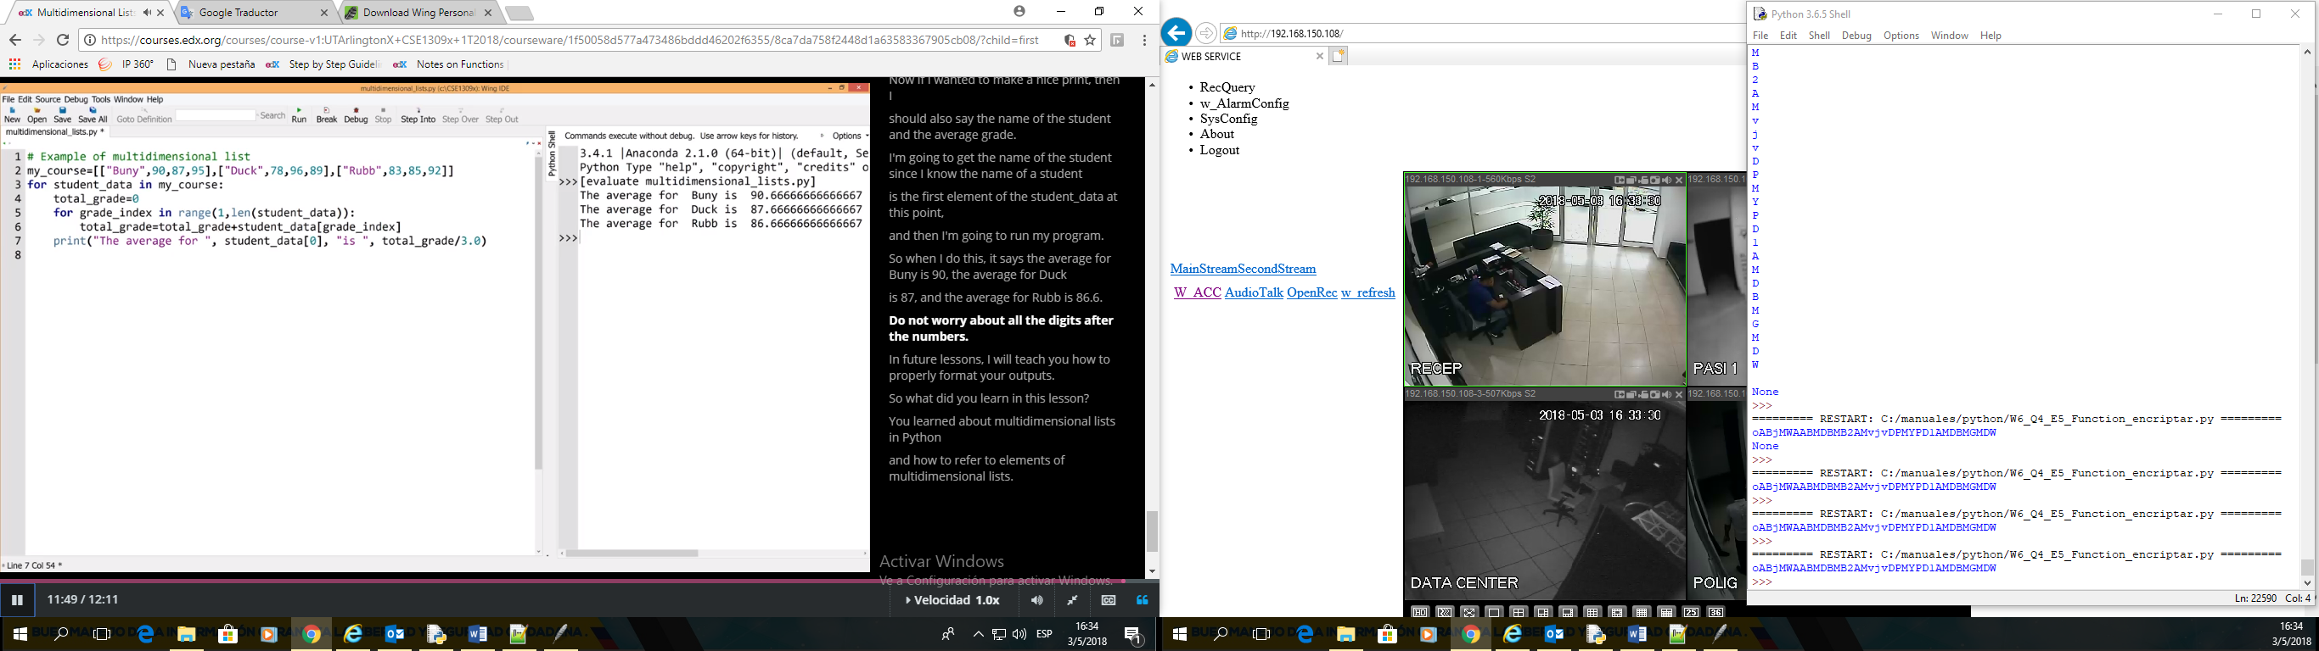

# Example of multidimensional list

my_course=[["Ivan",90,87,95],["Flor",92,89,94],["Samuel",99,87,97],["Bruno",90,85,99]]

for student_data in my_course:

total_grade=0

for grade_index in range(1,len(student_data)):

total_grade=total_grade+student_data[grade_index]

print("El promedio para", student_data[0], "es", total_grade/3.0)

## **Dictionaries**

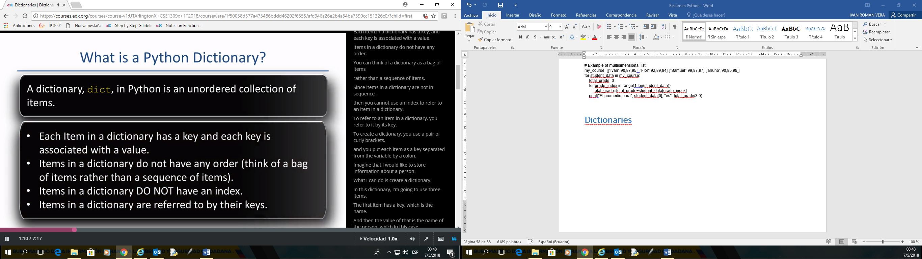

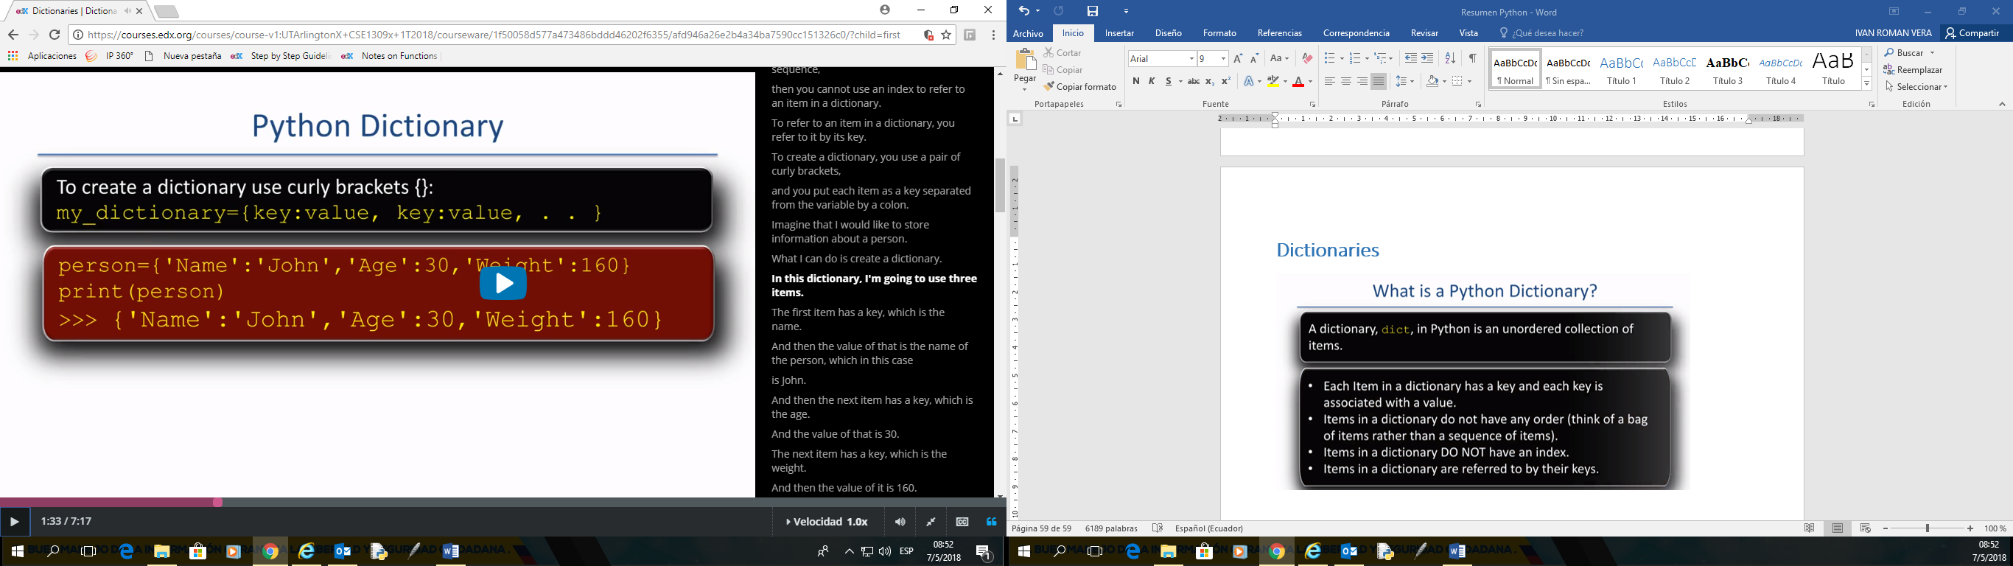

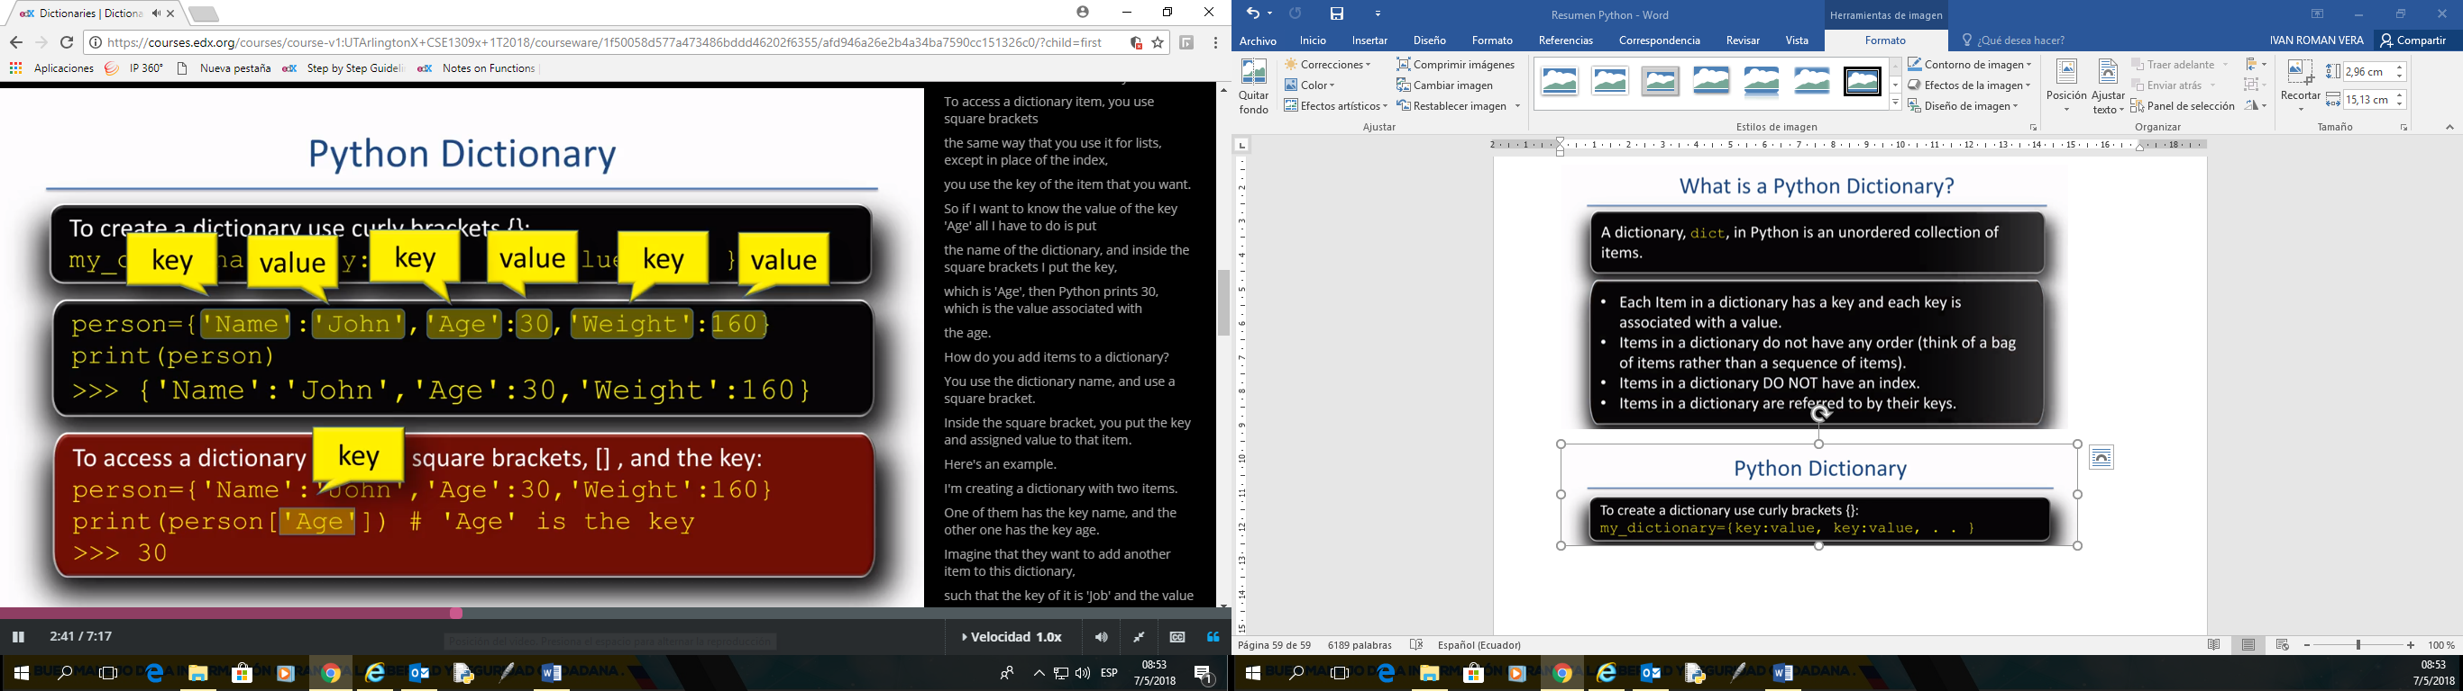

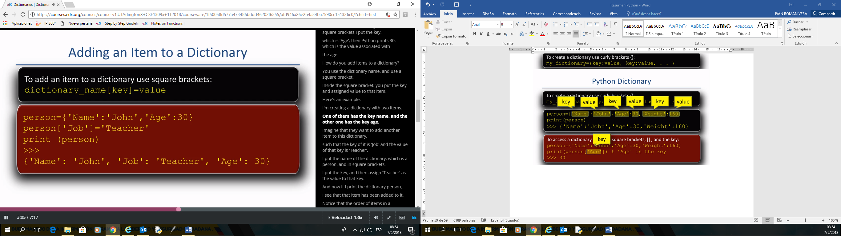

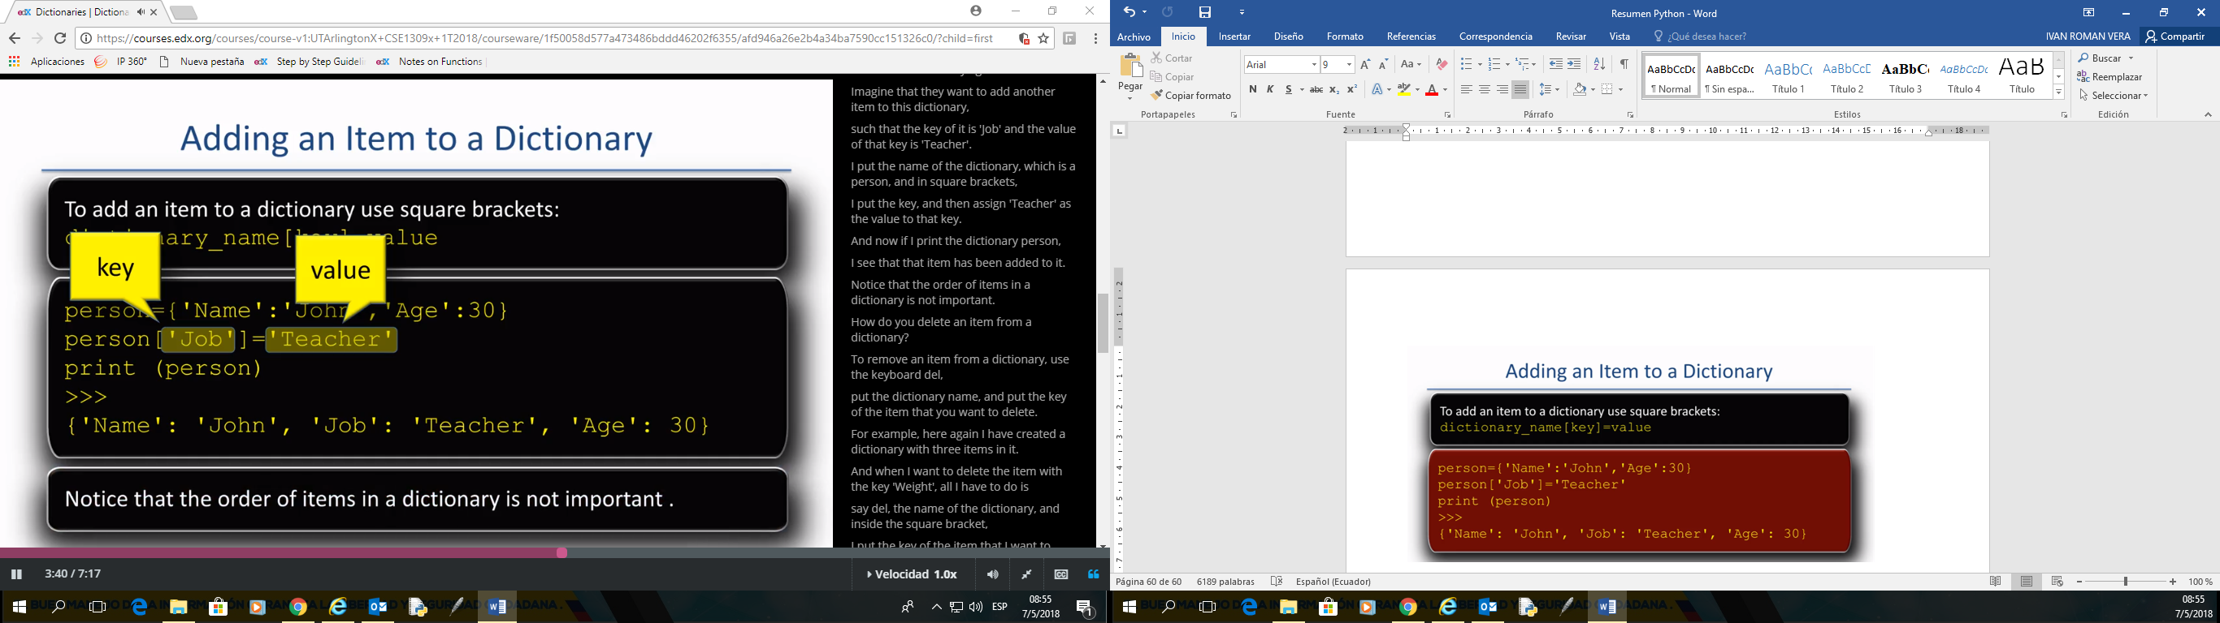

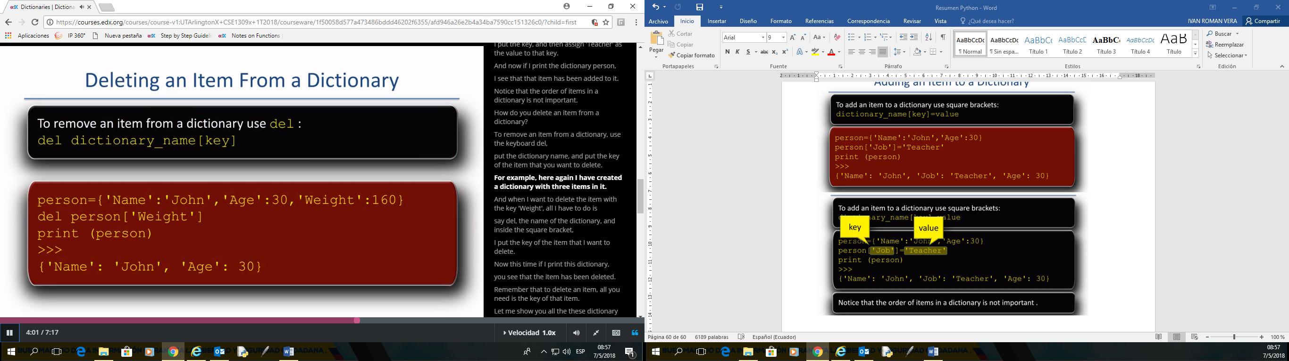

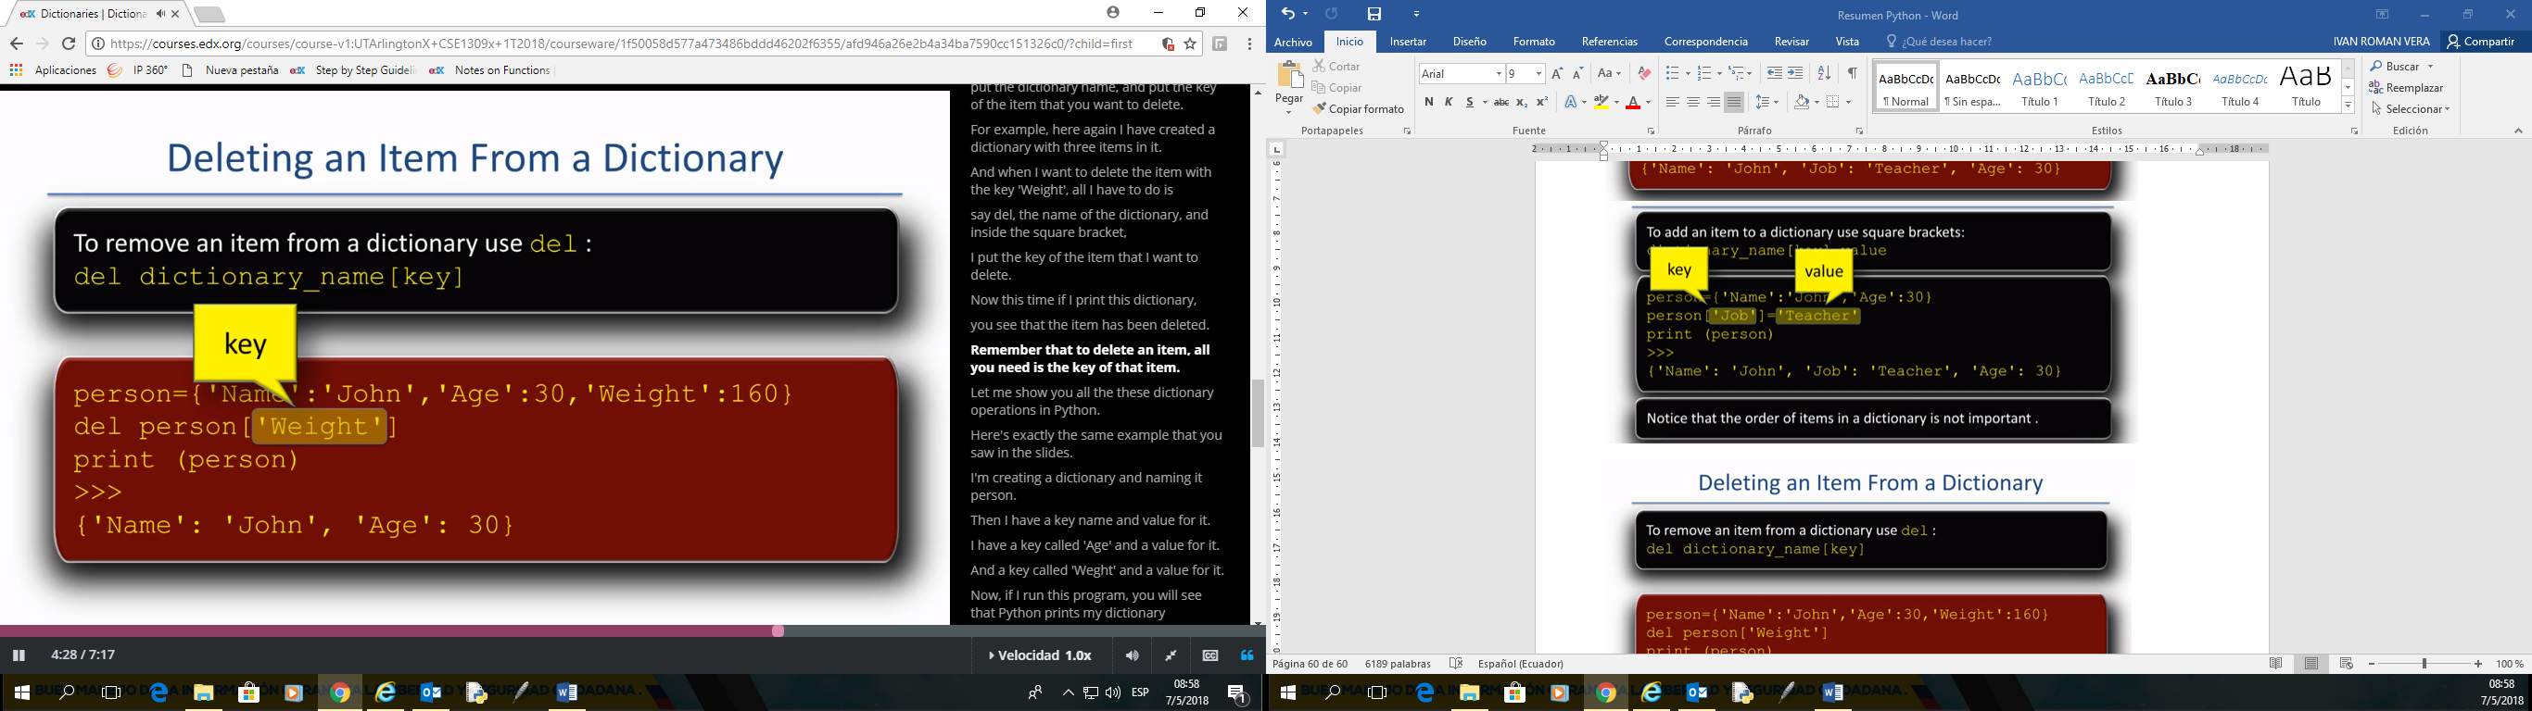

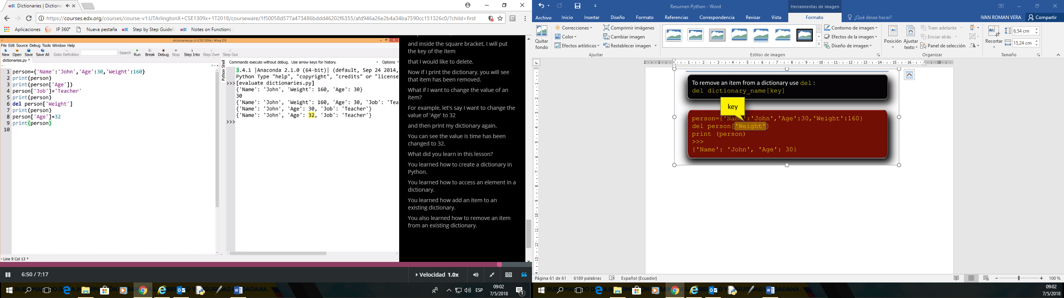

# Example of dictionary

person={'Nombre':'Ivan','Edad':51,'Altura':160}

print(person)

print(person['Edad'])

#AGREGAR

person['Trabajo']='Ingeniero'

print(person)

#ELIMINAR

del person['Altura']

print(person)

#MODIFICAR

person['Edad']=50

print(person)

## **Dictionary Methods**

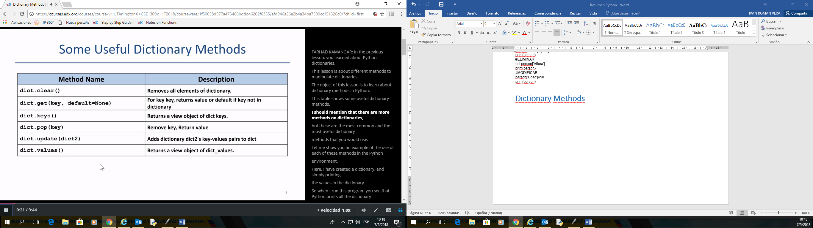

**Method dict.get()**

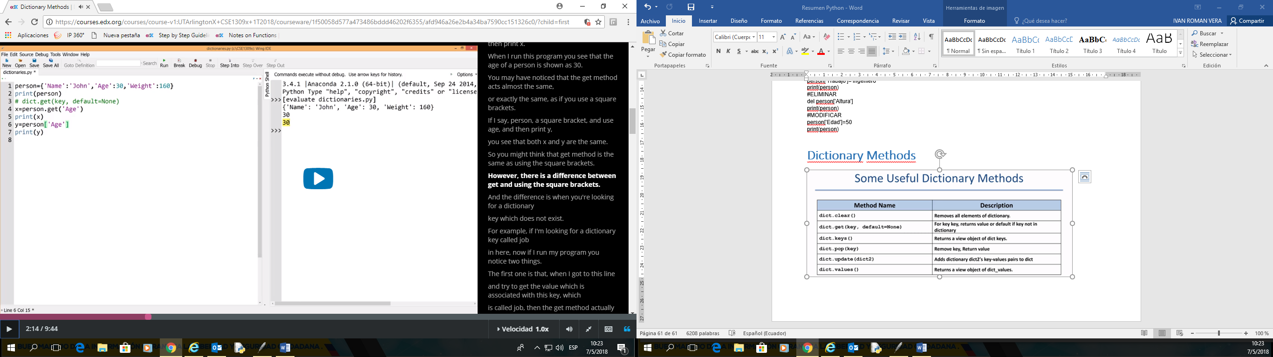

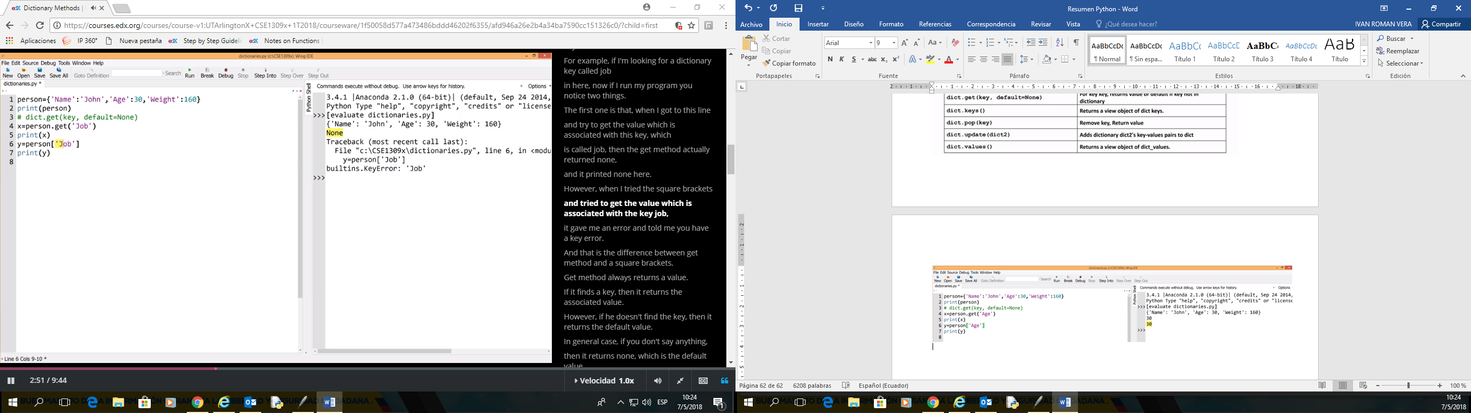

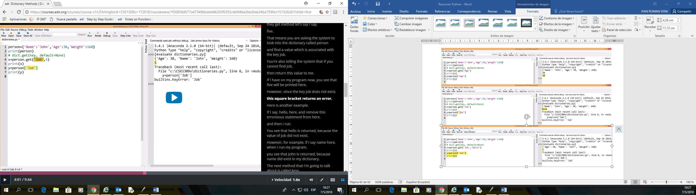

**Method dict.keys()**

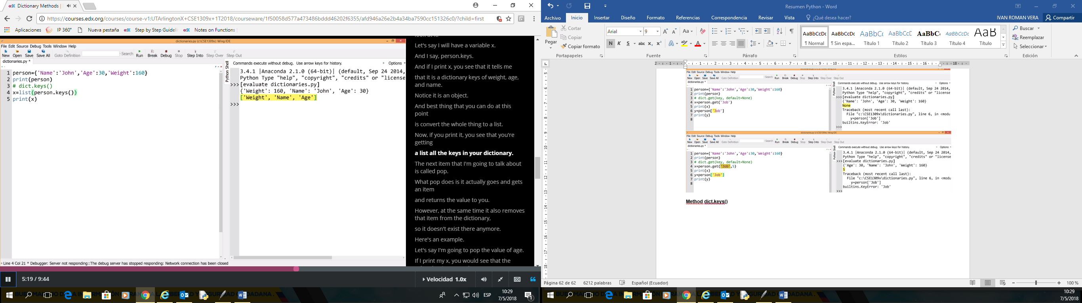

**Method dict.pop()**

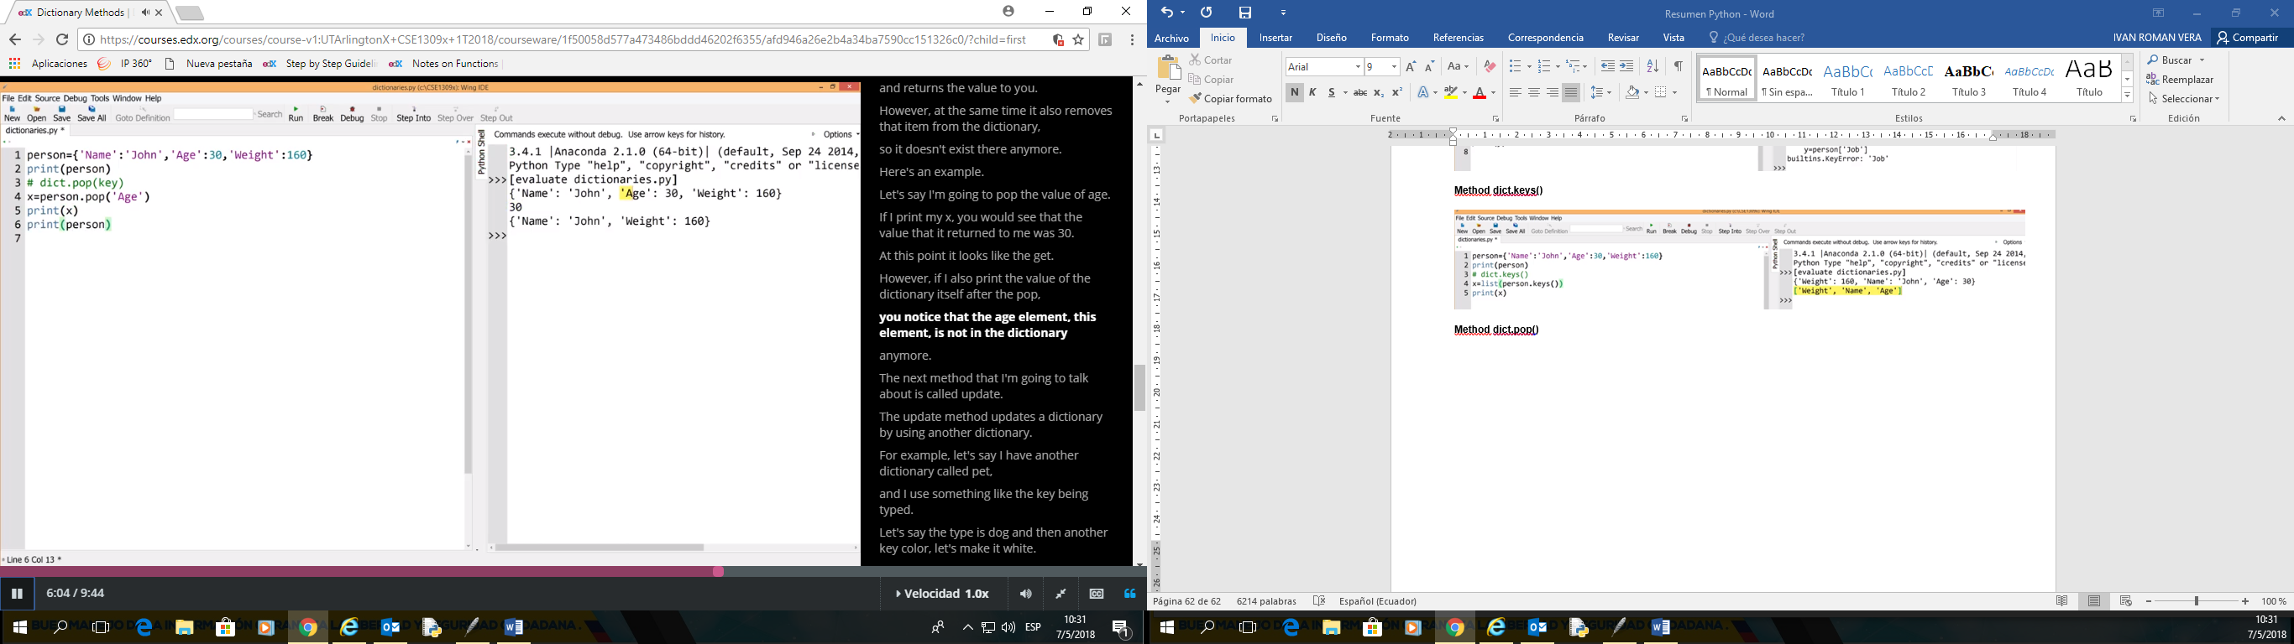

**Method dict.update(dict2)**

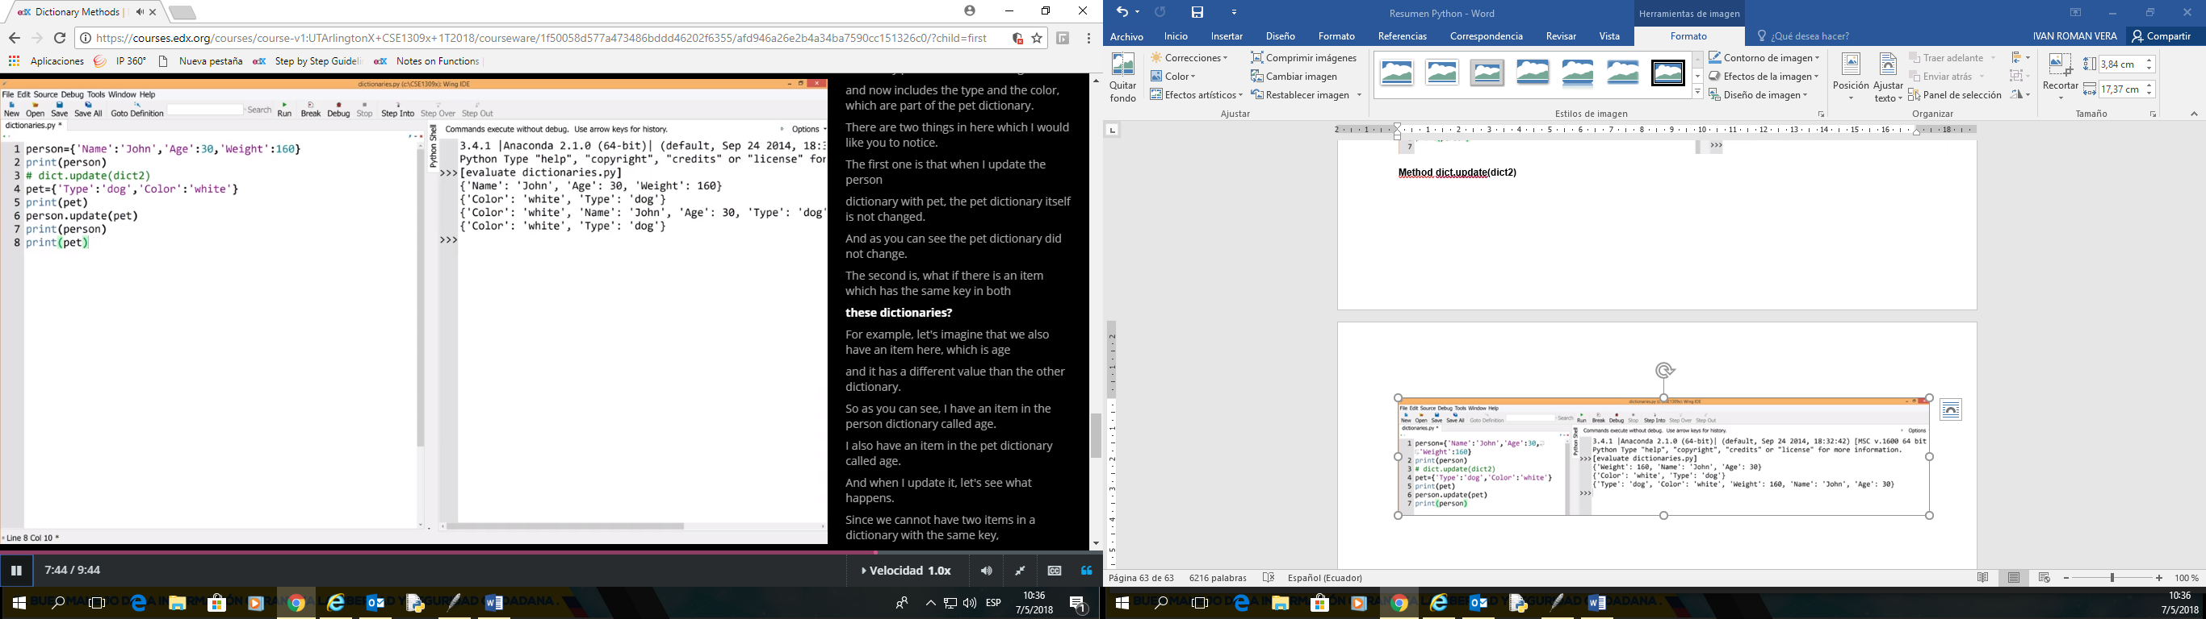

**Update mismo campo de diccionario**

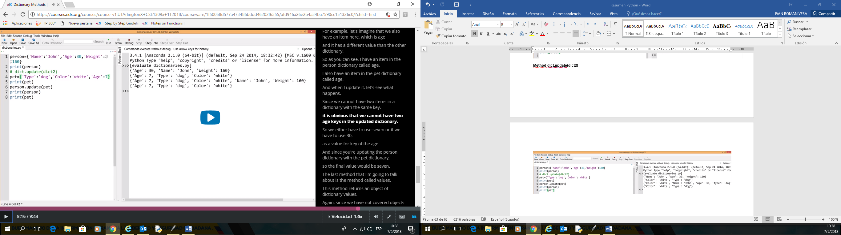

**Method dict.values()**

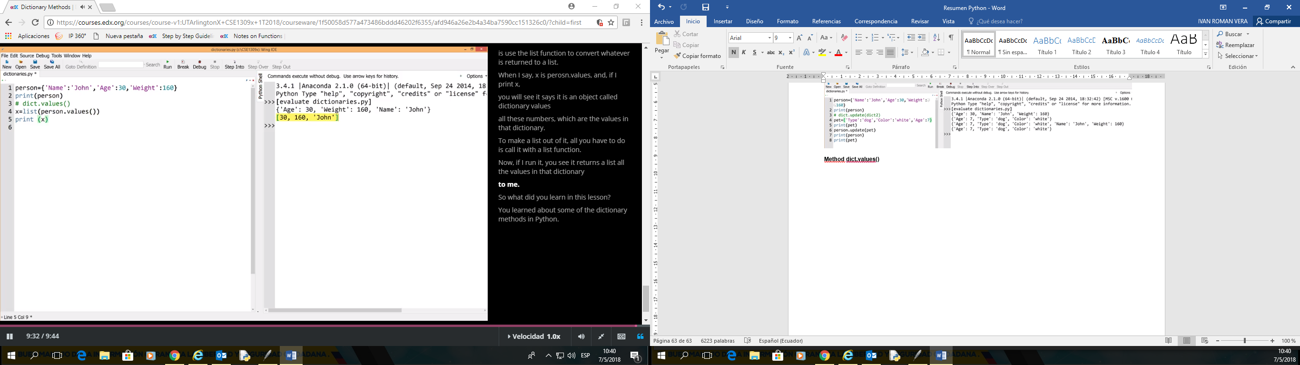

|  |  |
| --- | --- |
| **Table of common methods for Dictionaries** |  |
| **Method Name** | **Description** |
| dict.clear() | Removes all elements of dictionary. |
| dict.copy() | Returns a shallow copy of dictionary. |
| dict.fromkeys(seq[,value]) | Create a new dictionary with keys from seq and values set to value. |
| dict.get(key, default=None) | For key key, returns value or default if key not in dictionary |
| dict.items() | Returns a view object of dict items. |
| dict.keys() | Returns a view object of dict keys. |
| dict.pop(key) | Remove key, Return value |
| dict.setdefault(key, default=None) | Similar to get(), but will set dict[key]=default if key is not already in dict |
| dict.update(dict2) | Adds dictionary dict2's key-values pairs to dict |
| dict.values() | Returns a view object of dict_values. |

## **File I/O**

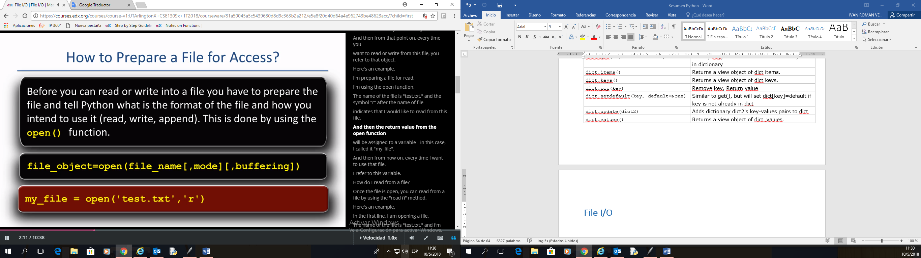

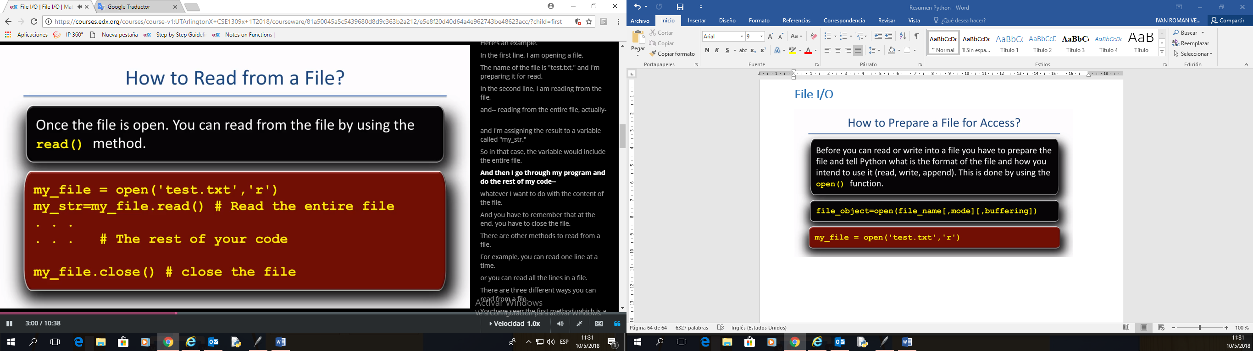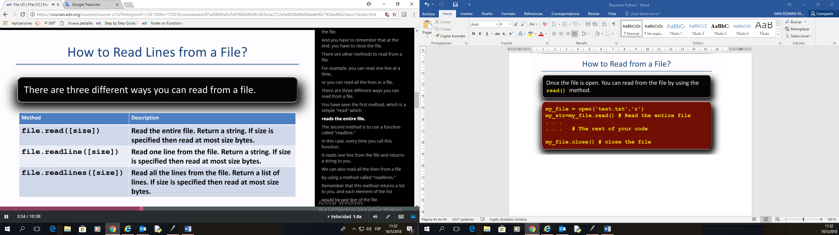

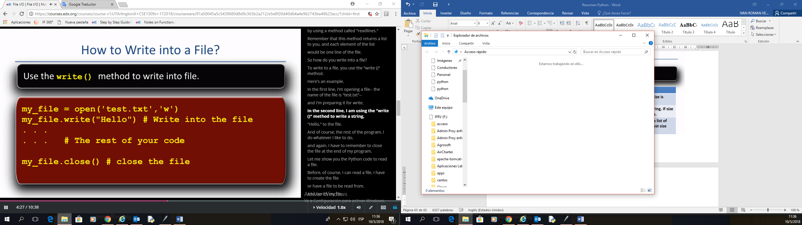

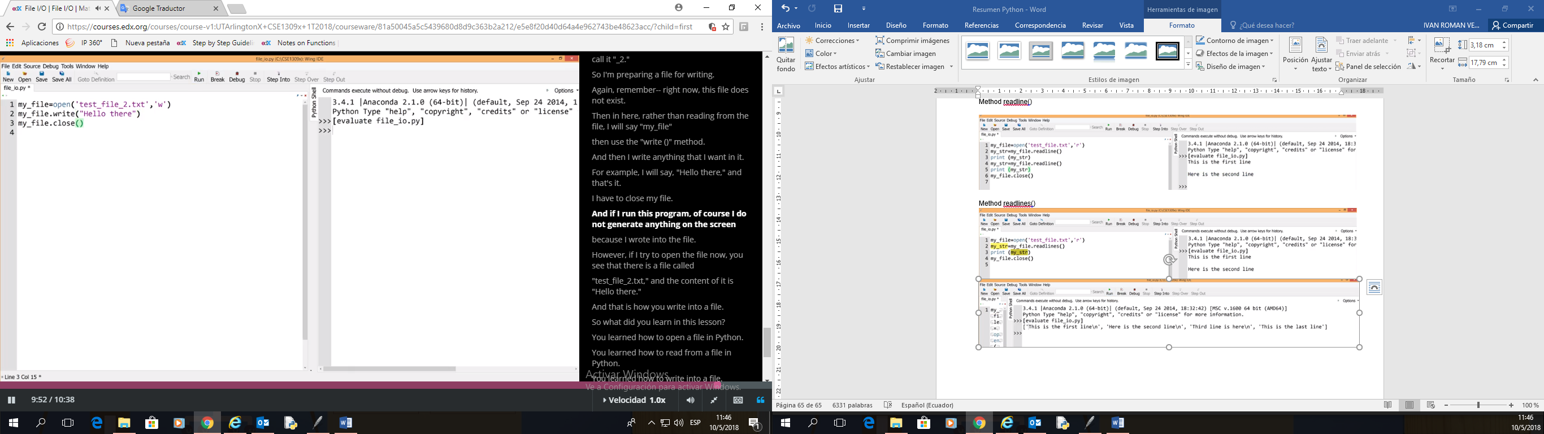

Method readline()

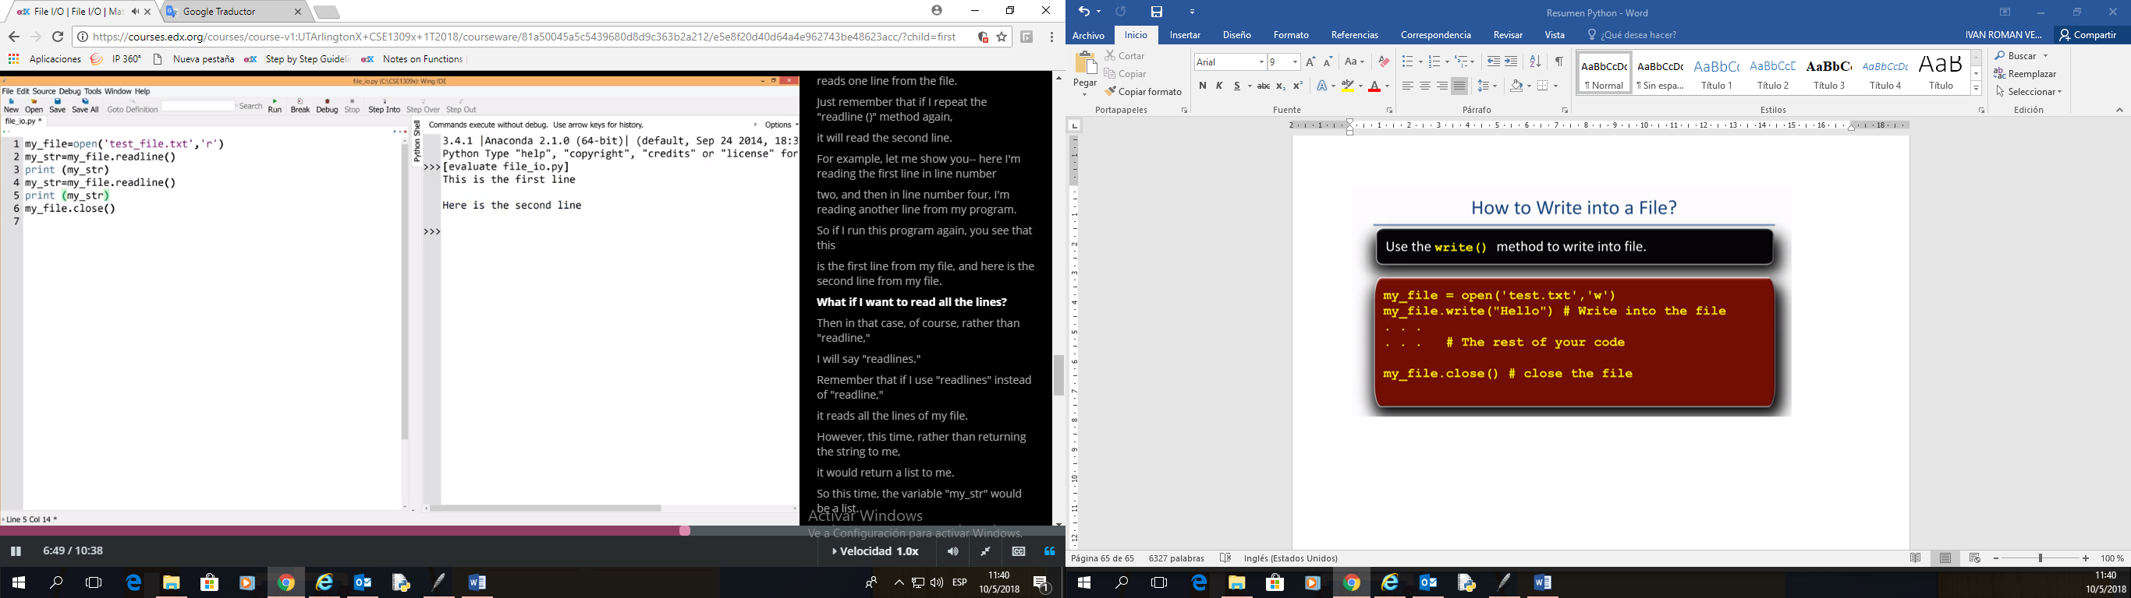

Method readlines()

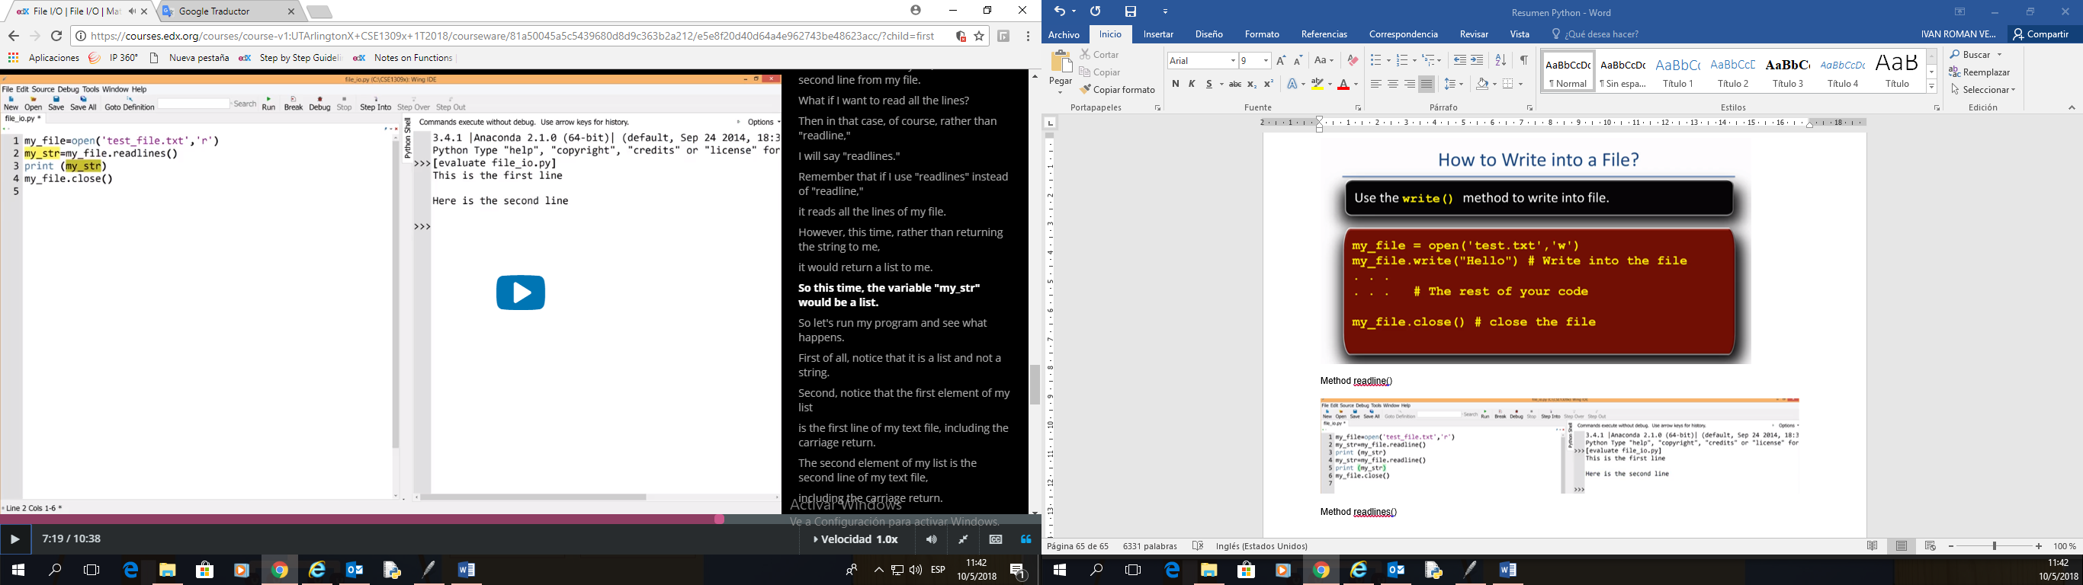

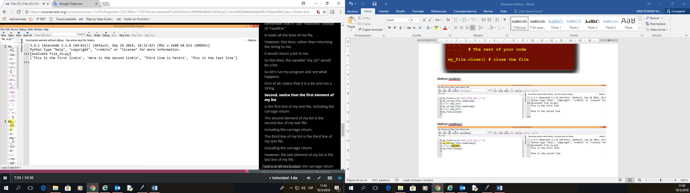

## **File Access Modes**

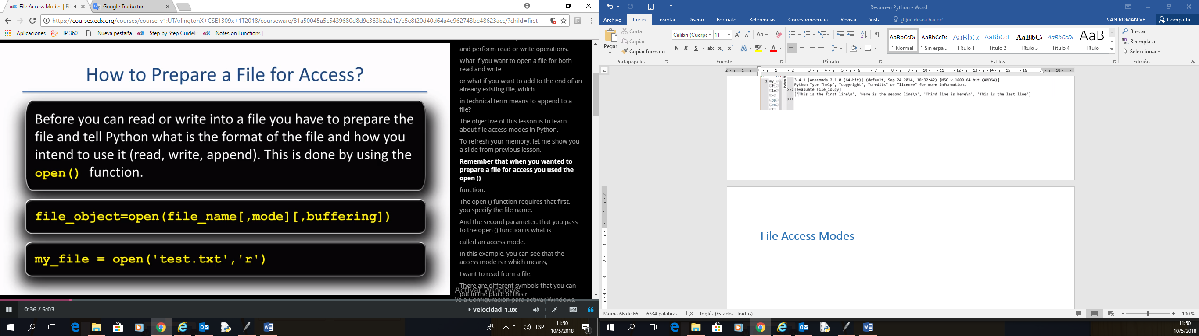

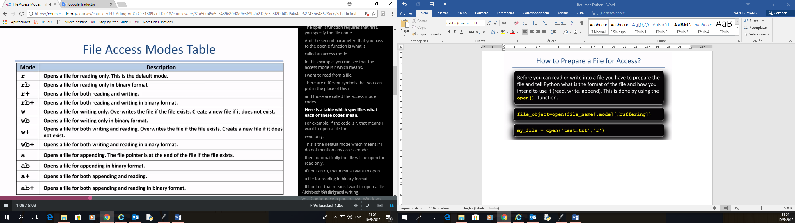

Con **‘r+’ SE puede leer y SE agrega texto** al final del archivo

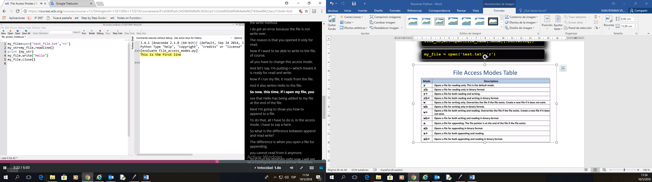

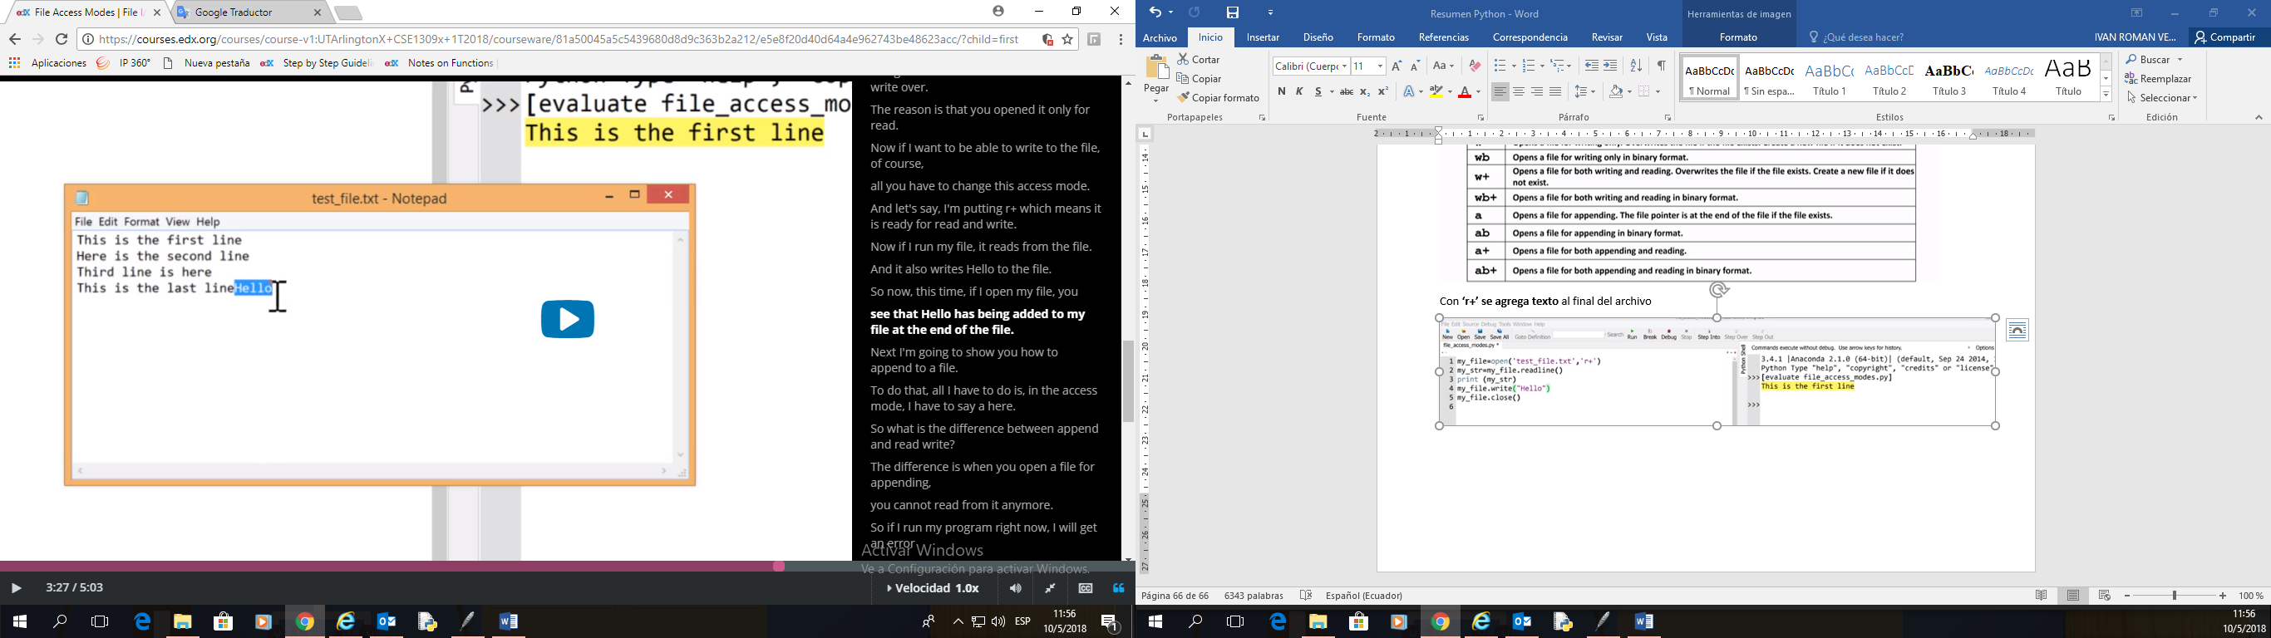

Con **‘a’ NO se puede leer pero SE puede agregar texto** al final del archivo

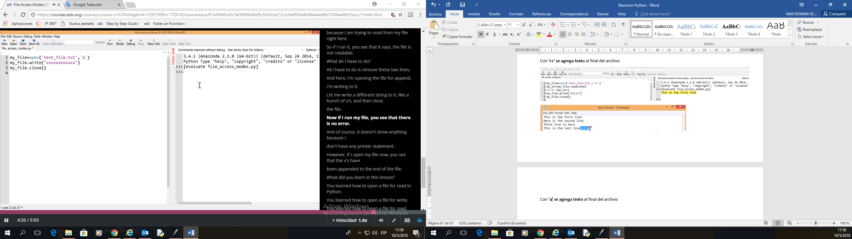

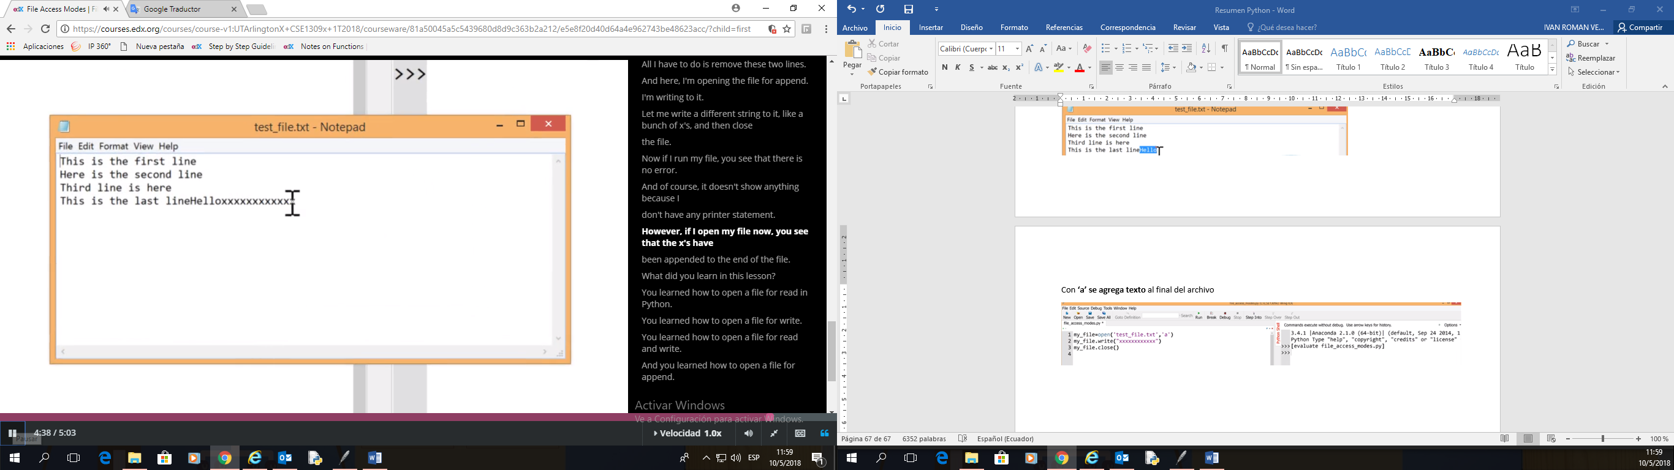

|  |  |
| --- | --- |
|  | File access Modes |
| **Mode** | **Description** |
| r | Opens a file for reading only. This is the default mode. |
| rb | Opens a file for reading only in binary format |
| r+ | Opens a file for both reading and writing. |
| rb+ | Opens a file for both reading and writing in binary format. |
| w | Opens a file for writing only. Overwrites the file if the file exists. Create a new file if it does not exist. |
| wb | Opens a file for writing only in binary format. |
| w+ | Opens a file for both writing and reading. Overwrites the file if the file exists. Create a new file if it does not exist. |
| wb+ | Opens a file for both writing and reading in binary format. |
| a | Opens a file for appending. The file pointer is at the end of the file if the file exists. |
| ab | Opens a file for appending in binary format. |
| a+ | Opens a file for both appending and reading. |
| ab+ | Opens a file for both appending and reading in binary format. |

## **File Position**

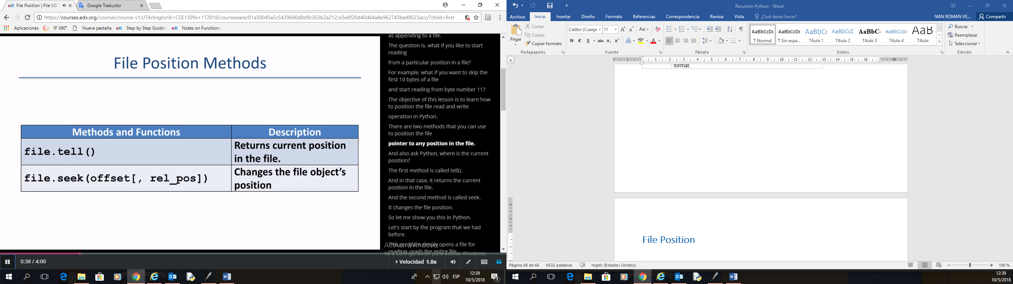

Method **seek() y tell()**

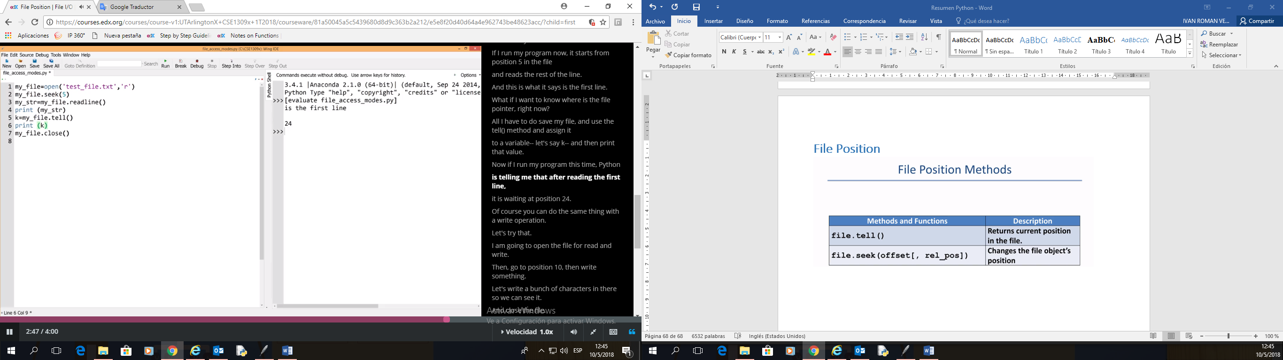

**Leyendo y escribiendo** en una **posición**

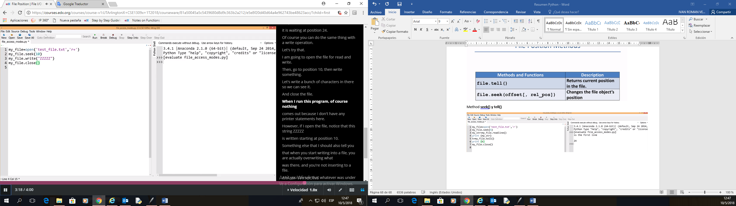

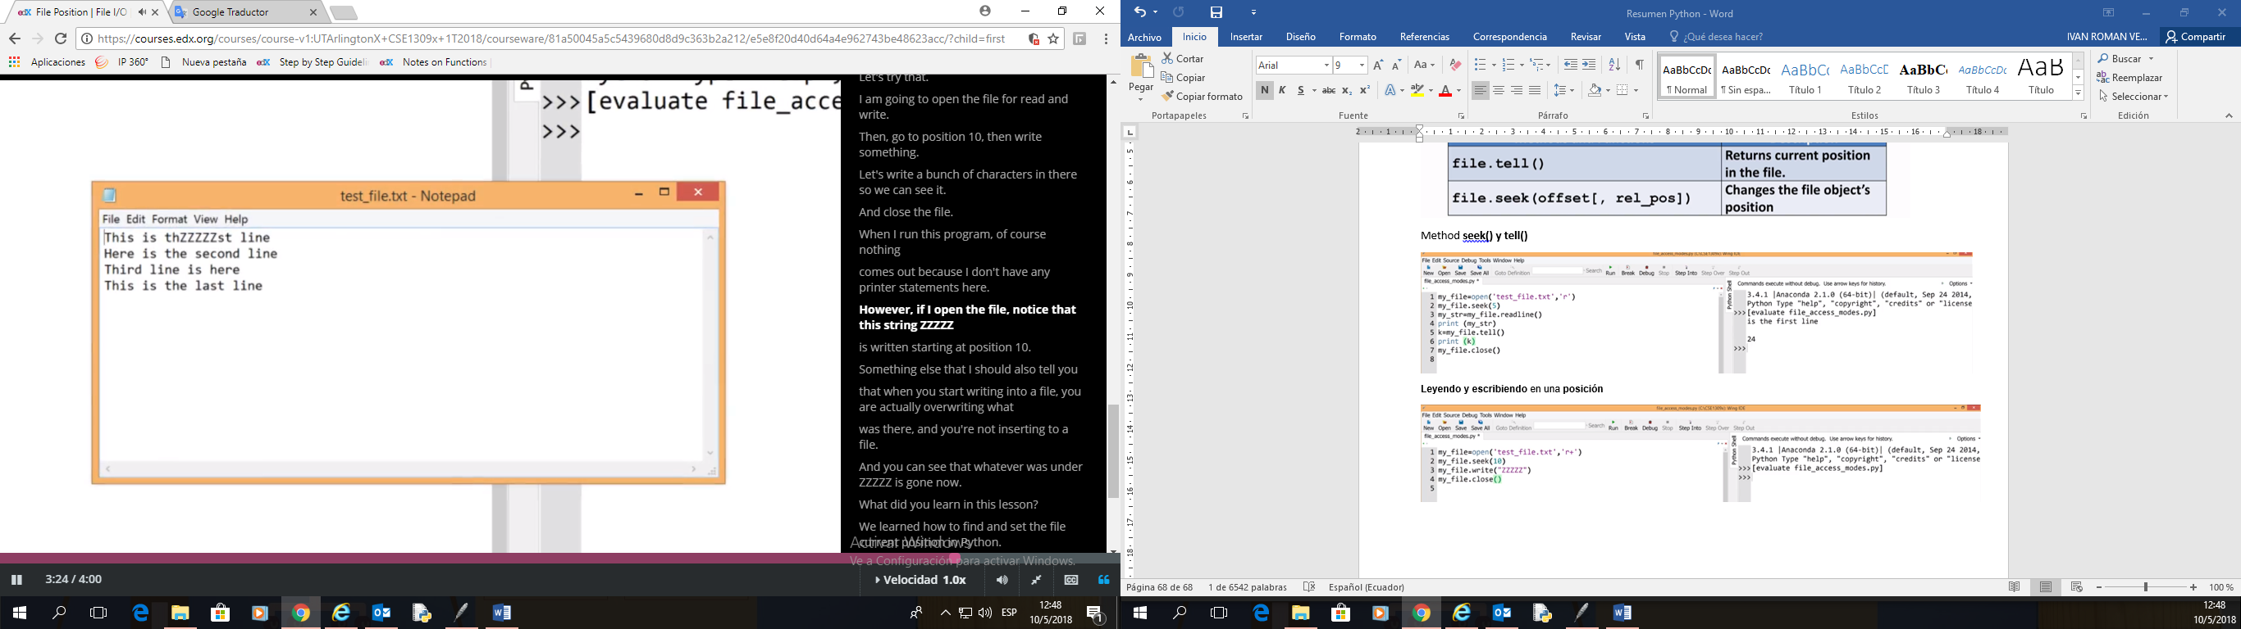

|  |  |
| --- | --- |
|  | Common File Functions and Methods |
|  |  |
| **Methods and Functions** | **Description** |
| open() | returns a file object, and is most commonly used with two arguments: open(filename, mode). |
| file.close() | Close the file |
| file.read([size]) | Read entire file. If size is specified then read at most size bytes. |
| file.readline([size]) | Read one line from file. If size is specified then read at most size bytes. |
| file.readlines([size]) | Read all the lines from the file and return a list of lines. If size is specified then read at most size bytes. |
| file.write() | Writes the contents of string to the file, returning the number of characters written. |
| file.tell() | Returns an integer giving the file object’s current position in the file |
| file.seek() | Changes the file object’s position |

## **Tuples**

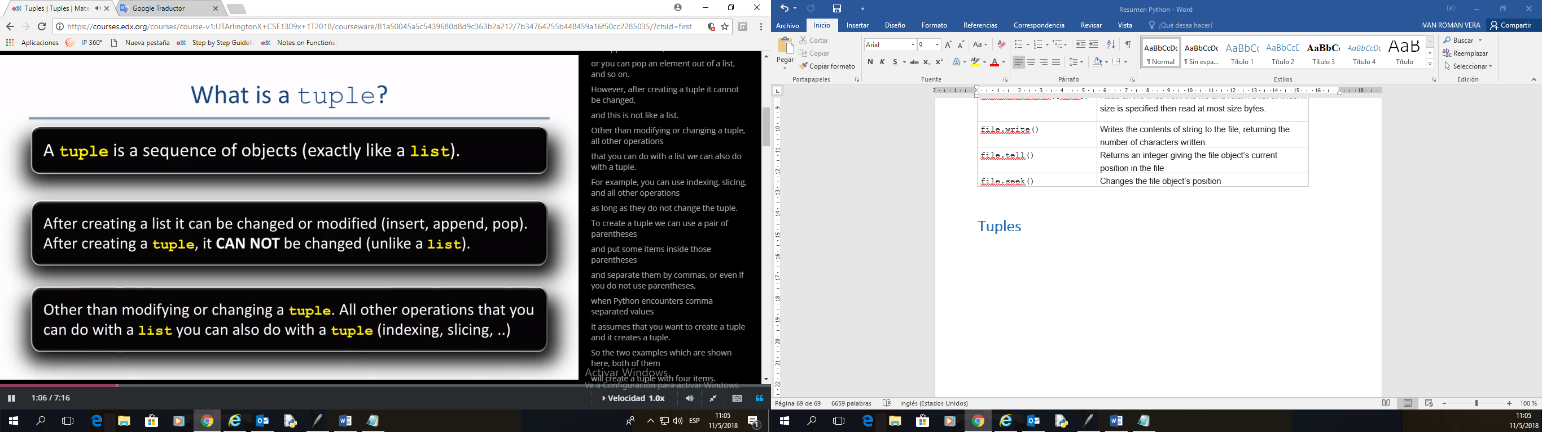

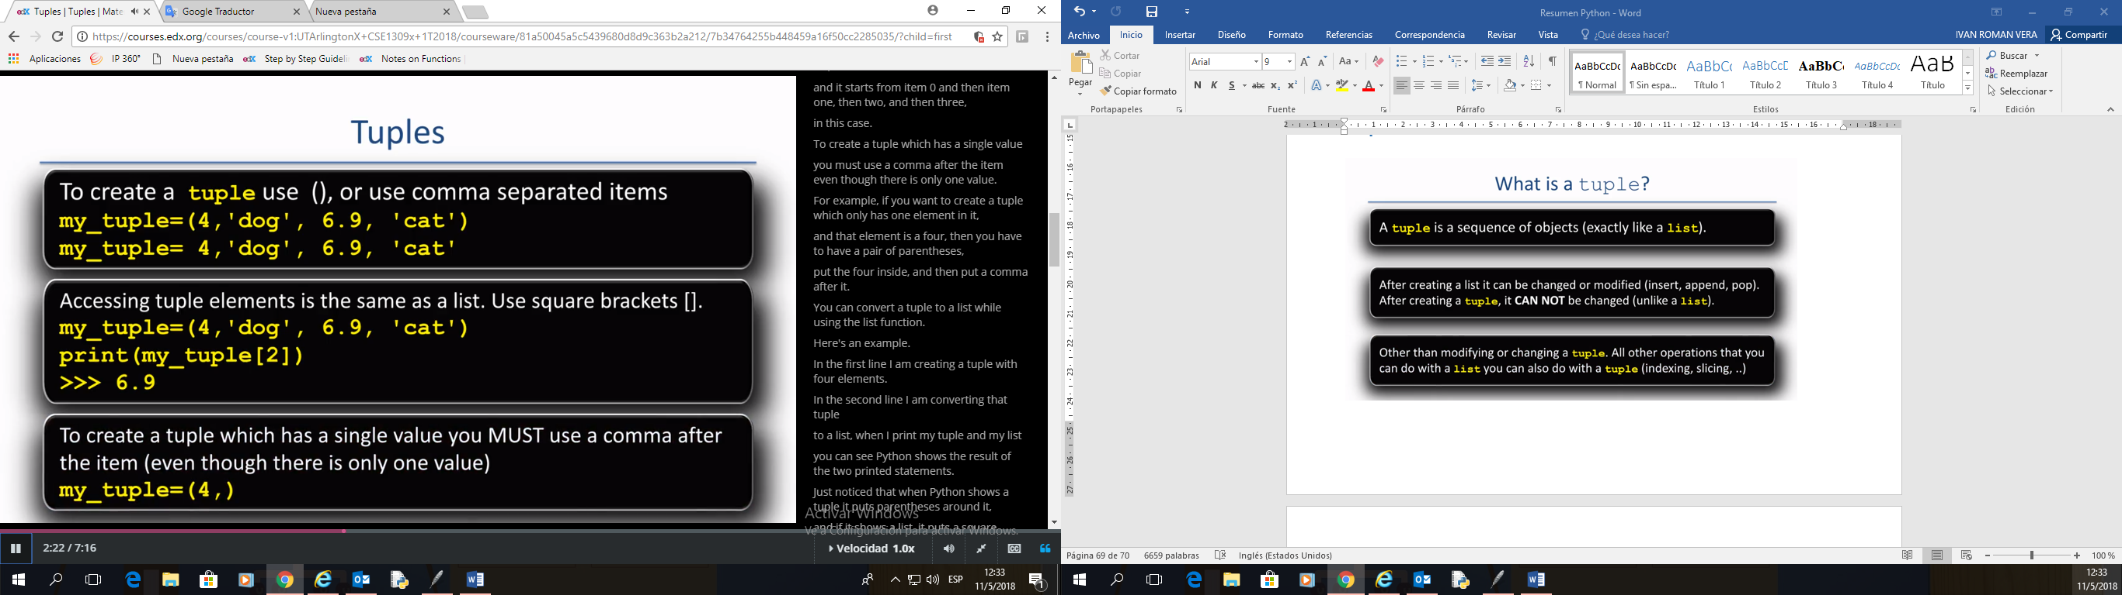

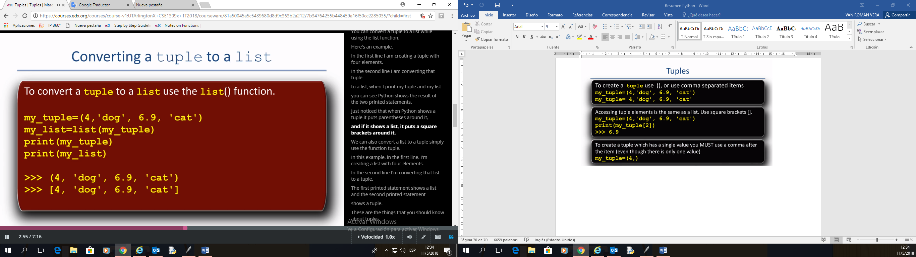

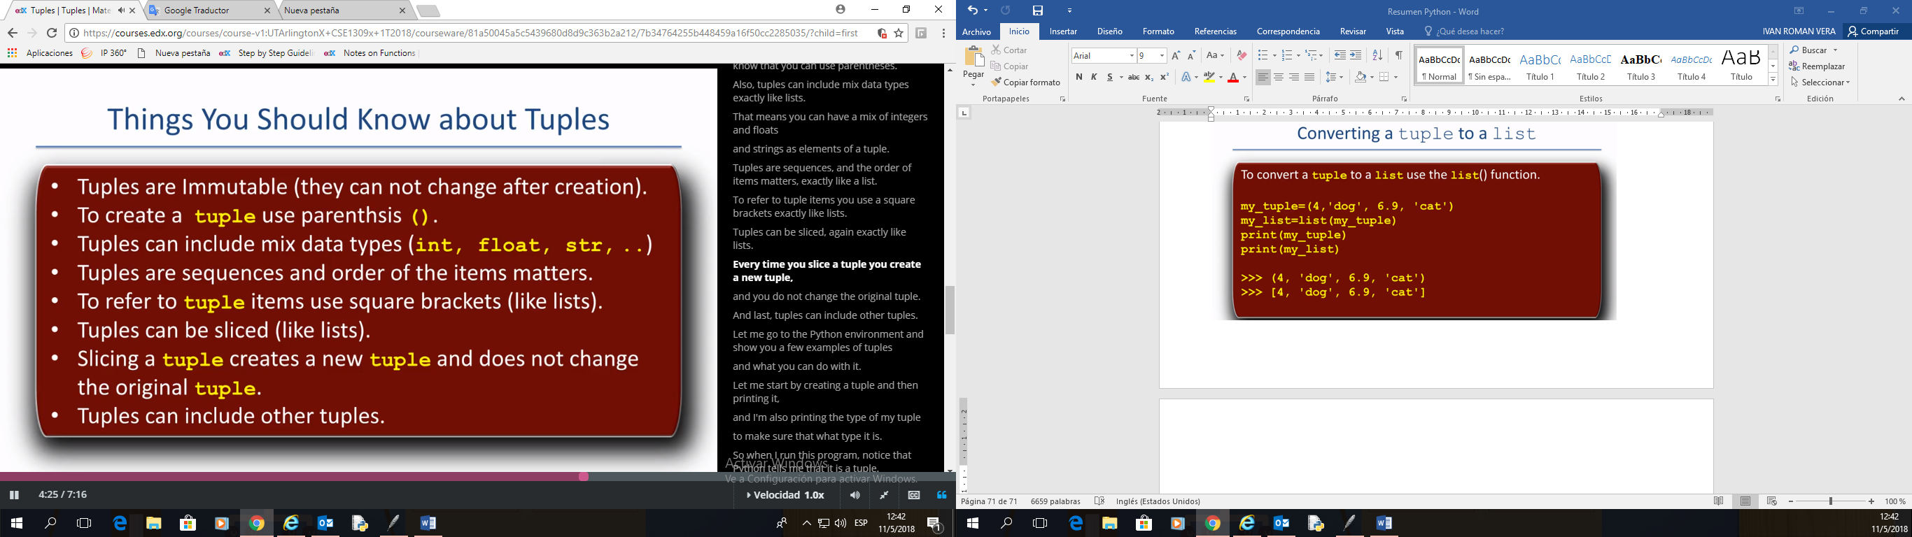

Creating tuple

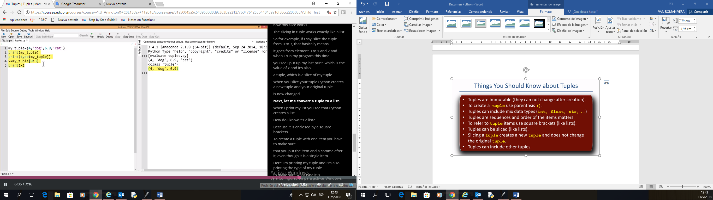

Transform tuple to list

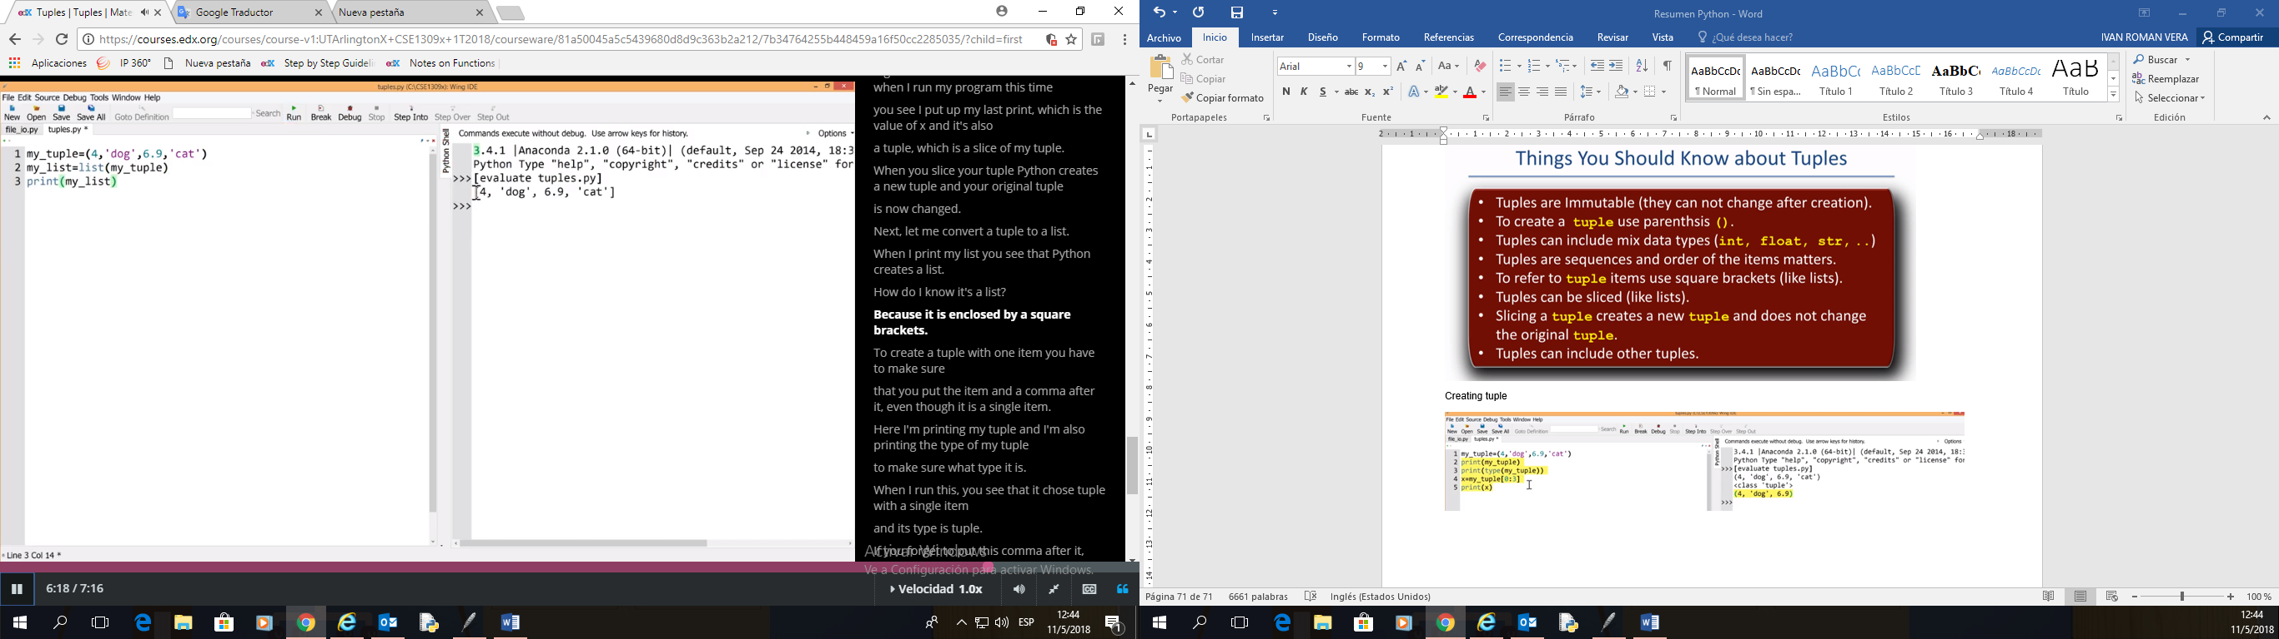

Observacion con la **(,)** en la tuple

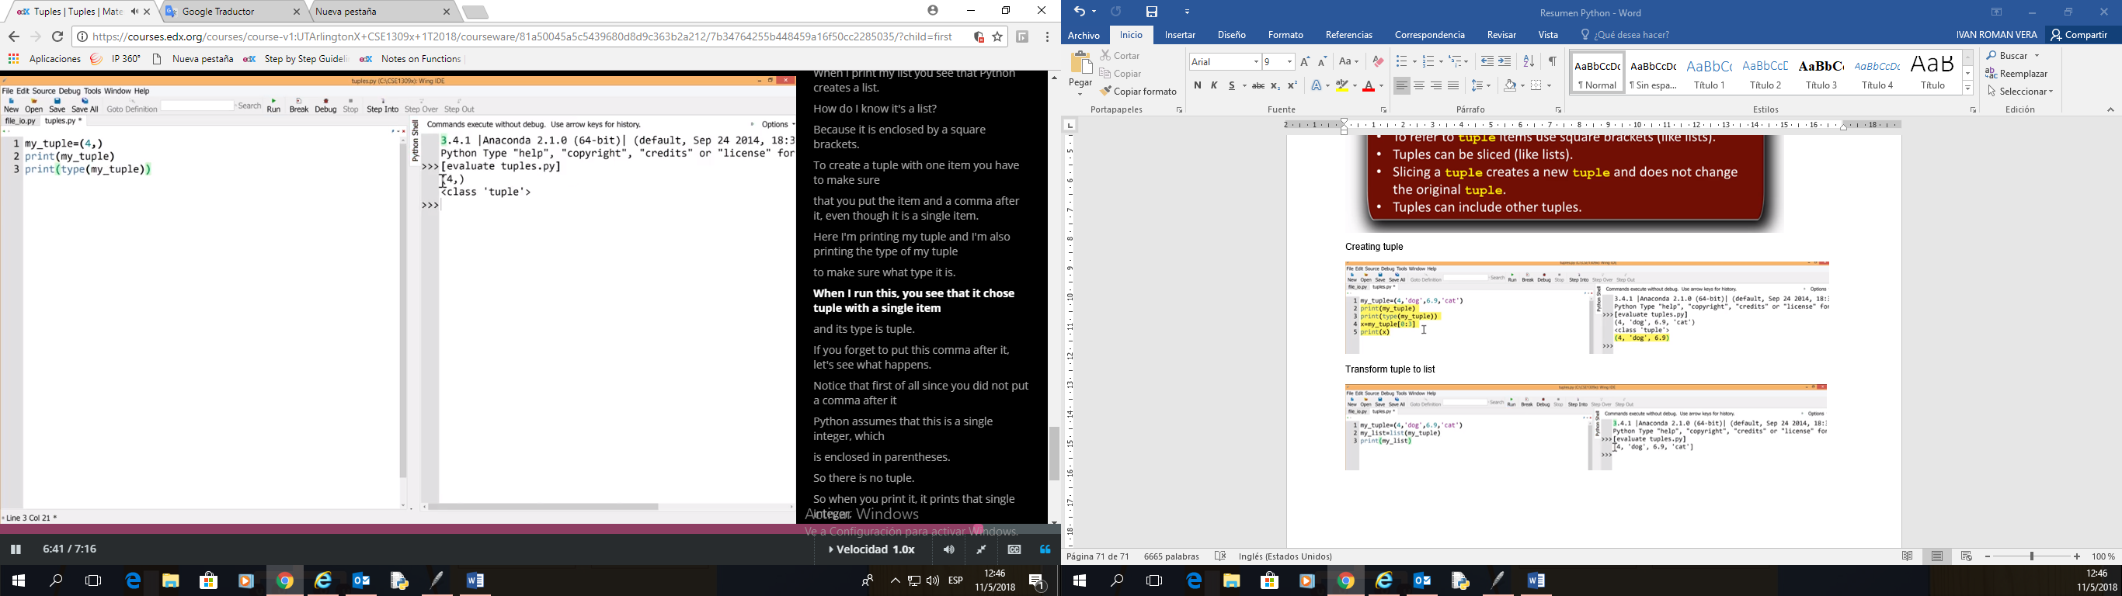

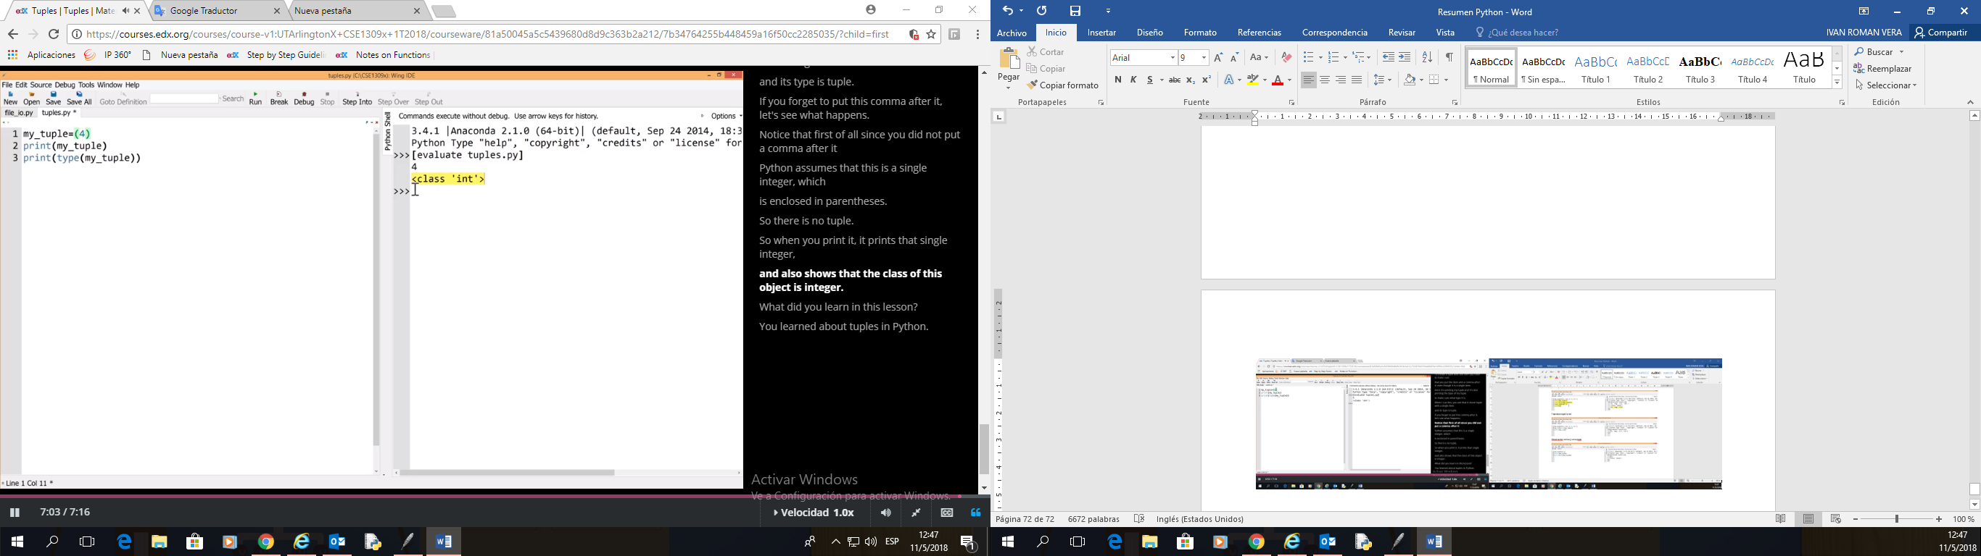

## **Tuples in Function Returns**

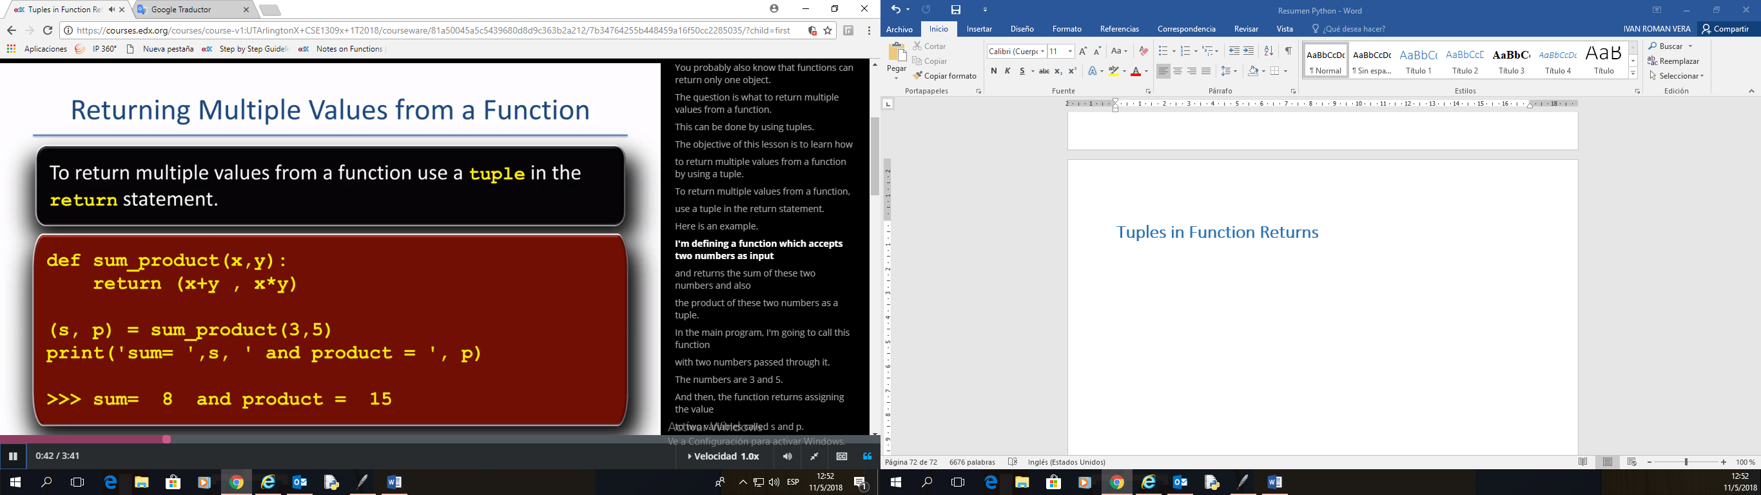

Note: **Use parenthesis in tuple, according to standard**

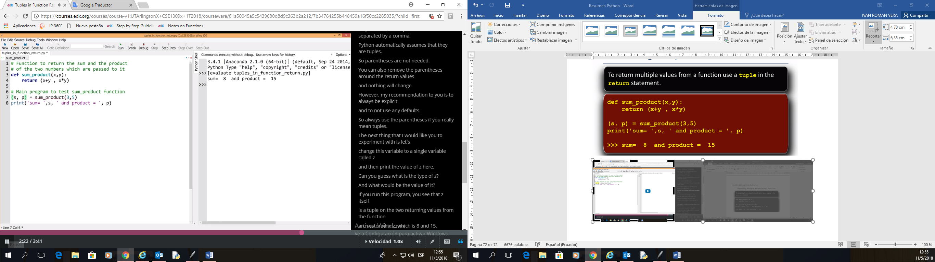

Other **example** is:

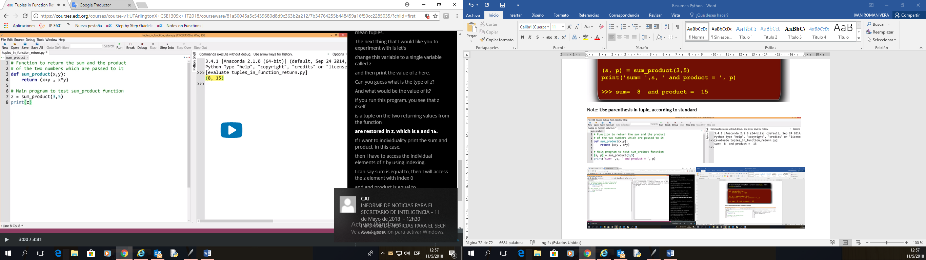

Other **example** with **index**:

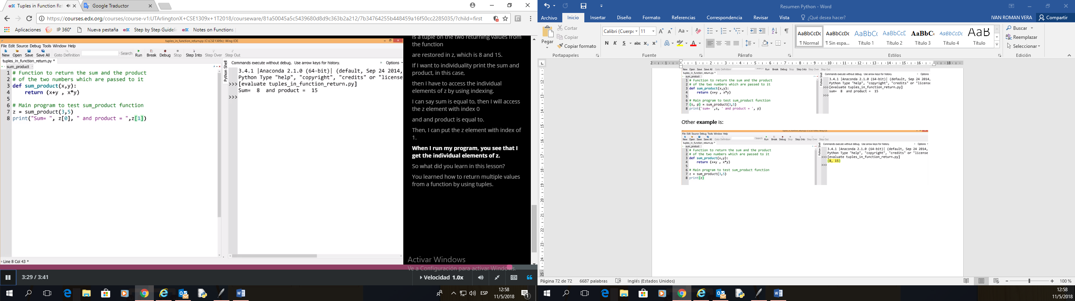

## **Formatting Basics**

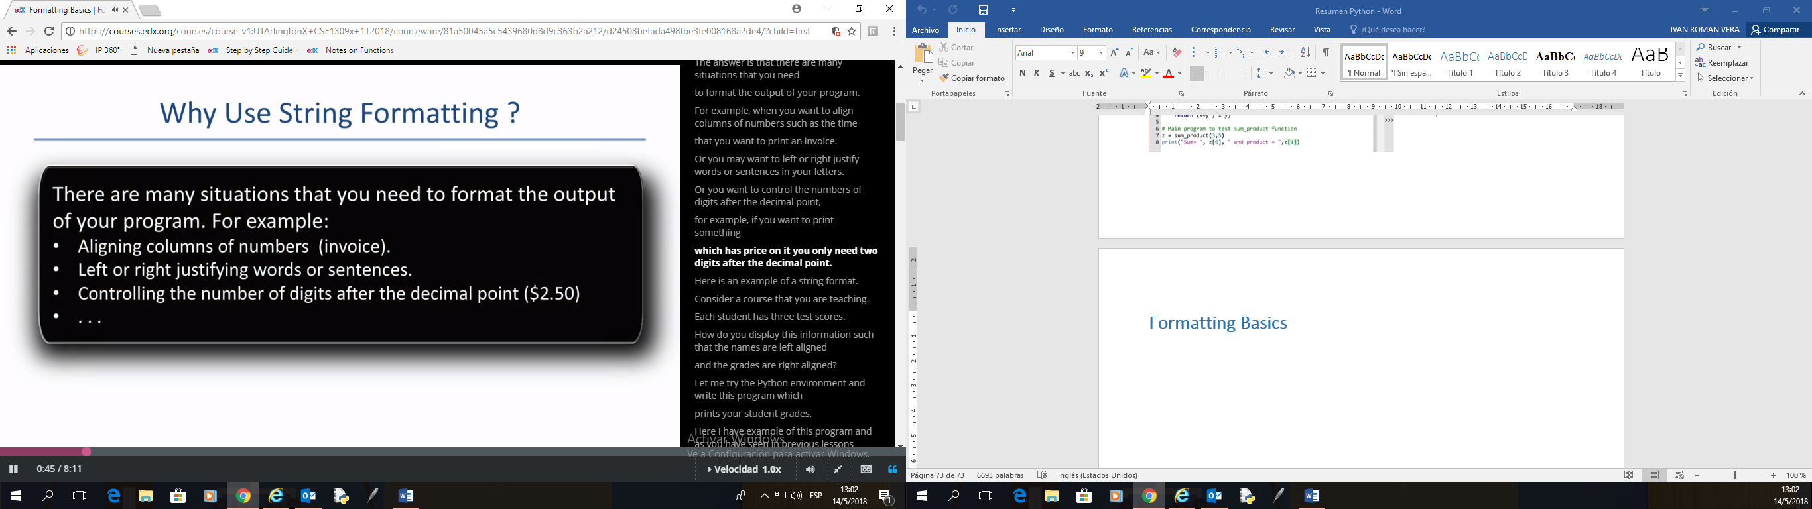

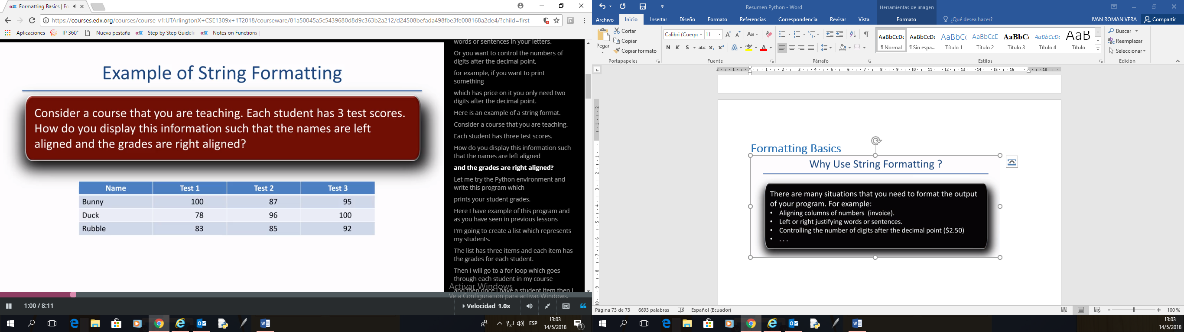

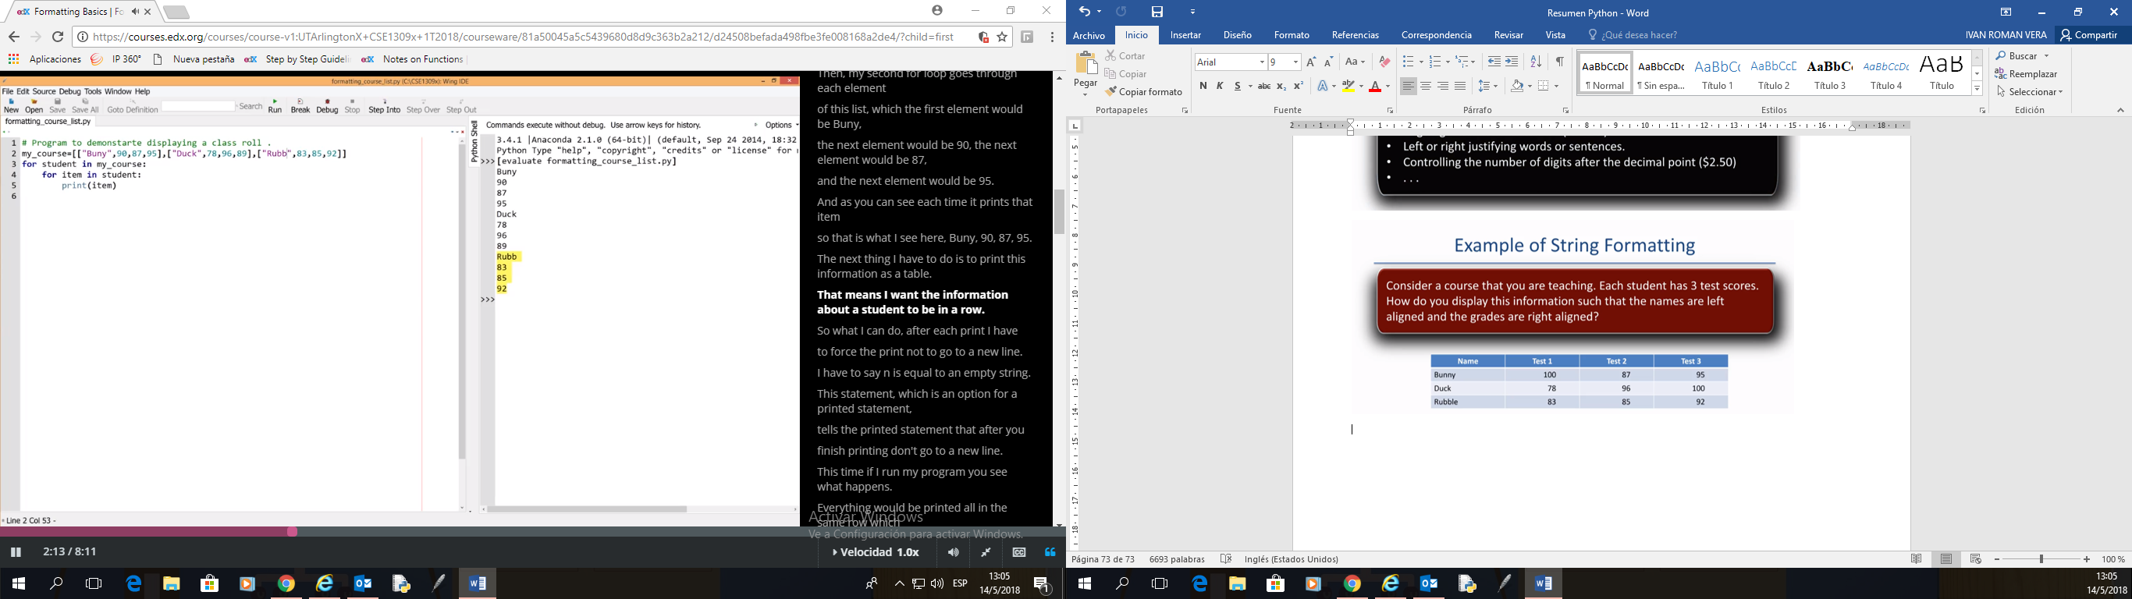

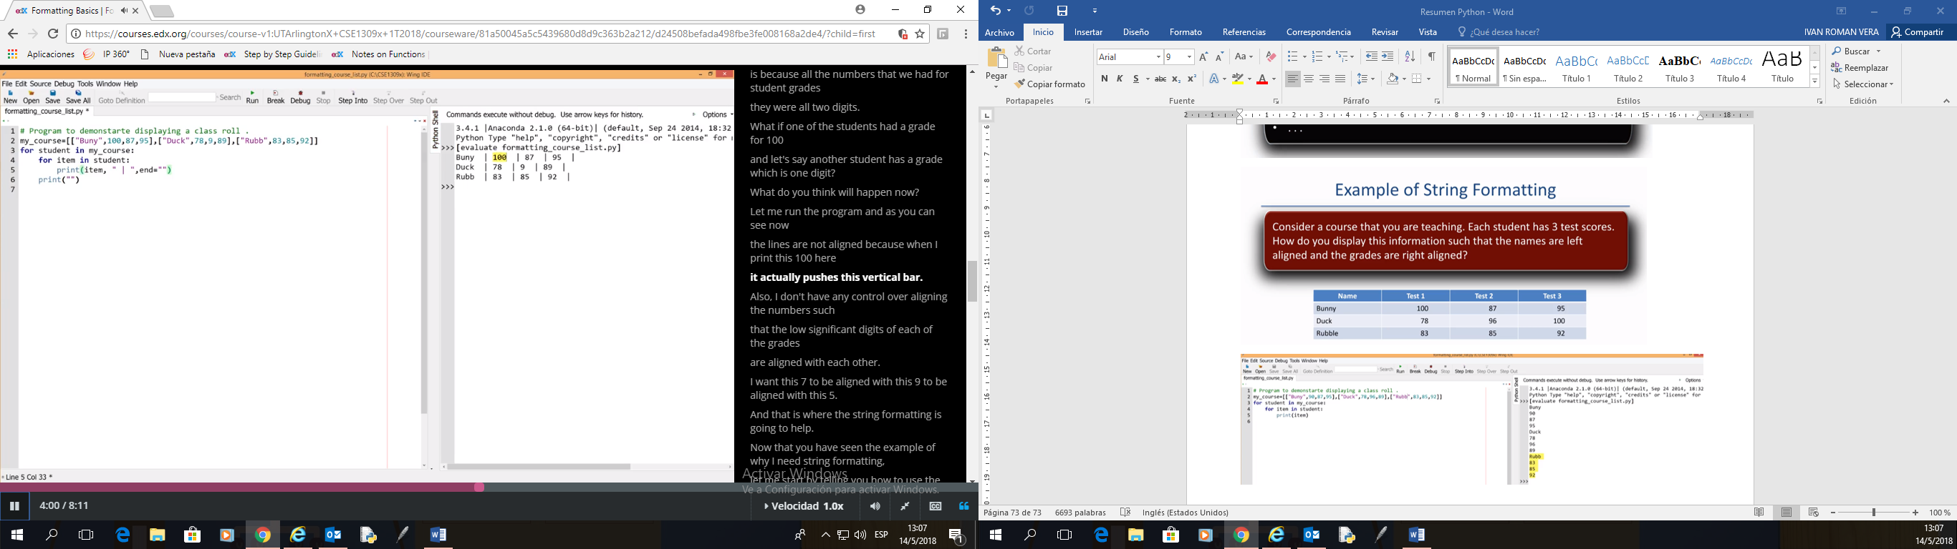

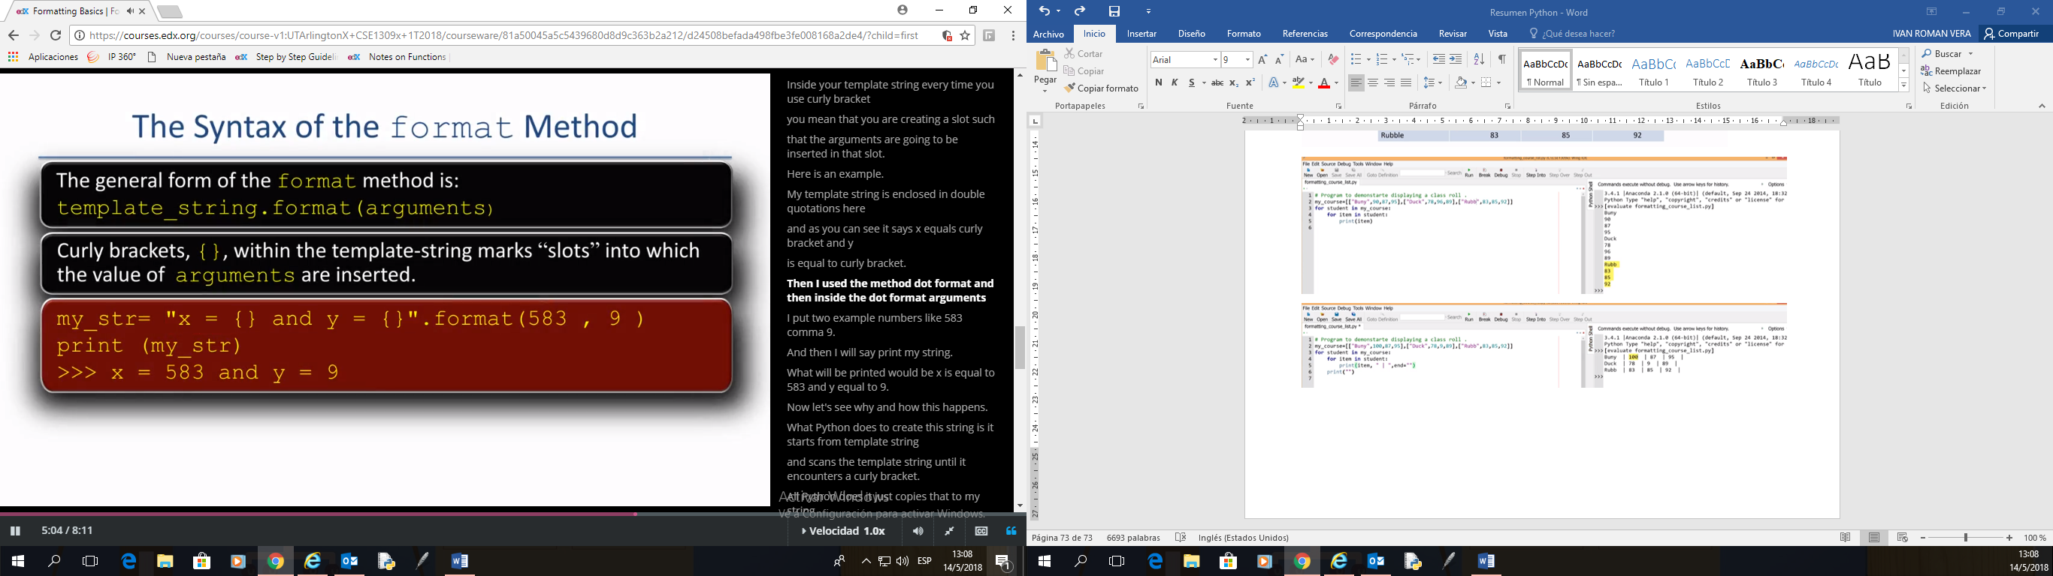

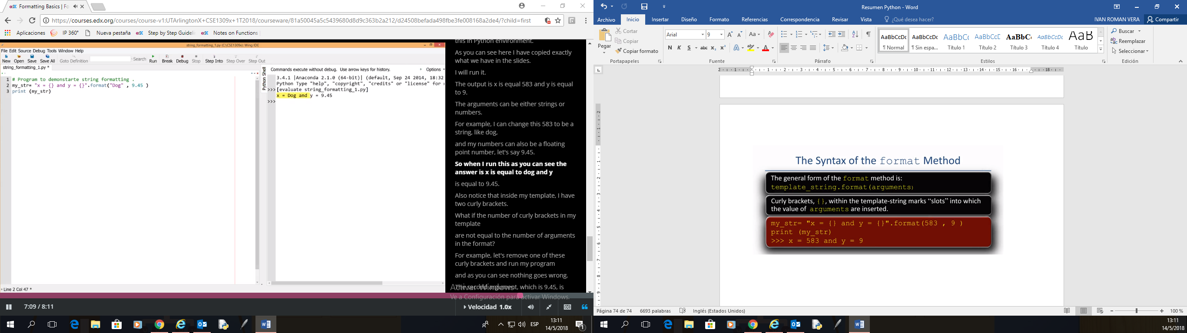

## **Formatting Positional**

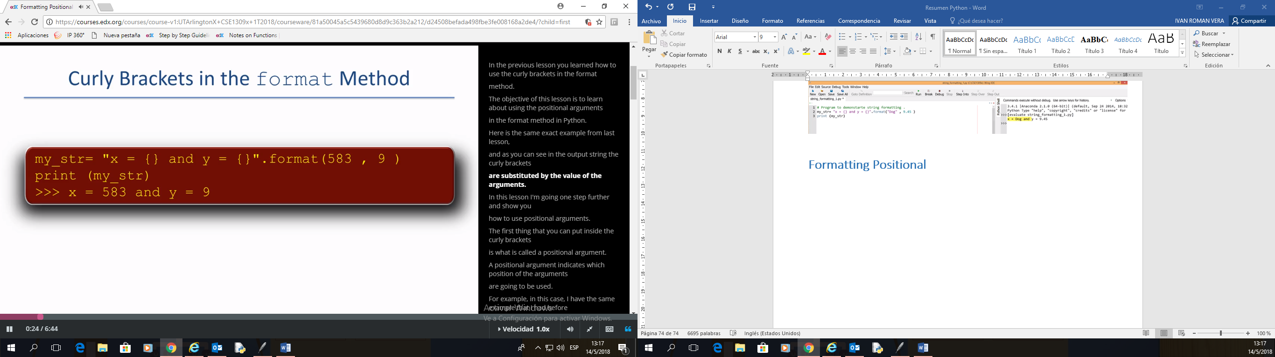

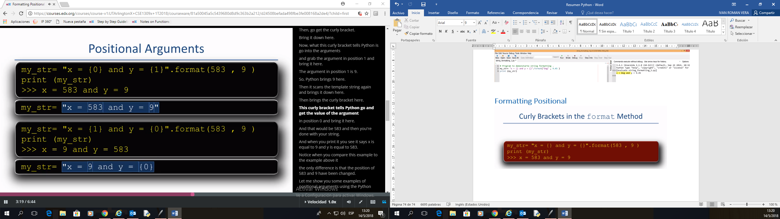

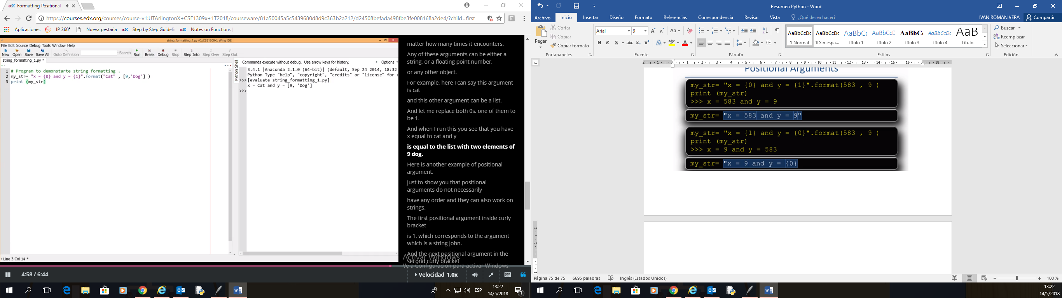

## **Formatting Width Precision Type**

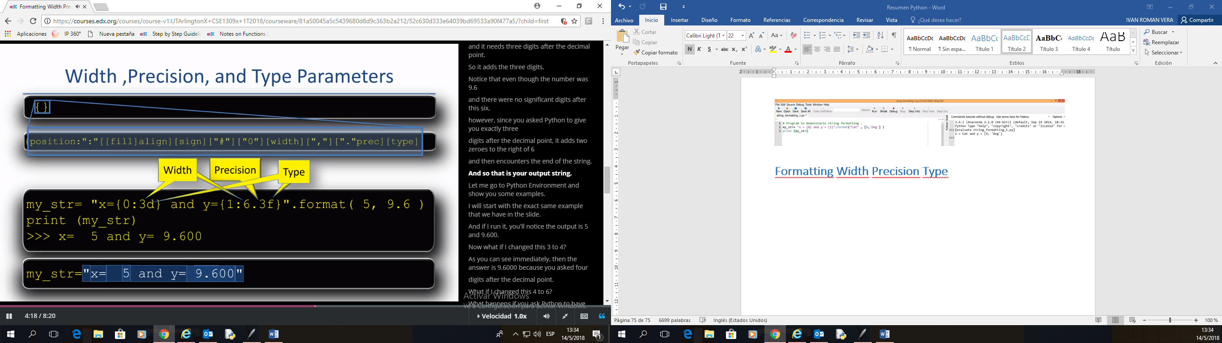

Ejemplo con string

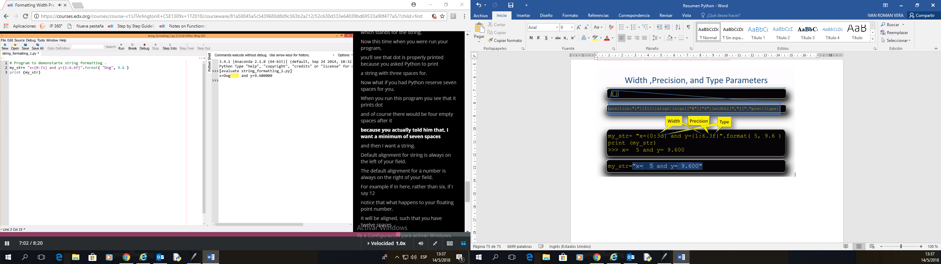

Otro ejemplo

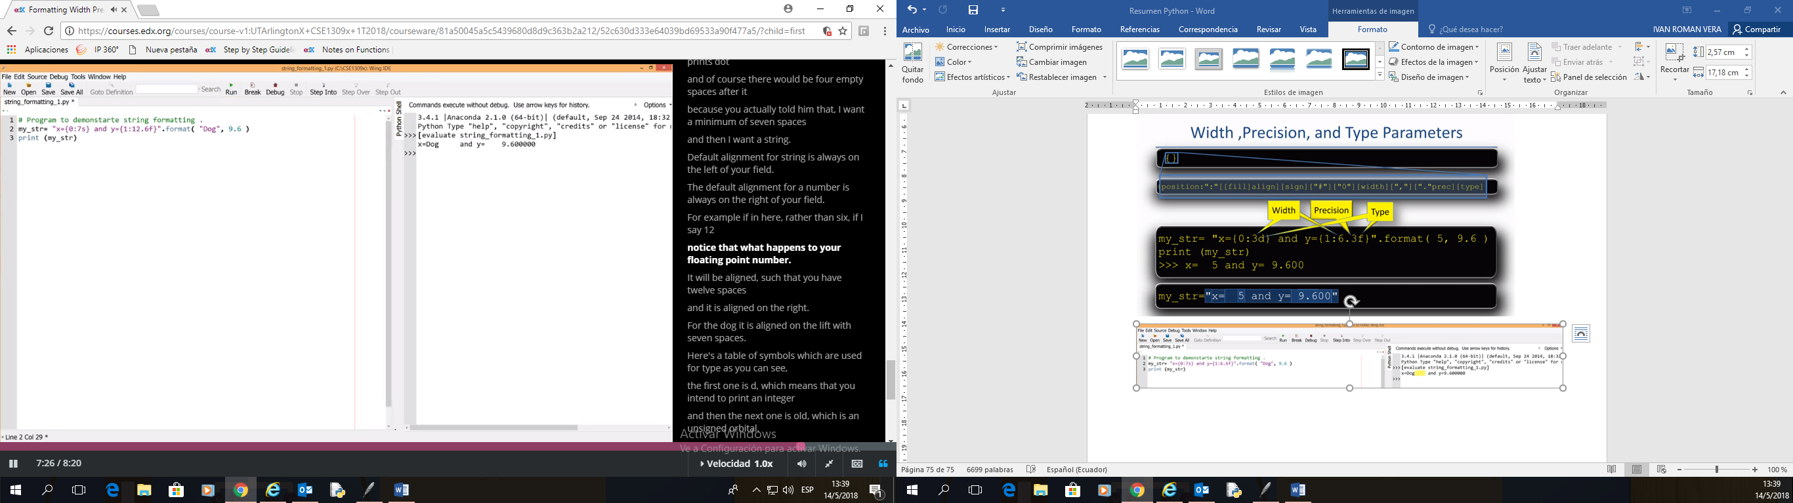

|  |  |
| --- | --- |
|  | **String Formatting** |
| **Symbol** | **Description** |
| b | Format an integer in binary. |
| c | Given a number, display the character that has that code. |
| d | Display a number in decimal (base 10). |
| e | Display a float value using the exponential format. |
| E | Same as e, but use a capital “E” in the exponent. |
| f | Format a number in fixed-point form. |
| g | General numeric format: use either f or g, whichever is appropriate. |
| G | Same as “g”, but uses a capital “E” in the exponential form. |
| n | For formatting numbers, this format uses the current local setting to insert separator characters. |
| o | Display an integer in octal format. |
| s | Used for string format. |
| x | Display an integer in hexadecimal (base 16). Digits greater than 9 are displayed as lowercase characters. |
| X | Display an integer in hexadecimal (base 16). Digits greater than 9 are displayed as uppercase characters. |
| % | Display a number as a percentage: its value is multiplied by 100, followed by a “%” character. |

## **Formatting Practice**

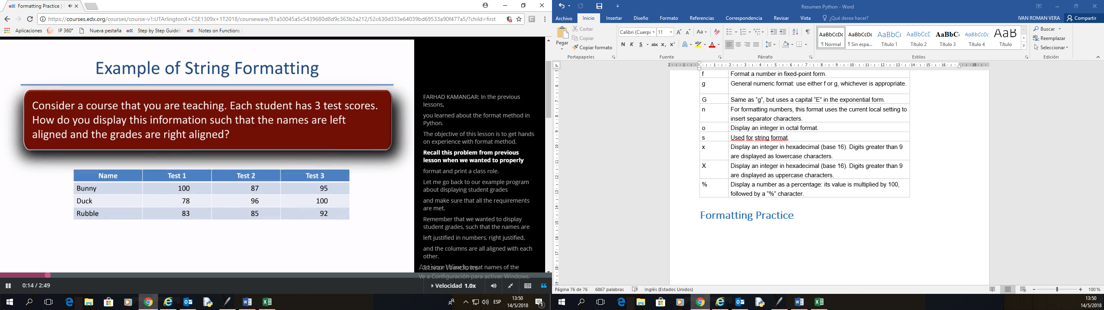

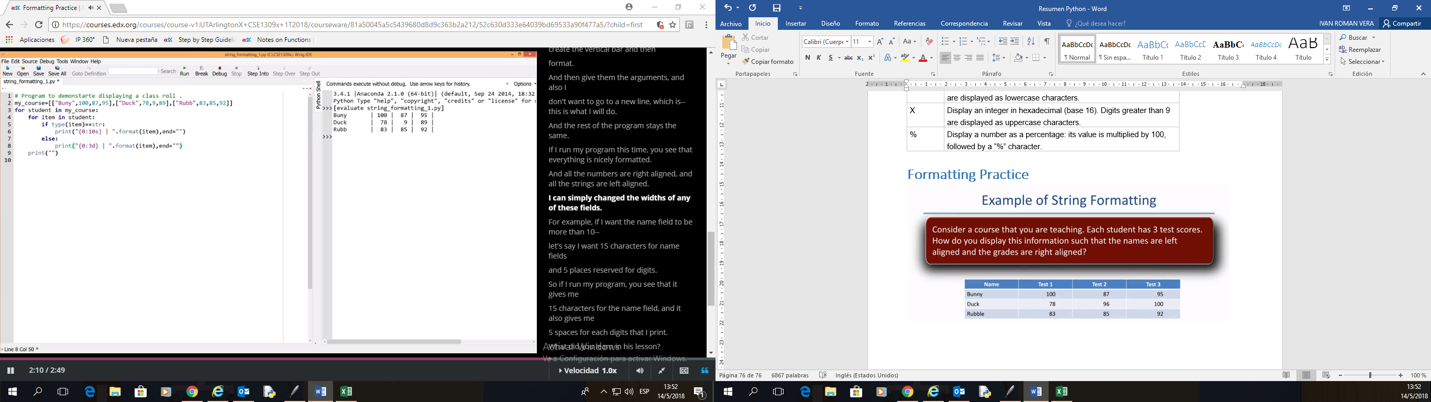

my_course = [["Bunny",100,87,95],["Duck",78,9,9],["Rubb",83,85,92]]

for student in my_course:

for item in student:

if type(item)==str:

print("|{0:10s} | ".format(item),end="")

else:

print("{0:3d} | ".format(item),end="")

print("")

## **Formatting Fill Align Part 1**